ACADEMIC CONNECTIONS
Mathematics
Middle School Connections in Agriculture Education

Name____________________________________ Period____ Date______________

Complete the following word problems.

- The average American consumes 97 pounds of beef, 64 pounds of pork, and 90 pounds of poultry in one year.

a.) How many pounds of meat will he/she have consumed over the span of ten years?

- How many pounds of meat does he/she consume in one day?

- Georgia’s poultry industry produces an average of 21 million pounds of poultry each day. How many pounds of poultry does Georgia produce in 2 months? (Assume there are 30 days in one month and 31 days in the other month.)

3.)
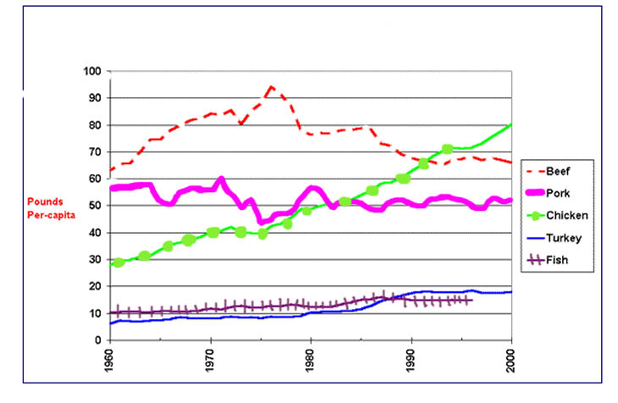

- In 1975, which meat product ranked highest in pounds per-capita consumed?

- In 1985, which meat product ranked lowest in pounds per-capita consumed?

- How many pounds per-capita of beef were consumed in 2000?

- Which meat product has maintained the steadiest increase in pounds per-capita consumed since 1960?

- What are some possible reasons for this increase?

Solutions

1.) a.) 97 lbs beef X 10 years = 970
64 lbs pork X 10 years = 640
90 lbs poultry X 10 years = 900

970 + 640 + 900 = 2510 lbs of meat
The average American will consume 2510 lbs of meat over the span of 10 years.

- 97 lbs beef / 365 days per year = .27
64 lbs pork / 365 days per year = .02
90 lbs poultry / 365 days per year = .25

.27 + .02 + .25 = 0.54
The average American consumes 0.54 lbs (a little more than half a pound) of meat in one day.

2.) 21 million X 30 days = 630 million
21 million X 31 days = 651 million

630 million x 651 million = 1281 million
Georgia produces 1281 million lbs of chicken meat in 2 months.

3.) a. beef
- turkey
- about 67
- chicken
- Americans have become more health conscience.
More emphasis has been placed on nutritional value.
Value-added products have been developed.
Convenience products flood our grocery stores.

