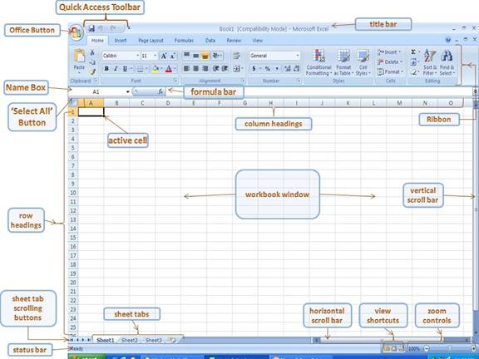
EXCEL ‘Spreadsheet/Worksheet’

