Name ________________________________________ Date ____________________ Period _____

EXCEL SPREADSHEET ^{03’}: BASIC PARTS

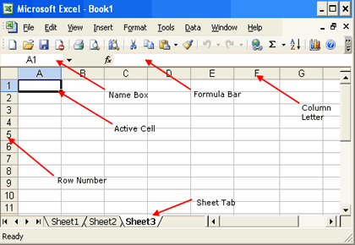
Horizontal Scroll
Vertical Scroll

