Dreamweaver:
Getting Started in Webpage Design!

- Start → Programs → Macromedia → Dreamweaver 8
- Modify → Page Properties
  - Change background and font colors.
- Insert → Table
  - 6 Rows, 2 Columns

- Highlight rows that need to be merged. Right Click. Select Table → Merge Cells.

Merge top 2 cells together also to create a Title Cell.
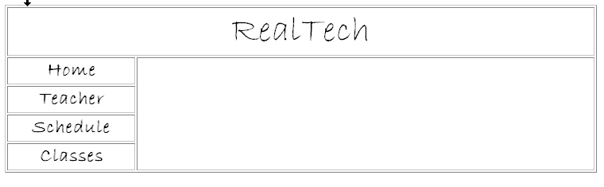
- Now type the name of your Website in the Title Cell and Create a Menu in the Cells on the left.

