Dreamweaver Quiz Information:
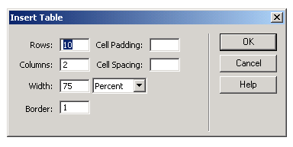
- How do you insert a table?
  - Click Insert
  - Click Table
  - Set the table to have a certain number of columns and rows and Press OK.

- How do you merge cells?

  - Highlight the cells
  - Right click
  - Go to Table → Merge Cells

- How do you center text in the Title Box?
  - Click in the Title Box
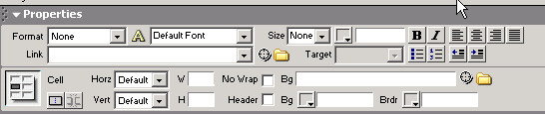
  - Click the Center Alignment Button.

- What box do you use to change the text?
  - PROPERTIES…located at the bottom of the screen.

- What do you click to insert a picture or a “Cool Text”?
  - First save the object from the internet.
  - Then click the TREE button and find the file that you just saved.

- What do you click to insert a FLASH movie?
  - First export your flash movie.
  - Then click the FLASH button on the Insert bar.

- How do you create a new page in your website?
  - First click File → New.
  - Click Basic Page → Create.
  - Then go back to your original page.
  - Click Edit → Select All. Repeat until all page is “gray” and selected.
  - Click Edit → Copy.
  - Go back to the new page.
  - Click Edit → Paste.
Dreamweaver Quiz Information:

- How do I change the colors on my page?
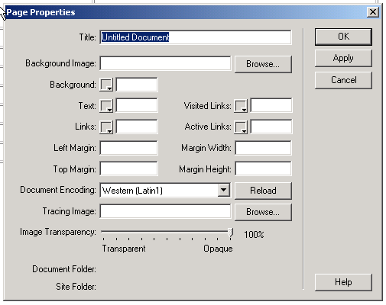
  - Click Modify → Page Properties
  - Type in the Title of the page
  - Change the Background Color, Text Color, and Link Colors.

- How do I link the pages together?
  - First save the page that you are trying to link.
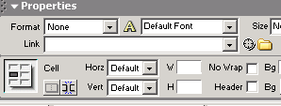
  - Then highlight the words that you are trying to link.
  - Click the link folder and select the file that you saved that you are trying to link to.
  - To link a website: Type the web address in the link box.
EXAMPLE: http://www.google.com

- How do I view my page on the internet?
  - Click File → Preview in Browser → IExplore
  - This will allow you to see your animated texts and pictures.
  - It will also allow you to test your links.

OTHER QUIZ INFO:

Quiz will be multiple choice and matching.

Please study and KNOW this material.

Happy STUDYING!! ☺

