WARM-UP #2: Graphing Linear Equations
8 – BCS – 8 - 3
ANSWER KEY

*Graph: 4x – 3y = 2 using the following x-values: -3, 0, 3, 6

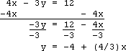
HINT: You may want to solve for ‘y=’ first. Show you work.

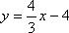

*Write the equation that you are actually graphing: _________________________

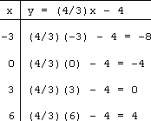
*Fill in your T-chart:

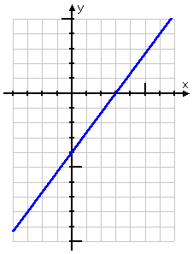
*Plot your points and draw/connect the dots:

