ACTIVITY #3: Line Equation
12 – BCS – 8 - 3
Name: ________________________________________ Date: _________________________

Equation: y = -2x + 3 (x = 0)

If we say, x = 0, then... y =

*What is the point? (___ , ___)

Now, with this information, we can find more points on the line.
Suggestion: you might want to convert the slope value to fractional form, to more easily do
the ‘up and over.’

Reminder: any number is a fraction if you put it over ‘1’

*In this case, we can say the slope is m = _____ -- this means that we will go ‘down #____ and over #____’ for EACH ‘new’ point**

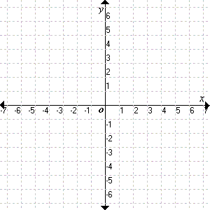
Start at the point you found above (___ , ___) and
go down ___ and over ___ to get the
next point: (___ , ___)

Go down another ___ and over another ___,
to get to the ‘next’ point on y = -2x + 3:
(___ , ___)

Now, connect-the-dots...

