ACTIVITY #3: Line Equation
13 – BCS – 8 - 3
ANSWER KEY

y = -2x + 3 (say -- x = 0)

If we say, x = 0, then... y = –2(0) + 3 = 0 + 3 = 3

*Then the point (0, 3) is on the line.

Now, with this information, we can find more points on the line.
Suggestion: you might want to convert the slope value to fractional form, to more easily do
the ‘up and over.’

Reminder: any number is a fraction if you put it over ‘1’

**In this case, we can say the slope is m = ^{–2}/₁ -- this means that we will go ‘down two and over one’ for EACH ‘new’ point**
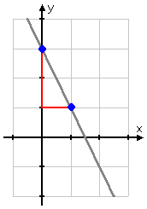

Start at the point we found above (0, 3) and
go down two and over one to get the
1, 1
next point: (1, 1)

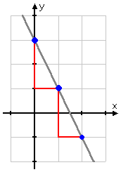

Go down another two and over another one,
to get to the ‘next’ point on y = -2x + 3:
(2, -1)
2, -1

