GRAPHING LINEAR EQUATIONS
5 – BCS – 8 - 3

KEY TERMS
linear equation y-intercept x-intercept
ordered pair slope coefficient
value plotting scale

ESSENTIAL QUESTIONS:
1. What is a linear equation?
2. Explain and demonstrate the x-intercept and y-intercept.
3. Give some examples of how the use of linear equations go beyond every-day problem solving. Name at least
three (3) careers that you are interested in, which use linear equations. Can you give at least one (1) example
of how this job/career utilizes linear equation skills?
4. What is a T-chart? Demonstrate drawing a T-chart and how it is used in graphing linear equations.
5. Explain how the values for x are selected and at least how many should be selected. Explain and demonstrate
when you should pick x-values that are multiples of three (3).
6. What is a scale and demonstrate how it should be labeled.
7. Demonstrate plotting computed T-chart points.
8. In what situation will the graph always be a horizontal line? Explain.
9. In what situation will the graph always be a vertical line? Explain.

NOTE: We solve linear equations in our heads all of the time without even noticing or thinking about it.

Example: You bought 2 CDs for the same price, and a book – you spent $20 total, and know that
the book was $6 – You solve the linear equation (2x + 6 = 20) to find out that the price
of each CD was $7.

*The use of linear equations go far beyond every-day problems like the one above:

Examples: Computer Graphics Programmer use what’s called ‘linear algebra.’ It describes the location
of each point on an image by a coordinate system – a point has co-ordinates (x, y)...

Economist and/or Financial Adviser
Supply and Demand – where your demand for a product will depend on the price of the product
and how much you earn.
*If the product is very expensive, and you are not rich, you probably don’t want too much of it.
Whereas, if the product is cheap, you may want a lot of it.

*The demand is often expressed as a linear equation: D = a – bP + cI
D = demand P = price I = your income

NOTE: Demand goes down if Price goes up
Demand goes up if your Income goes up

Scientists study genes. If you want to find out what a particular gene actually does, you have to
see how it influences all the chemical processes in the body.

*The way these processes work, and how they influence each other, can be expressed by large systems of linear equations.

Biologist use linear equations to get an idea of how a population of animals might change over
time.

Engineer works out the exact proportions of a building, like a bridge or a sky scraper, and how
much and what kind of materials to use.

Psychologists use a statistical analyses called the Pearson Correlation that is essentially a
glorified linear equation. It is used to assess whether a relationship exists between two things.

Meteorologists use linear equations to analyze the weather pattern. Especially, since recent
analyses suggest that the temperature has become increasingly linear in the past few years. This
is believed to be suggestive of global warming...

**For additional jobs/careers that utilize ‘linear equations’ directly and/or indirectly, please see the enclosed list labeled ‘JOBS/CAREERS USING LINEAR EQUATIONS.’ You may be suprised?

T-CHARTS:
*T-charts are used to find ‘plot points’
*It is called a T-chart because it looks like the letter ‘T.’

*Have the students draw on their own paper – while you draw on the board, overhead, active board, etc...
*The left column will contain the x-values that YOU will pick.
*The right column will contain the corresponding y-values that
will compute.

EXAMPLE: Graph y = 2x + 3

*Label the columns:

*Remember, the 1st column will be where YOU
y = 2x + 3
x
choose your input (x-values); and the 2nd column
is where you find the resulting output (y-values).

TOGETHER: these make a point (x, y)

NOTE: For best results, pick at least three (3) values for x (this is to verify that you are getting a straight line when graphing).

FYI: ‘Linear’ equations, the ones with just an x and a y, with no squared variables or square-rooted variables on any other fancy stuff, ALWAYS graph as straight lines. That’s where the name ‘linear’ comes from.

y = 2x + 3
x
(x, y)
Back to the equation ... y = 2x + 3
-4
We’ll pick the following values for x: -4, -2, 0, and 2 -2
*place them on the T-chart in the X column* 0
2

*Now that we have picked our x-values, we have to compute the corresponding y-values:
y = 2x + 3
x
(x, y)

-4 2(-4) + 3 = -8 + 3 = -5 (-4, -5)
-2 2(-2) + 3 = -4 + 3 = -1 (-2, -1)
0 2(0) + 3 = 0 + 3 = 3 (0, 3)
2 2(2) + 3 = 4 + 3 = 7 (2, 7)

*It is ‘optional,’ but you can add a third column to the T-chart to give room for a clear listing of the points that
you find* (see chart above)

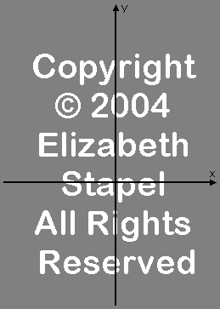

Plotting the Points and Drawing the Line:

*Let’s draw our axes:

**REMINDER: The arrows indicate the direction in which the values
values are increasing. Arrows go on the upper numerical ends of each axis.

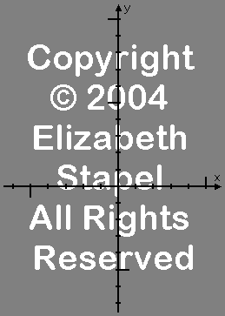

*Now, we need to label the axes with an ‘appropriate’
scale.

EXAMPLE:

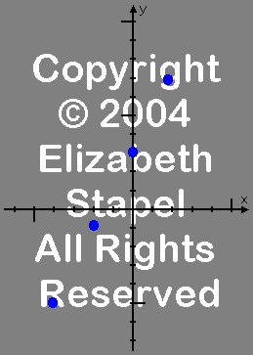
*Next, we need to plot / (draw) the points computed in the T-chart.

EXAMPLE:

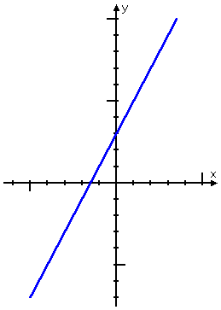
*Let’s finish by connecting the dots:

EXAMPLE:

**NOW, YOU TRY...

Graph: y = (-5/3)x – 2

HINT: Since you are multiplying x by a fraction, pick x-values that are multiples of 3, so the denominator will cancel out and you will not have fractions.
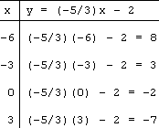
**POSSIBLE solution:
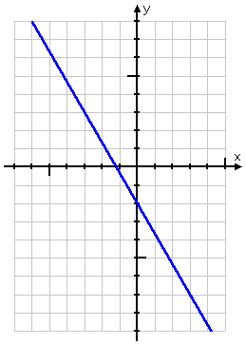

‘Possible’ T-chart

**NOTE-To-TEACHER**
If you want to check-for-understanding,
assign ‘precise’ x-values – for ‘precise’
y-value computations.
‘Possible’ plotted points

**TRY THIS ONE...

Graph: y = 3

**Tell the students: Do not let this one scare you. Yes, there is no ‘x’ in the equation, but that’s okay. Just think of it this way: it does not matter what x-value you pick; ‘y’ will ALWAYS be 3.
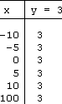

*Your T-chart could/would look something like this:

*Then your graph could/would look something like this:
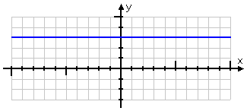

NOTE: Any time you have a ‘y equals a number’ equation, with NO ‘x’ in it, the graph will ALWAYS
be a horizontal line.

Graph: x = 4

**Tell the students: Do not let this one scare you either. Yes, there is no ‘y’ in the equation, so you can’t solve for ‘y =’, but that’s okay. The reasoning works just like the previous example. No matter what ‘y’ might happen to be, ‘x’ is ALWAYS 4.
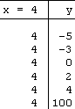
*You will do the T-chart BACKWARDS,
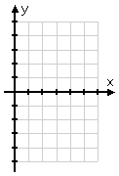
by picking various y-values and putting
‘4’ as the corresponding x-values.

EXAMPLE:

*Your graph will/should fill in something like this:

NOTE: Any time you have a ‘x equals a number’ equation, with NO ‘y’ in it, the graph will ALWAYS
be a vertical line.

ACTIVITY #2: Graphing Linear Equations

MINI-ASSESSMENT: Graphing Linear Equations

