MINI-ASSESSMENT: Graphing Linear Equations
10 – BCS – 8 - 3

ANSWER KEY

I. Complete the t-chart of ordered pairs and graph/plot the points. Don’t forget to connect-the-dots.
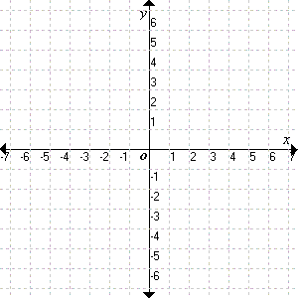
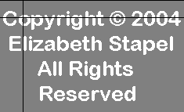
1. y = -²/₃ x + 1
x
-3
y = -2/3x + 1
0
3
6
3
1
-1
-3

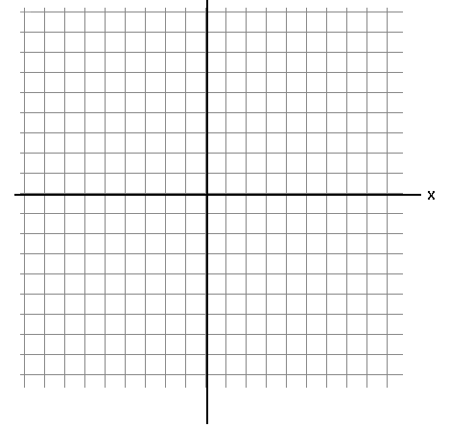
-12 -10 -8 -6 -4 0 4 6 8 10 12
12

10

8

6

4

-4

-6

-8

-10

-12

x
-3
y = 2x + 2
2
5
-4
6
12
2. y = 2x + 2
*Label axes with
‘appropriate’ scale*

-12 -10 -8 -6 -4 0 4 6 8 10 12
12

10

8

6

4

-4

-6

-8

-10

-12

3. y = -3x + 1
x
-3
y = -3x + 1
2
5
10
-5
14
*Label axes with
‘appropriate’ scale.

