GRAPHING POINTS
1 – BCS – 8 - 3

KEY TERMS
point plane coordinate x-axis y-axis negative
address positive coordinate plane quadrant horizontal vertical
origin

ESSENTIAL QUESTIONS:
1. Demonstrate the difference between horizontal and vertical by drawing a coordinate plane.
2. Explain how to use the coordinate plane to give the exact address of a point.
3. Which direction(s) are indicated by a negative sign?
4. Which direction(s) are indicated by a positive sign?
5. What is a quadrant? How many quadrants are there? How is each quadrant represented?
6. Explain the contents of each quadrant. What coordinates will be found in each quadrant?

*Have students to draw a horizontal line at the center of their graphing paper (while you demonstrating the same action on the board, transparency, and/or active board). Then, have students to count with you as you/they put the numbers on the line (one number per line of the graph paper) – ‘zero, one, two, three...’

Explain to the students that when you count backwards, you distinguish the numbers that come before ‘zero’ by placing a ‘-‘ sign in front of those numbers, so it goes: ‘two, one, zero ...’

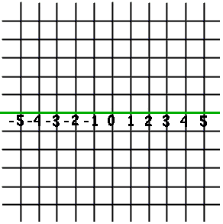
Tell students to make sure that they evenly space the numbers, since the distance from 1 to 2 should be the same as the distance from 2 to 3.

EXAMPLE:

*Tell the students that what we now have is
called a ‘number line’ or ‘coordinate plane.’

*It can be used to describe where a
point is on the line; to give the exact
address of a point.

*Now, points can be anywhere on the paper, not only on the line. To give an address for the points that are not on the number line, we will need to make a vertical number line.

*Draw a vertical line through the ‘zero’ of the horizontal number line.
*Now, label it with positive numbers above the horizontal number line and the negative numbers below the
horizontal number line.

NOTE: From this point on – instead of saying horizontal number line and vertical number line, we will refer to them by their mathematical names: horizontal = x-axis and vertical = y-axis.

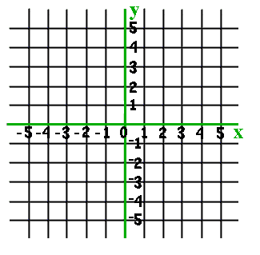
EXAMPLE:

NOTE: To create a standard way of referring to
points, start from zero, and go all the way to the
right or to the left, counting steps: one, two...
Then go up or down: one, two, three...

*Then write the number of steps like that: (2, 3)

Again, the first number is ‘left – right’ and the
second number is ‘up – down.’

*A ‘negative’ sign means either left or down –
So, if the point is (-2, -3) – go two steps to the left,
and then three steps down.

*CHECK-UP: Do you remember the names of the number lines? horizontal line is called x-axis & the vertical line is called the y-axis.
*CHECK-UP: Can you think of a better way to describe the address of a point instead of left-right-up-down?
We could call the address by the names of the lines – so the address of a point would be described as (x, y).

NOTE: The mathematical term for the address of a point is called coordinates.

NOW, does everyone see how the x-axis and y-axis divide our paper into four sections? These sections are called quadrants because there are four (4) of them and there are four (4) dies to a quadralateral.

*We get our prefix ‘quad’ from the Latin word ‘quattuor’ which means four.

*Each of the quadrants are referred to by a roman numeral (I, II, III, and IV).

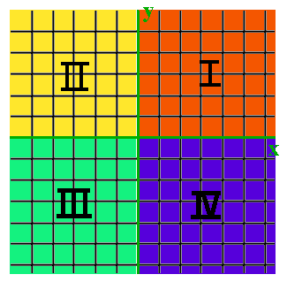
EXAMPLE

*The first (I) quadrant -- contains all the points
with positive x and positive y coordinates and is
represented by the roman numeral I.

*The second (II) quadrant -- contains all the points
with negative x and positive y coordinates and is
represented by the roman numeral II.

*The third (III) quadrant -- contains all the points
with negative x and negative y coordinates and is
represented by the roman numeral III.

*The fourth (IV) quadrant -- contains all the points with positive x and negative y coordinates and is represented by the roman numeral IV.

**REVIEW: have students to complete ‘Activity #1’

**ASSESSMENT: Assessment #1: Graphing Quiz

