SLOPES: Straight-Line Equations (Slope-Intercept Form)
11 – BCS – 8 - 3

KEY TERMS
slope-intercept formula rise-over-run convert
straight-line equation

ESSENTIAL QUESTIONS:
1. What is the formula for the slope-intercept form?
2. In the equation y = mx + b, what does each variable represent?
3. Explain and demonstrate what should be done when an exercise only gives ‘pieces’ of information about a line.
4. What is the slope formula?
5. Explain why it does not matter which point you choose to ‘plug-in’ when finding the line of an equation.

REVIEW:

*Straight-line equations or ‘linear’ equations, graph as straight lines and have simple variable expressions with no exponents.

NOTE: If you see an equation with only x and y – as opposed to x² or sqrt (y) – you are dealing with a straight-line equation.

Slope-Intercept Form equation: y = mx + b
*m = the slope *b = gives the y-intercept
*x = the value YOU plug-in *y = is what you solve for after plugging in YOUR x-value

*Some exercises may only give you some ‘pieces’ of information about a line -- and you will have to come up with the equation of the line*

How do you do that?
Start by plugging in whatever is given -- and solve for what you need.

EXAMPLE #1: Find the equation of the straight line that has slope m=4 and passes through the point (-1, -6).
1st -- value of the slope is m = 4
2nd -- a point on the line: (x-value = -1) (y-value = -6)
What do you need to solve for? ‘b’
What will this give you? ‘the y-intercept’
equation: y = mx + b
given (plugged-in): (-6) = (4) (-1) + b
-6 = -4 + b
-2 = b
*The line equation must be: y = 4x -2
EXAMPLE #2: Find the equation of the line that passes through the points (-2, 4) and (1, 2).
NOTE: If you have two points on a straight line, you can ALWAYS find the slope.
(4) - (2) 2 2
Slope Formula (given plugged-in): m = = = -
(-2) - (1) -3 3

Now, we have a slope and two points. We know that we can find the equation by solving for ‘b’ first.

We need to pick one of the points (it doesn’t matter which one), and use it to solve for ‘be.’
*Let’s use the point (-2, 4)
y = mx + b
4 = (-²/₃) (-2) + b
4 = ⁴/₃ + b
4 - 4/3 = b
12/3 - 4/3 = b
b = 8/3

So, y = (-2/3)x + 8/3

*If we use the point (1, 2):
y = mx + b
2 = (-2/3) (1) + b
2 = -2/3 + b
2 + 2/3 = b
6/3 + 2/3 = b
b = 8/3

*See, it doesn’t matter which point we choose. Either way, the answer is the same:
y = (-2/3)x + 8/3

NOTE: Once you have the slope, it doesn’t matter which point you use in order to find the line equation. The answer will work out the same either way.

SLOPES: Find the Intercepts of A Linear Equation

*Plug ‘0’ in for x and solve for y to find the y-intercept.
EXAMPLE: 3x + 5 = y
3 (0) + 5 = y5
y-intercept (0, 5)

*Plug ‘0’ in for y and solve for x to find the x-intercept.
EXAMPLE: 3x + 5 = y
3x + 5 = 0
*subtract 5 from both sides
*divide both sides by 3
x-intercept = (-5/3, 0)

NOTE: The linear equation crosses the x-axis at the x-intercept and the y-axis at the y-intercept.

EXAMPLE: 3x + 5 = y
*It crosses the x-axis at (-5/3, 0) and the y-axis at (0, 5).

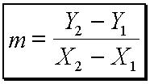
REVIEW: Learn that the slope of a linear equation can be expressed with the equation
*The numbers in this equation that you see next to the variables
are NOT to be multiplied or subtracted – they are simply there
to denote that there is point ‘y-one’ and point ‘y-two’ as well as
point ‘x-one’ and point ‘x-two.’

Remember: The y’s go over the x’s in this equation ...
*remember ‘rise-over-run’ will give you slope*

SLOPES: Using Slope and Y-Intercept to Graph Lines

*SLOPE is a number that describes the ‘steepness’ of a line.

Slope Equation: vertical change

horizontal change

*Given two points (X₁ , Y₁) and (X₂ , Y₂), the formula for the slope of the straight line going through these two points:
*The subscripts (1 & 2) merely indicate that you have a first point (whose coordinates are subscripted with a 1) and a second point (whose coordinates are subscripted with a 2).

NOTE: The point that you pick as the ‘first’ one does NOT matter – you get the same value for the slope.

*The formula for slope is sometimes referred to as ‘rise over run’ because the fraction consists of the ‘rise’ (the change in y, going up or down), divided by the ‘run’ (the change in x, going from left to right).

EXAMPLE: y = (2/3)x - 4
Compute the slope, and draw the line.

*To find points from the line equation, we have to pick values for one of the variables, and then compute the corresponding value of the other variable.

*If we say, x = –3, then y = ( ²/₃ )(–3) – 4 = –2 – 4 = –6
so, the point (-3, -6) is on the line.

*If x = 0, then y = ( ²/₃ )(0) – 4 = 0 – 4 = –4
so, the point (0, -4) is on the line.
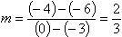
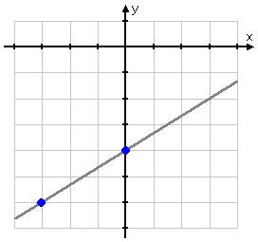
Now that we have two points on the line, we can find the slope of that line from the slope formula:

*Let’s look at these two points on the graph:

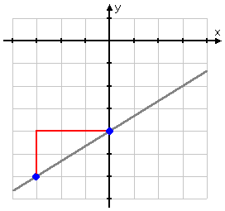

*In stair-stepping up from the first point
to the second point, our ‘path’ can be
viewed as forming a right triangle:”

NOTE: The distance between the y-values of the two points (height of the triangle) is the ‘Y₁ , Y₂’ part of the slope formula.

The distance between the x-values (length of the triangle) is the ‘X₁ , X₂’ part of the slope formula.

*The slope is 2/3, or ‘two over three’ -- to go from the first point to the second point – we went ‘two up and
three over’

*This relationship between the slope of a line and pairs of points on that line is ALWAYS true.
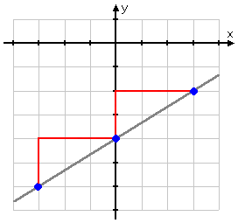

*To get to the ‘next’ point, we can go up another two (to y = -2),
and over to the right another three (to x = 3):

*With these three points, we can graph the line
y = ( ²/₃ )x – 4.

??Not sure of the last point?? Just put 3 in for x,
and verify that you get -2 for y.

NOW, you try... y = -2x + 3

Activity #3: Line Equations

