Name ___________________________________ Date ____________________
17 – BCS – 8 - 3

UNIT ASSESSMENT: Linear Equations
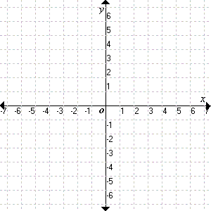
I. Name the point with the given coordinates.
E
1. (1, 5) __________ 2. (0, 3) __________
3. (-2, 1) _________ 4. (-3, 0) __________
G
5. (-5, -2) _________ 6. (5, -3) __________
D
F
A
C
B

II. In which quadrant or on which axis does each
ordered pair lie?

7. (21, -56) ______ 8. (0, -34) ______
9. (│-12│, 5) _____

III. Graph each equation.

10. y = 2x + 2 11. -2x = y + 3 12. y = -³/₂x + 3

IV. Find the slope and the y-intercept of each equation.

13. y = 6x 14. y = -3x -8 15. y = 5x + 6
____________________ ____________________ ____________________

16. y = 8 17. y = ²/₃x - 4
____________________ ____________________

V. Find the slope of each line.
(-3, 3)
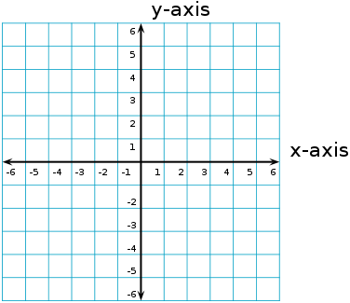
(-1, 3)
(2, 3)
18. 19. 20.
(-1, 2)
(3, 1)

(-1, -1)
(1, -2)
(-3, -2)

____________________ ____________________ _____________________
VI. Circle the correct answer for the questions below.

21. What do you select to combine one or multiple cells into one?
a. combine b. merge c. align d. format

22. When you select one cell or a range of cells, where is the data displayed?
a. entry bar b. formula bar c. display bar d. format bar

23. What symbol must always precede a formula in Excel?
a. > b. < c. = d. #

24. On a chart/graph, what do you call the placement box which displays the key for the data represented in
the chart/graph?
a. legend b. data box c. source box d. range

25. When making formatting (font, size, color, etc...), changes to individual parts of a chart, you will need
to _____ on that part of the chart/graph.
a. click b. right-click c. left-click d. double-click

