- On the spine of the book image, write the 5 study skills in order.
- Inside the circle, draw a picture that represents the study skill (ex: a clock would represent time.)
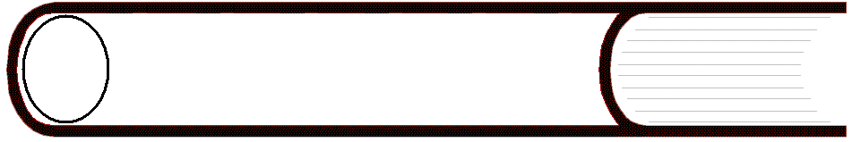
- In the area that represents the pages, give one specific example of how to accomplish the study skill.

