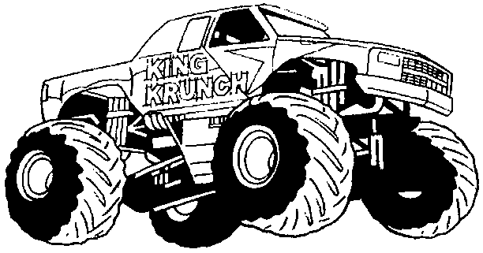
(You may work with a parent on this since they have lots of experience with balancing life roles)

FAMILY
PERSONAL
WORK
LEISURE



What happens if tires on a car are not properly balanced? (too much or too little air in one tire, wheels not aligned, etc.)

What happens in life when our various roles are not balanced? (too much time and energy devoted to one role while others are neglected)

What happens to the car when one tire goes flat?

How are other life roles impacted when a crisis affects one of our roles? (death in family, personal illness, work stress, TV goes out, etc)

