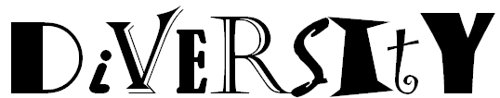
In the spaces below, list the 9 examples of diversity from your graphic organizer. Your teacher may choose to put the slide from your unit introduction on the screen as an alternative so you can copy them.
Just by looking at these words, how would you define “Diversity” in 5 words or less without using any of the words at the left(use the space below)

Your classroom is diverse even if the students don’t match any of the examples listed above. In the middle column, write the word that best describes you based on the categories in Column 1. When your teacher directs you to do so, go and find one person who has an answer that differs from yours and get them to sign Column 3. Do not get the same person to sign more than twice.
Category of Diversity | Me | Signature of someone whose answers differ
Hair Color
Eye Color
Gender (male or female)
Height (tall, short, average)
Skin Color
Country of Origin
Religious Faith
Age
Extracurricular Activities | List all | Someone who does none of the ones you do
MORE

Count the number of people in your classroom who fit into each of the categories below for hair color. When you are finished, make sure the total of all the numbers equals the number of students in your class

HAIR COLOR | COUNT
Brown
Black
Red
Blonde
Other
TOTAL

Assume the hair color of everyone in your class is representative of the populations of various countries or even the entire world. Using an algebraic equation(proportion), calculate how many people would have each hair color given the population estimates listed below? Do your math for each color within each cell of the table, round to the nearest whole number, and circle your answers.

In the bottom row, explain whether you agree or disagree with your answers and give your reasoning.

Hair Color | United States  307,212,123 | Mexico  111,211,789 | Sweden  9,059,651 | World  6,790,062,216
Brown
Black
Red
Blonde
Other
Source: https://www.cia.gov/library/publications/the-world-factbook/geos/
Reasoning

