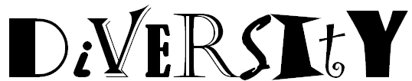

In the space below, see how many of the 9 examples of diversity you can list from memory using the acronym above.
Disabilities | Income | Viewpoints
Ethnicity | Religion | Sex
Intelligence | Tolerance | Youth

Divide into groups of 2 or 3 as directed by your teacher and answer the following questions. Be prepared to share your answers with the class.

What does it mean to respect diversity?
Student answers may vary, but examples of acceptable answers include but are not limited to:
- Accepting others regardless of their age, gender, race, religion, national origin, etc.
- Working to get along with others even if they are different from you
- Realize that people have all kinds of differences and deserve a chance to be respected

What impact does your ability to respect diversity have on your success both now and in the future?
Student answers may vary, but examples of acceptable answers include but are not limited to:
- I will be a better student because I realize all people regardless of differences are here to learn
- I will have better work relationships if I recognize and accept differences in my co-workers
- I will be a good employee if I am able to deal with customers’ differences

List 3 positive results of respecting diversity in the workplace. | List 3 negative consequences of not respecting diversity in the workplace  (avoid using opposites of your positives)
- Positive work relationships  - Meeting the needs of diverse customers  - Peaceful work environment | - Getting fired  - Stress caused by tension that may result  - You could get sued

Imagine you are a supervisor and you have an employee who is not respecting those around him or her because of their differences, what would you say to help that person realize the need to respect diversity?
- We all have to work together, so it’s important that we accept each others’ differences and focus on our mission.
- Our customers come from all different types of backgrounds and need to feel that they are welcomed here.
- Everyone will be more productive if we realize we can all learn from each other and not focusing on our differences.

