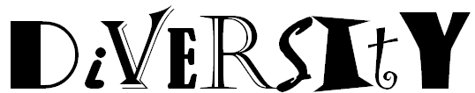

In the space below, see how many of the 9 examples of diversity you can list from memory using the acronym above.

Divide into groups of 2 or 3 as directed by your teacher and answer the following questions. Be prepared to share your answers with the class.

What does it mean to respect diversity?

What impact does your ability to respect diversity have on your success both now and in the future?

List 3 positive results of respecting diversity in the workplace. | List 3 negative consequences of not respecting diversity in the workplace  (avoid using opposites of your positives)

Imagine you are a supervisor and you have an employee who is not respecting those around him or her because of their differences, what would you say to help that person realize the need to respect diversity?

