Name: _______________________________________
Date: ________________________________________
Period: _______________________________________

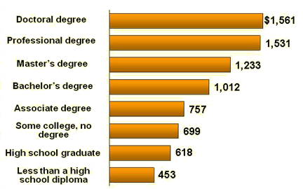
INSTRUCTIONS: The graph below shows the median weekly earnings of wage earners in the US for 2008 (Source: Bureau of Labor and Statistics). Using the graph, calculate the percentage increases requested below. If you don’t know how to calculate percentage changes, you may be asked to research on your own or your teacher will help.

 | What is the Percentage difference between salaries given the following levels of education (NOTE: some answers may be negative indicating a decrease in salary) |  | CALCULATIONS  (Round to the nearest 10th of a percent) | Answer
1 | High School dropout | HS graduate | 618-453=165  165/453=.364238 | 36.4%
2 | HS graduate | Bachelor’s Degree | 1,012-618=394  394/618=.637540 | 63.8%
3 | Bachelor’s Degree | Master’s Degree | 1233-1012=221  221/1012=.218379 | 21.8%
4 | Bachelor’s Degree | Doctoral Degree | 1561-1012=549  549/1012=.542490 | 54.2%
5 | Some college, no degree | HS graduate | 618-699=-81  -81/699=-.115880 | -11.6%
6 | Associate’s Degree | Some College, no degree | 699-757=-.076618 | -7.7%
7 | Associate’s Degree | Bachelor’s Degree | 1012-757=255  255/757=.336856 | 33.7%
8 | HS dropout | Bachelor’s Degree | 1012-453=559  559/453=1.233996 | 123.4%
9 | Some college, no degree | HS dropout | 453-699=-246  -246/699=-.351931 | -35.2%
10 | HS graduate | Doctoral Degree | 1561-618=943  943/618=1.52589 | 152.6%

