Name: ____________________________
Date: _____________________________
Period: ___________________________

Introduction (Write / Type answers)
If you have Internet access, you may use the Internet as directed by the teacher. If not, follow your teacher’s directions for how to work in groups.

- GPA stands for --

- Your GPA is (Explain what it is in your own words)--

- 3 things my High School GPA will be used for include (in groups as teacher directs you)--

Activity

NOTE: This activity can be done without the use of a computer, however, if students have access to a computer lab and a shared network drive, please follow the instructions below.

- Open the GPA Worksheet(if you have access to a shared network drive and save to your student file location.
- In the quality points column, put a 4 for an A, a 3 for a B, a 2 for a C and 0 for an F. Colleges give you 1 for a D (60 – 69), but high schools don’t.

- After typing in all the quality points, click the blue box beside 9th grade Semester 1, then click the arrow of the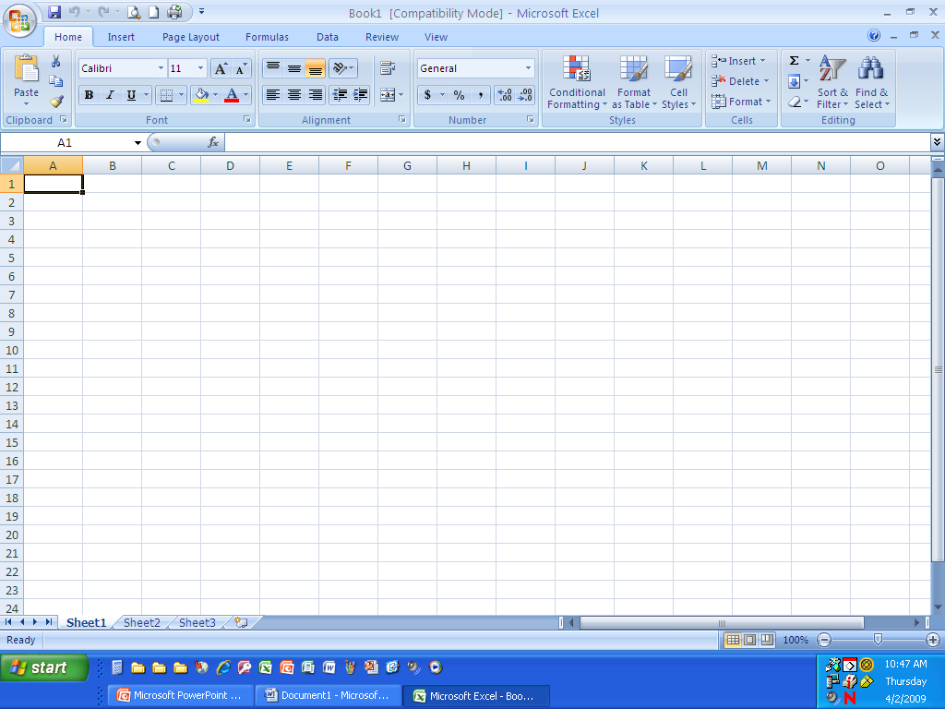 Button and choose “Average”—Click and drag the first 4 cells under “quality points” (first 4 only) and press Enter. This is your GPA after one semester of high school.

- Now—Click the next blue box beside 9th grade Semester 2, click the button and choose “Average” and drag the 4 cells under quality points for 9th grade Sem 2.

- Next – Click in each blue box and average the quality points for each semester as you did in the instructions above.

- When finished, save to your Student drive and follow the teacher’s directions for what to do when finished.

