Name: _____________________________________
Date: _______________________________________
Class Period: _________________________________

INSTRUCTIONS: The graph below shows the median weekly earnings of wage earners in the US for 2008 (Source: Bureau of Labor and Statistics). Using the graph, calculate the percentage increases requested below. If you don’t know how to calculate percentage changes, you may be asked to research on your own or your teacher will help.
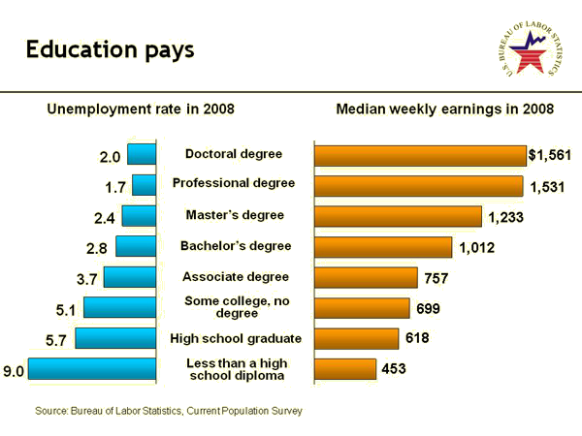

 | What is the Percentage difference between salaries given the following levels of education (NOTE: some answers may be negative indicating a decrease in salary) |  | CALCULATIONS  (Round to the nearest 10th of a percent) | Answer
1 | High School dropout | HS graduate
2 | HS graduate | Bachelor’s Degree
3 | Bachelor’s Degree | Master’s Degree
4 | Bachelor’s Degree | Doctoral Degree
5 | Some college, no degree | HS graduate
6 | Associate’s Degree | Some College, no degree
7 | Associate’s Degree | Bachelor’s Degree
8 | HS dropout | Bachelor’s Degree
9 | Some college, no degree | HS dropout
10 | HS graduate | Doctoral Degree

