

Measuring Review

Case | Question | Answer | Value
1 | 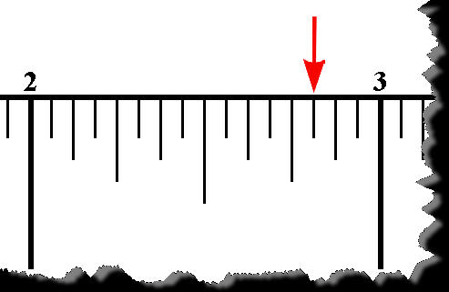 | 2 3/16” | 100
2 | 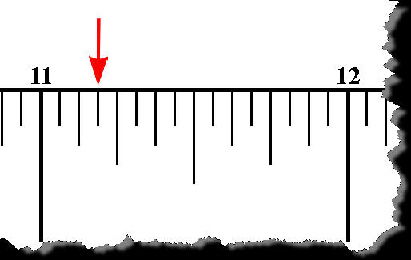 | 11 3/16” | 300
3 | 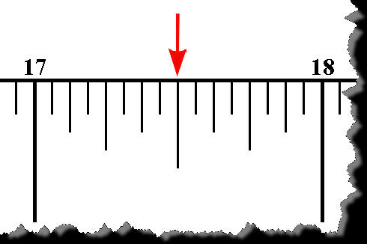 | 17 ½” | 150
4 | 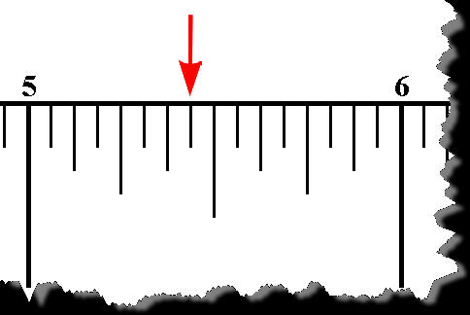 | 5 7/16” | -250
5 | 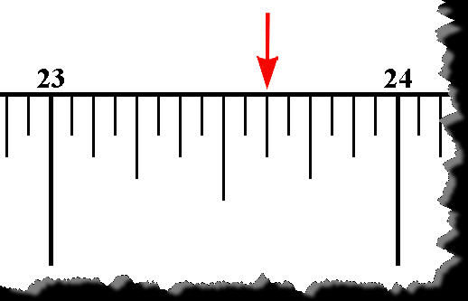 | 23 5/8” | 450
6 | 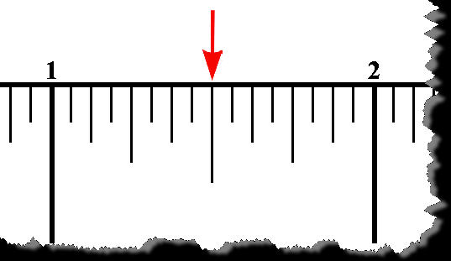 | 1 ½” | 500
7 | 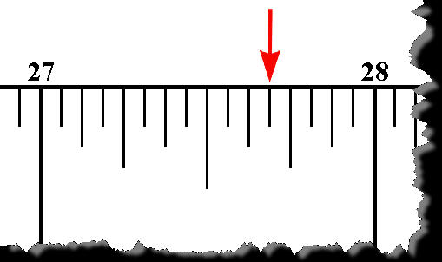 | 27 11/16” | 200
8 | 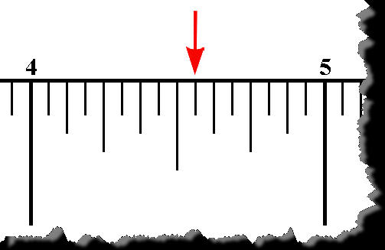 | 4 9/16” | 350
9 | 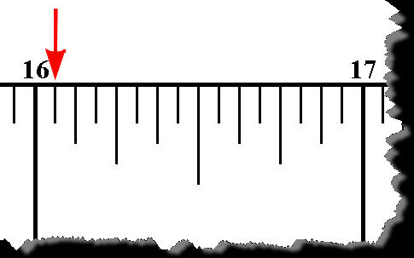 | 16 1/16” | -150
10 | 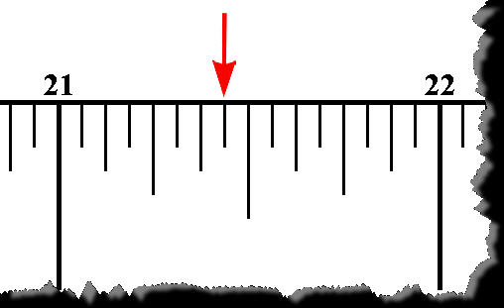 | 21 7/16” | 250
11 | 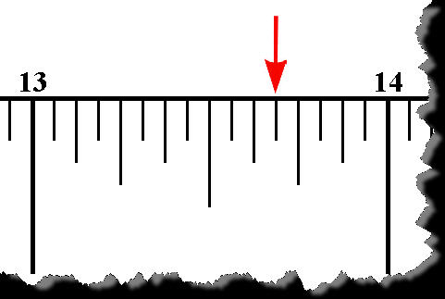 | 13 11/16” | -100
12 | 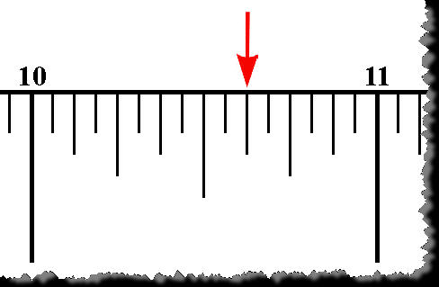 | 10 5/8” | 400
13 | 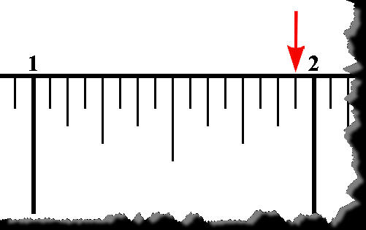 | 1 15/16” | 100
14 | 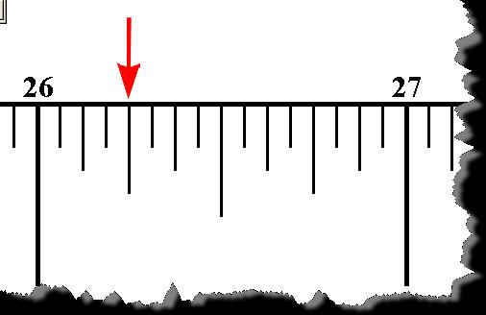 | 26 ¼” | -200
15 | 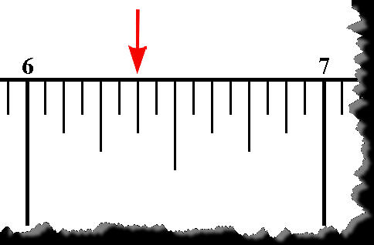 | 6 3/8” | 700
16 | 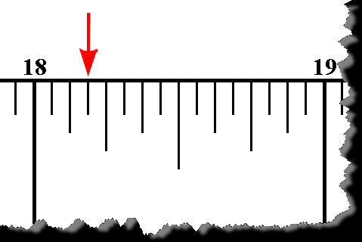 | 18 3/16” | 450
17 | 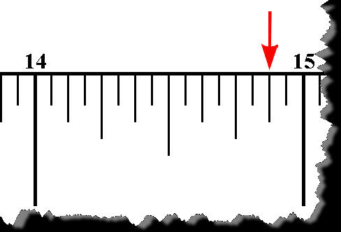 | 14 7/8” | 350
18 | 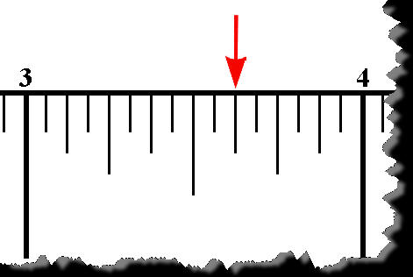 | 3 5/8” | -300
19 | 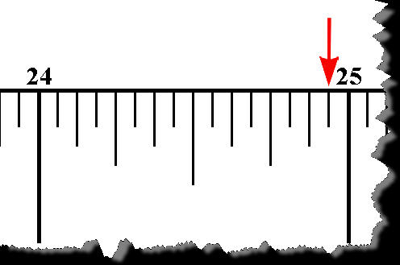 | 24 15/16” | -100
20 | 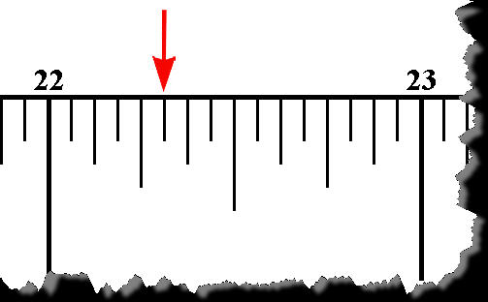 | 22 5/16” | 800
21 | 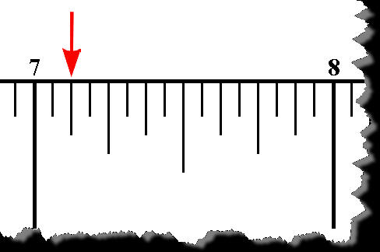 | 7 1/8” | 250
22 | 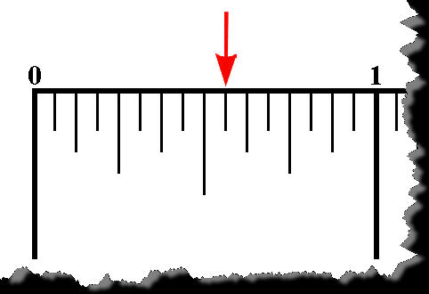 | 9/16” | 150
23 | 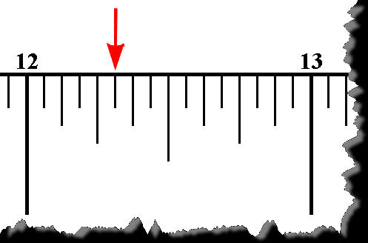 | 12 5/16” | 400
24 | 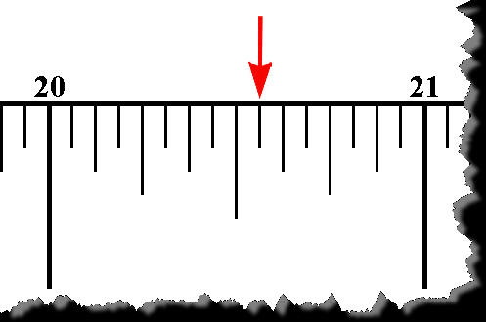 | 20 9/16” | -200
25 | 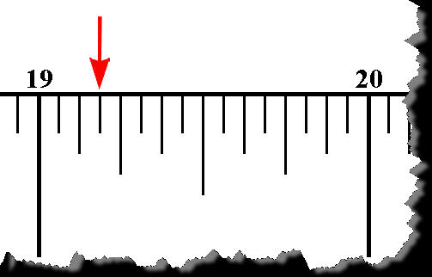 | 19 3/16” | 100
26 | 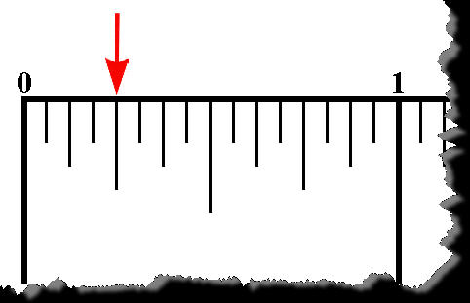 | ¼” | 900
27 | 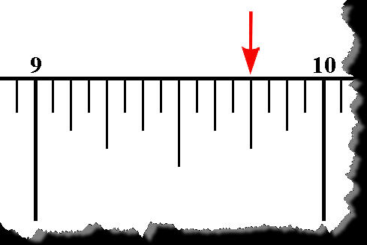 | 9 ¾” | 300
28 | 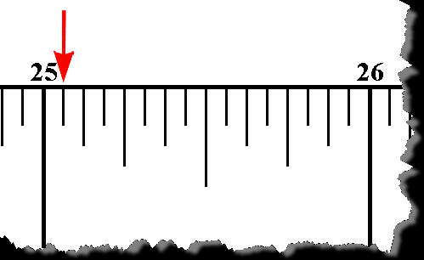 | 25 1/16” | 200
29 | 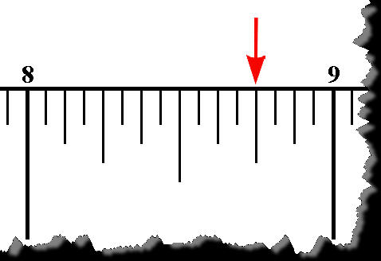 | 8 ¾” | 600
30 | 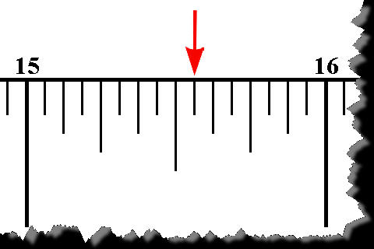 | 15 9/16” | -150

