3D Solid Modeling Study Guide – Answer Key

Face Any surface of an object
Extrusion A push or pull on any shape or a face of an object
You can add or remove material with the extrusion.

Reading Dimensions on a drawing
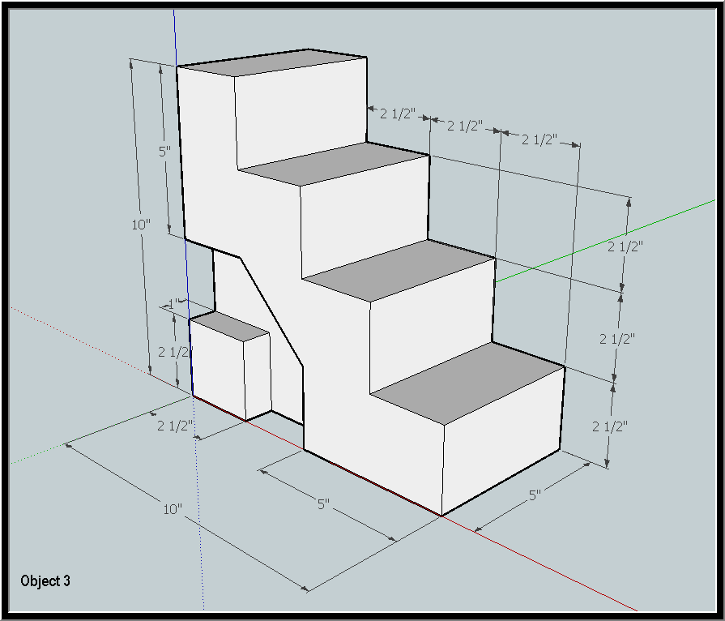

Length (X) 10” Width (Y) 5” Height (Z) 10”
What is the rise (height) for each step 2 ½”
What is the run (front to back of the tread) for each step 2 ½”
How far is the side shape extruded? 1”
What is the initial shape that you had to draw for this object? rectangle

Identify the tools A B C D E F G H I J
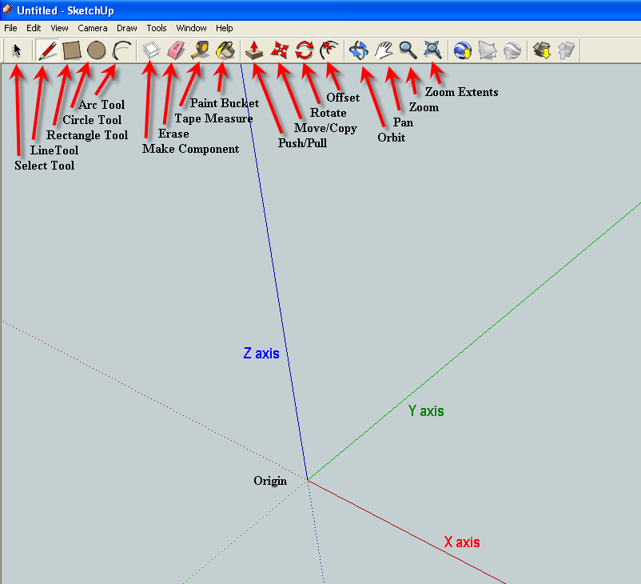

G - Push/Pull
I - Pan
J - Zoom
D - Circle
C - Rectangle
B - Line
A - Select
E - Erase
F – Measure
H - Orbit

Identify the origin and axis

What is the radius if the diameter is 20? 10 D=2R

