Name: _____________________ Date: ____________

3D Solid Modeling Study Guide

________________ Any surface of an object
________________ A push or pull on any shape or a face of an object
You can _________________ or _________________ material with the extrusion.

Reading Dimensions on a drawing
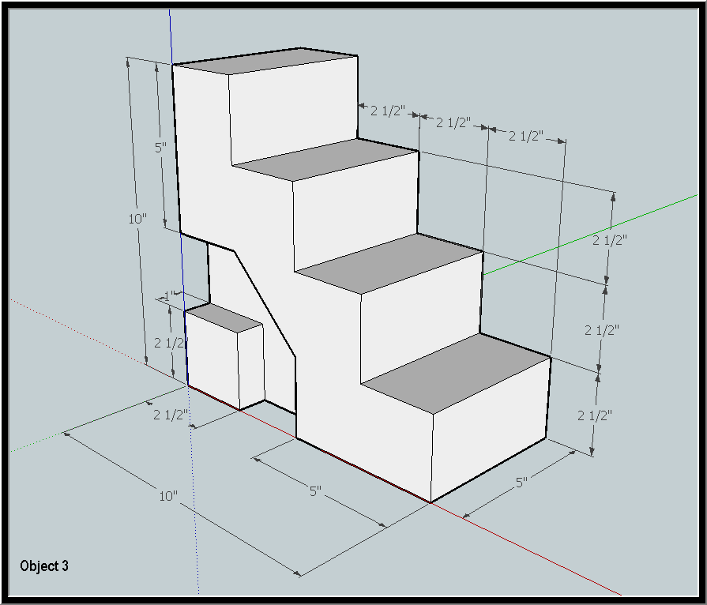

Length (X)__________ Width (Y) __________ Height (Z) __________
What is the rise (height) for each step ____________
What is the run (front to back of the tread) for each step ____________
How far is the side shape extruded? ___________
What is the initial shape that you had to draw for this object? ______________________
A B C D E F G H I J
Identify the tools 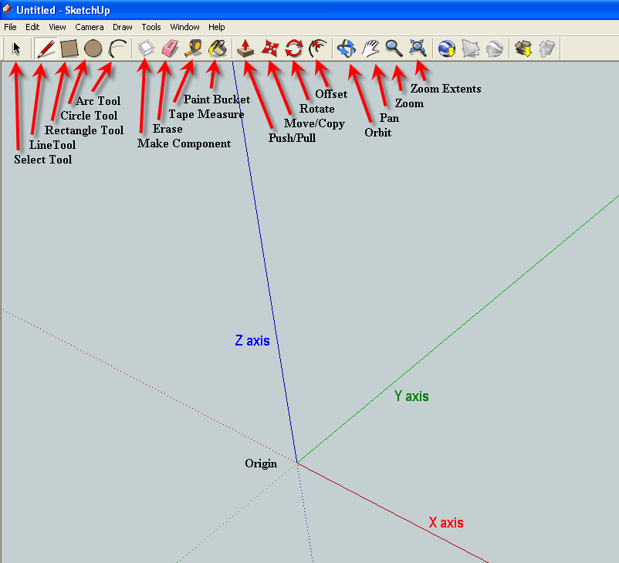

__ - Push/Pull
__ - Pan
__ - Zoom
__ - Circle
__ - Rectangle
__ - Line
__ - Select
__ - Erase
__ - Measure

Identify the origin and axis

What is the radius if the diameter is 20? __________ D=2R

