Using Google SketchUp for Basic 3D Solid Modeling

- Open Google SketchUp 7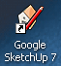

- The Welcome to SketchUp Window will appear: 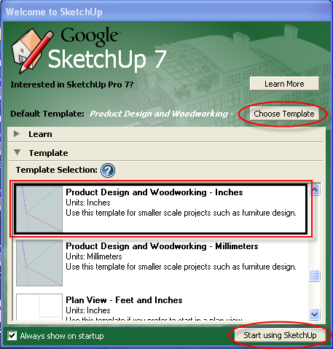

- Click on Choose Template on the upper right hand side of the window.
- Choose Product Design and Woodworking – Inches
- Click Start using SketchUp

- You are now ready to begin your drawing.
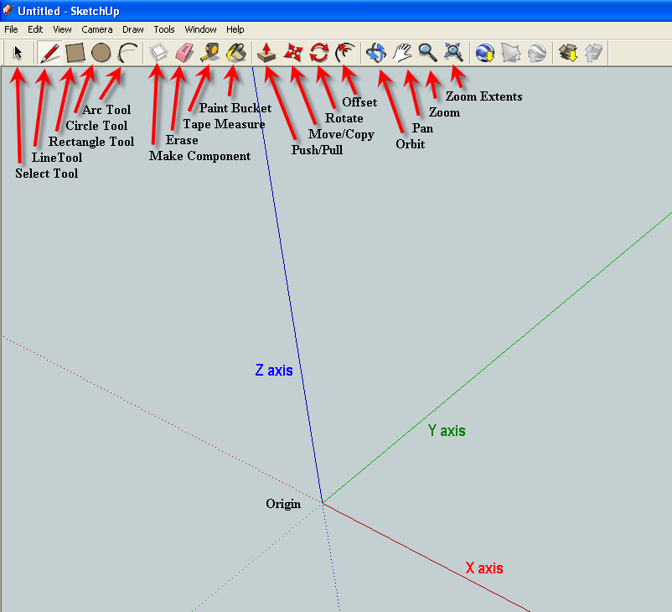

Note: The red axis line is X, the green axis line is Y, and the blue axis line is Z.
- Re-create each of the following objects. Include the dimensions on the objects. You need to show the instructor each object before you begin the next object, so that the object can be graded. Be sure to save each object with the object number and your name.

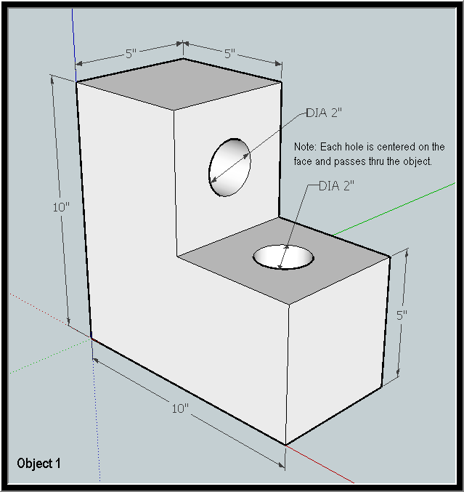

Remember you can type in the dimension values as you are drawing the shapes.
For the size of the circles you will have to enter the radius value not the diameter. (D=2R)

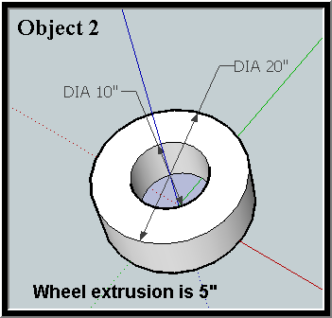
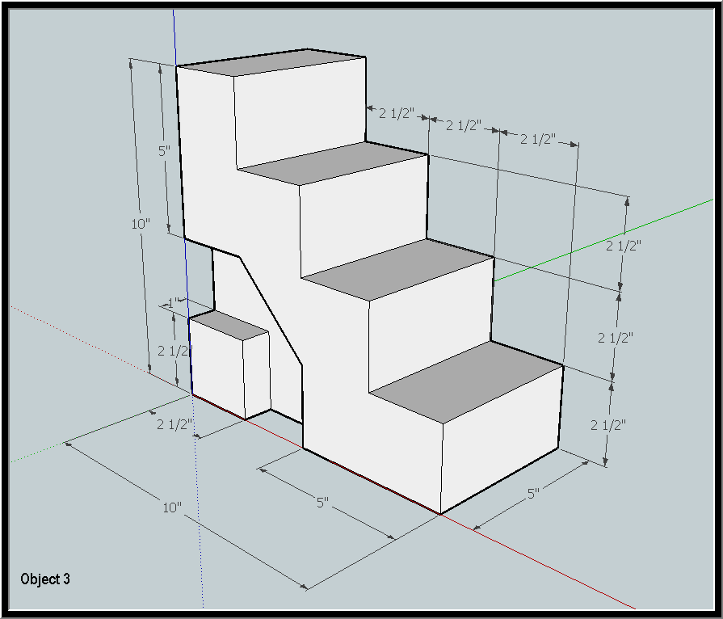

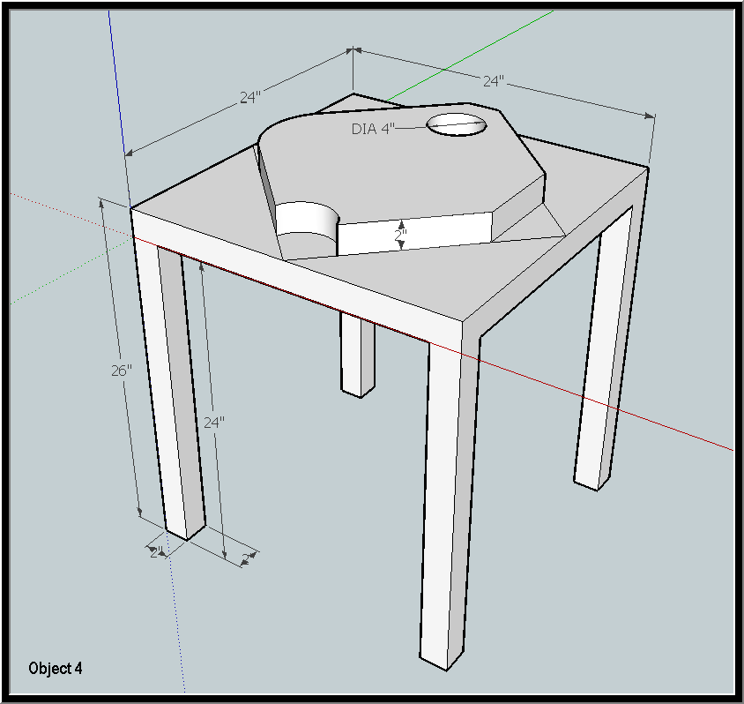

Creating a Chair using SketchUp

Now that you have learned the basics of how to use Google SketchUp, you are to design a chair.

Before you begin your design you should watch the video Google SketchUp New Users 4: Create a Chair. http://www.youtube.com/watch?v=RCqr3ZJ8Igc&feature=player_embedded

Your chair should be the appropriate size for an adult.

You may measure various chairs in the lab to determine appropriate sizes.

Be creative as you design your chair.

