CLOSET MATH
Name
Use the following diagram of a closet to answer the following questions.

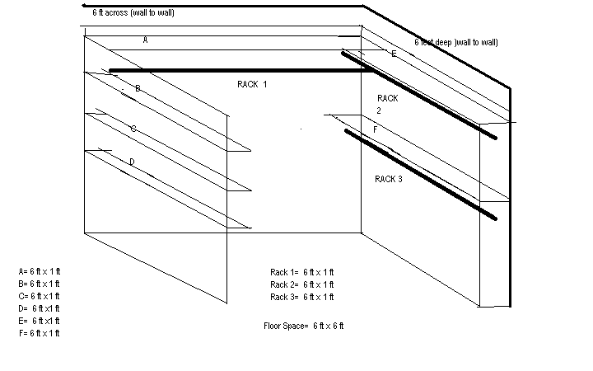

Closet Dimensions
FORMULAS: Total linear feet = L + L
Square feet / Area = L x W

- What is the total linear (length by line) feet of hanging space for the closet? (add)

- What is the total square feet of floor space? (multiply)

- What is the total linear (length by line) feet of shelf space? (add and/or multiply)

- What is the total square feet of shelf space? (multiply then add)

- If each hanging garment needed 1 ½ inches of hanging space to remain unwrinkled, how many hanging garments could this closet hang? (convert from total feet to total inches then divide).

