PERSONAL QUILT DESIGNS

OBJECTIVE:

Each student will create six personal quilt designs. Each design must be design and mathematically balanced. All designs need to be colored to help visualize the design.

Resources:

1/4 “ Grid paper Ruler Colored Pencils Pencils Erasers

- The design area needs to be set by girding graph paper provided. To grid graph paper, count by four squares and at the intersecting points of 4 x 4, make a slash mark or a dot.
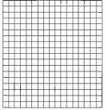

- Graph paper should have a grid made on the front and the back of the paper. In this way, there will be more space for more individual designs.

- After placing grid marks on the graph paper, you will need to draw lines to draw the outlined design area for each design. Each design area will need to be 16 squares x 16 squares (or 4” x 4”).

4. Create a sample design to help you better see designs that are made of mathematically balanced designs. (Note that all points should intersect when using your graph paper—this example is not perfect)

- Draw a line from corner to corner using all corners

- Draw line intersecting each horizontal and vertical line of points.

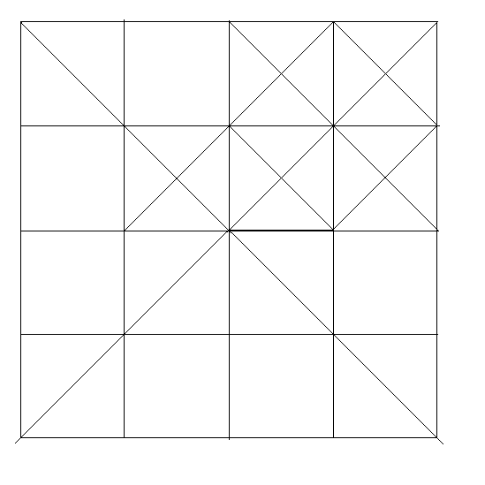
Completed basic drawing
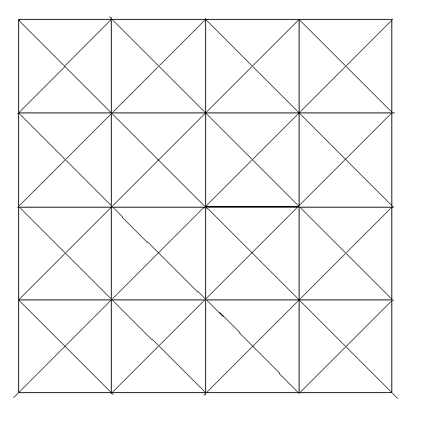

c. This is an example of a basic drawn pattern that many other designs can be use as a foundation. See the following examples.

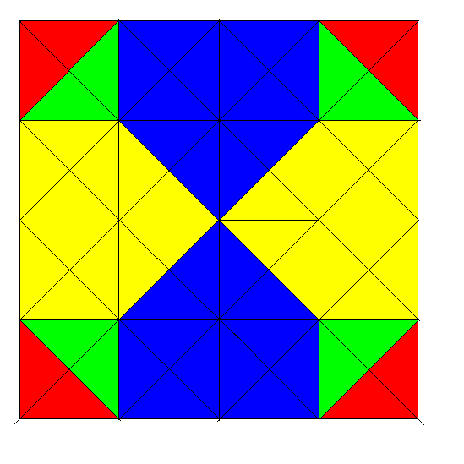
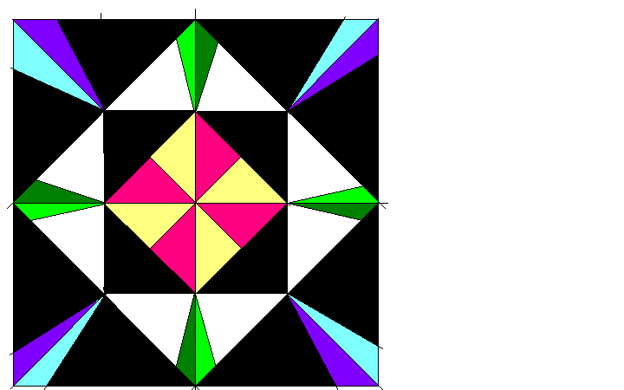

- Now that you have the basic design to draw from, draw six (6) designs.

- Color each design so that it is balanced mathematically by being an example of reflection, rotation, and / or dilation.
RESOURCES

Graph paper
Examples of small designs
Examples of previous student work
Crayons, colored pencils, markers
Wallpaper samples

ASSESSMENT

- All quilt designs have lines drawn by a ruler – freehand drawing will result in a 50% deduction per design.
- All designs will be mathematically balanced and show reflection or rotation as well as dilation and translation
- Six designs – grade for each (50 pts each)
- Six designs colored – grade for each (lower than drawing) (10 pts each)
- Graph paper has grid on both sides with every 4th intersection marked.(50 pts each)

