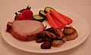
MEAL COMBINATIONS
Using tree diagrams to determine possible number of outcomes
Food, Nutrition, and Wellness
Meets Mathematics Georgia Performance Standards: M7D1, M7P4

Name: ____________________ Date: ____________

Introduction: You are a restaurant owner. A competing restaurant offers a three course dinner where patrons can choose one each of 5 appetizers, 7 entrees, and 3 desserts. The restaurant states in its advertisements that it has 105 different meal combinations for only $20 a meal. This has attracted a lot of customers to the restaurant. You would like to create your own three course dinner for $20 but with more meal combinations than your competitor to attract more customers.

Step 1.
Show how your competitor came up with 105 different meal combinations with only the 15 items given in the introduction. (Hint: Look at tree diagrams as a method of figuring this. A tree diagram that gives all 105 combinations will take a long time to construct, but try drawing a smaller tree diagram with 2 choices of appetizer, 2 choices entrees, 2 choices of dessert and looking at how the number of outcomes can be calculated. The diagram below is set up for you. Fill in the resulting outcomes and then determine answer the questions.)
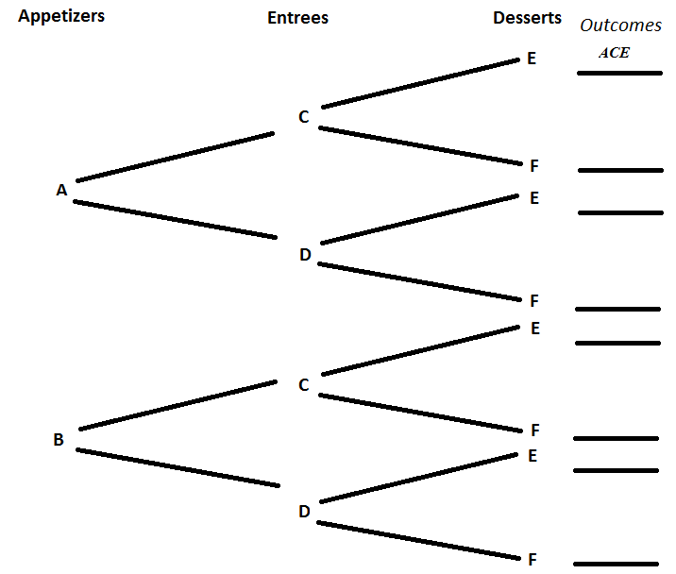

Key
Appetizers | A | Onion Peels
Appetizers | B | Potato Skins
Entrees | C | Steak
Entrees | D | Chicken
Desserts | E | Cheesecake
Desserts | F | Tiramisu

a. Total number of outcomes: _____
b. What will your meal consist of if you have the combination ADE?

c. What will your meal consist of if you have the combination BCE?

d. How could you calculate the total number of outcomes without drawing the entire tree diagram?

Step 2.
In your restaurant you can afford to either add one more appetizer, one more entree, or one more dessert than your competitor (giving a total of 16 items). Which of these additions will result in the largest number of combinations for your three course dinner? (Hint: Use what you learned in Step1 about calculating the number of possible outcomes to determine which course you should add to.)

Example: If you were able to have 20 total items: 7 appetizers, 8 entrees, and 5 desserts you could figure out the possible number of meal combinations (outcomes) by
7 x 8 x 5 = 280 total combinations
Key
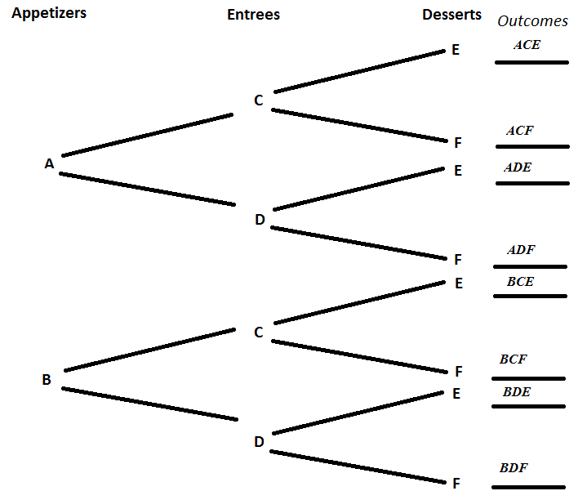

a. Total number of outcomes: 8
b. What will your meal consist of if you have the combination ADE?
Onion Peels, Chicken, Cheesecake
c. What will your meal consist of if you have the combination BCE?
Potato Skins, Steak, Cheesecake
d. How could you calculate the total number of outcomes without drawing the entire tree diagram?
Multiply the number of items for each course together
2 x 2 x 2 = 8

Step 2.
In your restaurant you can afford to either add one more appetizer, one more entree, or one more dessert than your competitor (giving a total of 16 items). Which of these additions will result in the largest number of combinations for your three course dinner? (Hint: Use what you learned in Step1 about calculating the number of possible outcomes to determine which course you should add to.)

If you add one more appetizer:
6 x 7 x 3 = 126 combinations

If you add one more entrée:
5 x 8 x 3 = 120 combinations

If you add one more dessert:
5 x 7 x 4 = 140 combinations

Therefore you will produce more combinations by adding another dessert.

