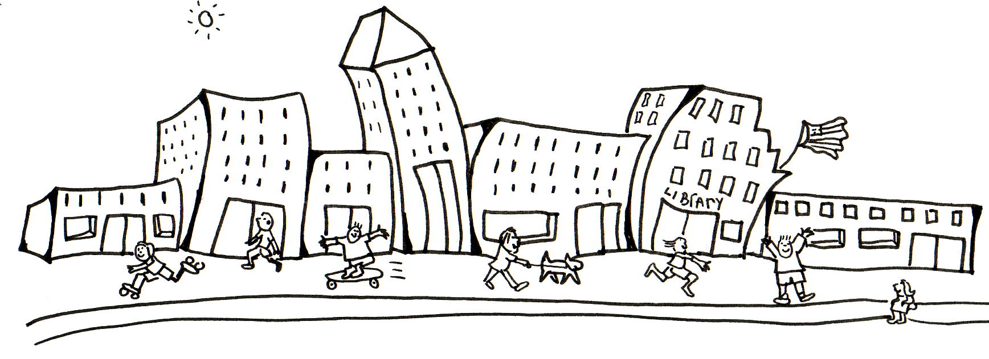Design A City

Meets Mathematics Georgia Performance Standards: M8G1, M8P4

Name: ______________________________________________ Date: _________ Period: _________

You are planning your own city. Give your city a name and a population size and place this information at the top of your chart. Your city must have each of the following items and be mathematically correct in order to receive full credit.
1. 4 parallel streets (give each street a name)

2. 2 perpendicular streets (give each street a name)

3. 3 transversal streets (give each street a name)

The following buildings must be placed as directed.

1. A gas station and a fast food restaurant (alternate exterior angles)
2. Your house and an elementary school (same side interior angle)
3. A town hall and a bank (vertical angles)
4. A library and a church (corresponding angles)
5. A bookstore and a park (alternate interior angles)

Locations
A gas station and a fast food restaurant (alternate exterior angles) | ____/3
Your house and an elementary school (same side interior angle) | ____/3
A town hall and a bank (vertical angles) | ____/3
A library and a church (corresponding angles) | ____/3
A bookstore and a park (alternate interior angles) | ____/3
Other
At least 4 parallel streets | ____/2
At least 2 streets perpendicular to each other | ____/2
At least 2 transversal streets | ____/2
Neatness (labeling, use of appropriate paper, lines are straight) | ____/2
Creativity and Effort (use of color, other additions to city) | ____/2
Total | ____/25

