American Housing, 1900-1990
Via Brad DeLong, an interesting illustration of improved standards of living across the 20th century:
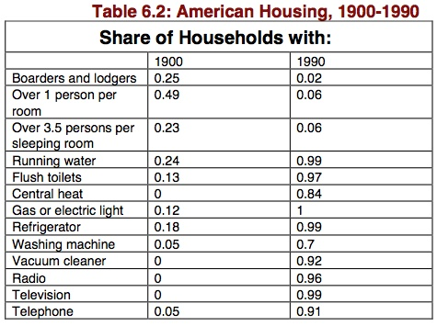
It strikes me as noteworthy that the trend toward bigger-and-bigger houses has continued apace over the past 20 years even though by 1990 the problem of overcrowded housing had become the exclusive province of the very poor. Part of the story is that we have a number of policies—ranging from odd tax incentives to land use regulations and beyond—in place that encourage people to live in big houses. This is not a very efficient use of valuable energy and land resources, and it arguably intensifies the problem of providing an adequate standard of housing to the relatively small remaining minority that can’t afford decent shelter.

