Venn diagram: Medical vs. Surgical Asepsis

Name: __________________________ Date: _____________

Directions: Compare and contrast medical and surgical asepsis by determining points that are alike and points that differ between the two. Fill out the Venn diagram below with your information.

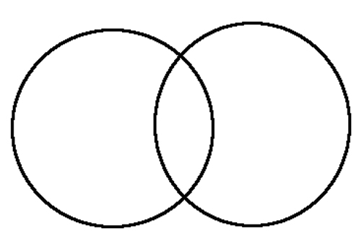
Medical Asepsis
Surgical Asepsis

A Venn diagram is often used in mathematics to show relationships between sets. Venn diagrams are made up of two or more overlapping circles. They are useful in a number of applications. In this case, a Venn diagram is used to visually show the similarities and differences between medical and surgical asepsis. Venn Diagrams help people visualize and organize thoughts.

