Introduction to Genetics Teacher Notes

PART ONE: GENETIC BASICS

INTRODUCTION TO GENETICS POWERPOINT

STUDENT HANDOUT for Vocabulary and Lesson Resources:

Genetic Basics
Vocabulary
genetics - the study of genes and heredity, or how characteristics are passed from parents to children.
geneticist - a scientist who studies genes.
cell - the basic unit of life; the smallest basic part of every living thing that can function by itself. It is made of a nucleus surrounded by cytoplasm, organelles (similar to organs in a body) and proteins. Each cell contains the entire genome

genome - all the genetic information necessary to build a living organism. It is species-specific.
gene - the unit of heredity in chromosomes; a segment of double-stranded DNA.
nucleus - the center part of the cell. It contains 6 feet of DNA in 23 pairs of chromosomes and is the largest part of the cell.
chromosome - a long coiled strand in the nucleus, made up of DNA and protein. There are 46 human chromosomes, each containing DNA for hundreds or thousands of individual genes.
DNA (deoxyribonucleic acid) - a large double-stranded, spiraling molecule that contains genetic instructions for growth, development and replication. It is organized into bodies called chromosomes and found in the cell nucleus.
electrophoresis - a method of separating large molecules such as DNA fragments from a mixture of similar molecules.
bases - the molecular building blocks of DNA and RNA: adenine (A), cytosine (C), guanine (G), thymine (T), and in RNA only, uracil (U). In DNA, A attaches only to T, and C attaches only to G. In RNA, A attaches only to U, and C attaches only to G.
base pairs - the pairs of complementary bases that form the rungs of DNA: adenine (A) pairs with thymine (T), cytosine (C) pairs with guanine (G)
In DNA: A always bonds with T
C always bonds with G
electrophoresis - a method of separating large molecules such as DNA fragments from a mixture of similar molecules.
ACTIVITY SEPARATING DNA for Genetic Basics
DNA Extraction from http://library.thinkquest.org/28599/experiment_dna_extraction.htm
Purpose:
The purpose of this lab is to extract DNA from a variety of cells and see DNA molecules (this procedure actually took scientists many years to discover). This will show that, contrary to popular opinion, DNA is not just found in blood cells, but in a variety of tissues (try at least one plant tissue and one animal tissue). Prior knowledge should include the fact that cell membranes are layers of lipids, or fat molecules, that DNA is found in the nucleus of a cell, and that enzymes speed up chemical reactions. The plant and animal cells will be chemically treated to break open the cell and nuclear membranes. The part of the cell mixture containing DNA will be separated from the cell membranes and associated proteins (gloppy portion), and the solution containing the dissolved DNA will be altered so that the DNA can no longer remain dissolved. It will be “precipitated,” and observable with the naked eye.
Supplies:
plant or animal tissues--liver and onions, for example
blender
salt
clear liquid dish soap
warm water
clear glass
strainer
toothpicks
rubbing alcohol

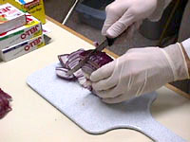 | Cut up a small amount of the cell source.

Add it into a blender and fill it with enough warm salty water to cover it (use several pinches of salt--you may experiment with what works best). | 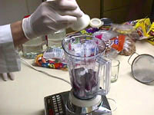

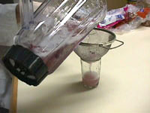 | Blend for 5-10 seconds, but don’t totally liquefy. Pour through the strainer into a clear glass, filling about half full.

Gently stir in about 2-3 teaspoons of the soap (again, you may want to experiment with the amount to see what works best). Stir very gently, trying not to make bubbles. | 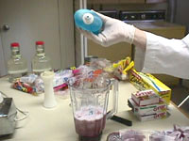

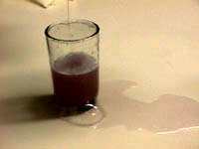 | (Be careful when pouring and make sure not to use too much soap...)

Slowly pour the alcohol into the glass, pouring it down the side of the glass so that it forms a separate layer on top of the soapy cell mixture. Fill nearly to the top. Let it sit for 3 - 5 minutes, observing what happens. | 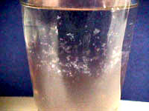

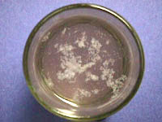 | The DNA will slowly rise from the watery lower layer up into the alcohol layer above it. The DNA will look stringy and have small bubbles attached to it. It will be a clear, “snotty” substance, and may be hard to see. Slowly twist substance onto a toothpick. (Do not scoop up cell scum from the lower layer.) Congratulations--you have extracted DNA!

Mmmmmm! Tasty! (Do not actually drink it.) | 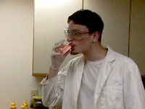

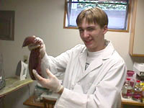 | You can try this experiment with a variety of materials.

(When working with liver, make sure it is actually dead.) | 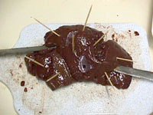

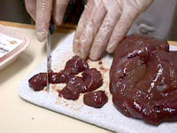 | Make sure to chop up liver before blending it.

Again, the DNA will float to the top. | 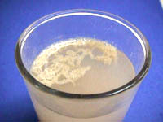

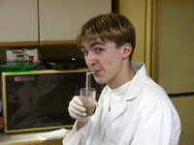 | Bon Appetite! (Do not actually drink it.)

Assessment for DNA Separation Activity –
Completion of DNA Separation Questionnaire with 90 to 100% accuracy
Genetic Basics
Questionnaire for Separating DNA

Results, Questions:
1. What does the salt do? (Salt provides the DNA with a favorable environment; it contributes positively charged atoms that neutralize the normal negative charge of DNA.)
2. What does the blender do? (help break down the cell walls)
3. When you mix the blended cell source with the soap, what is happening? (In the experiment, the enzymes in the soap are breaking down the lipid molecules of the cell and nuclear membranes, releasing the contents of the cell, including the DNA. These enzymes in the soap are what break down grease while washing dishes.)
4. What does the alcohol do? Why does the DNA rise to the top after adding alcohol? (DNA will not dissolve in this alcohol, so the DNA comes out of the solution, or precipitates. It is less dense than water or cell scum--which is what settles to the bottom of the glass--so it floats up into the alcohol layer, where you see it as a snotty, string-like substance, with small bubbles formed on it.)
5. If you try a seed food such as peas, there will be more protein residue in the liquid. Why? (Because protein is stored in them for the nutrition of the new plant.)
6. Why can’t you see the double helix? (It is too small to be seen with the naked eye. What you extracted is millions of strands of DNA.)
7. What part of the cell did the DNA come from? (99% is from the nucleus.)
Applications:
1. If you did the experiment with both plant and animal cells, how do their DNA compare?

PART TWO GENE THERAPY
INTRODUCTION TO GENETICS POWERPOINT

STUDENT HANDOUT for Vocabulary and Lesson Resources:
Gene Therapy and Heredity Vocabulary
.heredity - all of the traits passed on to children by parents (plant or animal) or the process of transferring these traits.
dominant gene - a gene which passes on a certain physical characteristic, dominating over a recessive gene present on another chromosome.

recessive gene - a gene which is hidden by a dominant gene; it must be present on both chromosomes in a pair (one from the father, one from the mother) to show outward signs of the characteristic.

carrier - an individual who carries a recessive trait.

Punnett Square - a chart that shows all possible genetic outcomes of a mating

pedigree chart - A list of ancestors; a family tree.
genetic disease - a disease caused by a genetic mutation.
gene therapy - a method of treating a disease by exchanging the defective gene causing the disease with a healthy one in a cell
genetic code - all the genes a living thing has inherited. They determine appearance, function, growth, behavior, etc

Reference and source for vocabulary:
- Thinkquest , located at this web address: http://library.thinkquest.org/28599/glossary.htm
- Answers.com, located at this web address:
http://www.answers.com/

RESOURCES FOR LEARNING ACTIVITIES:
Gene Therapy - http://library.thinkquest.org/28599/gene_therapy.htm
Genetic Testing - http://library.thinkquest.org/28599/gene_therapy.htm
Human Genome Project - http://library.thinkquest.org/28599/human_genome.htm
In Depth – You can learn more about genetics by reading these interesting articles Frankenstein's Monster: Building New Life, Jurassic Park: Fact or Fiction?, Cardiothoracic Gene Therapy and Human Cloning, at this web address: http://library.thinkquest.org/28599/depth.htm

HEREDITY Lesson
Punnett Square
Reference: http://www.usoe.k12.ut.us/CURR/Science/sciber00/7th/genetics/sciber/punnett.htm
Pedigree Chart
References of Punnett Square shown as a pedigree chart:
http://anthro.palomar.edu/mendel/mendel_2.htm

Probability of Inheritance http://anthro.palomar.edu/mendel/mendel_2.htm
The value of studying genetics is in understanding how we can predict the likelihood of inheriting particular traits. This can help plant and animal breeders in developing varieties that have more desirable qualities. It can also help people explain and predict patterns of inheritance in family lines.
One of the easiest ways to calculate the mathematical probability of inheriting a specific trait was invented by an early 20th century English geneticist named Reginald Punnett . His technique employs what we now call a Punnett square. This is a simple graphical way of discovering all of the potential combinations of genotypes that can occur in children, given the genotypes of their parents. It also shows us the odds of each of the offspring genotypes occurring.
Setting up and using a Punnett square is quite simple once you understand how it works. You begin by drawing a grid of perpendicular lines:

Next, you put the genotype of one parent across the top and that of the other parent down the left side. For example, if parent pea plant genotypes were YY and GG respectively, the setup would be:
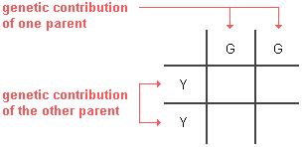
Note that only one letter goes in each box for the parents. It does not matter which parent is on the side or the top of the Punnett square.
Next, all you have to do is fill in the boxes by copying the row and column-head letters across or down into the empty squares. This gives us the predicted frequency of all of the potential genotypes among the offspring each time reproduction occurs.
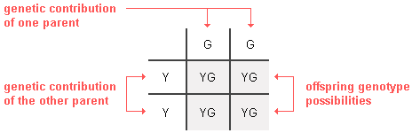
In this example, 100% of the offspring will likely be heterozygous (YG). Since the Y (yellow) allele is dominant over the G (green) allele for pea plants, 100% of the YG offspring will have a yellow phenotype, as Mendel observed in his breeding experiments.
In another example (shown below), if the parent plants both have heterozygous (YG) genotypes, there will be 25% YY, 50% YG, and 25% GG offspring on average. These percentages are determined based on the fact that each of the 4 offspring boxes in a Punnett square is 25% (1 out of 4). As to phenotypes, 75% will be Y and only 25% will be G. These will be the odds every time a new offspring is conceived by parents with YG genotypes.
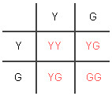
An offspring's genotype is the result of the combination of genes in the sex cells or gametes (sperm and ova) that came together in its conception. One sex cell came from each parent. Sex cells normally only have one copy of the gene for each trait (e.g., one copy of the Y or G form of the gene in the example above). Each of the two Punnett square boxes in which the parent genes for a trait are placed (across the top or on the left side) actually represents one of the two possible genotypes for a parent sex cell. Which of the two parental copies of a gene is inherited depends on which sex cell is inherited--it is a matter of chance. By placing each of the two copies in its own box has the effect of giving it a 50% chance of being inherited.
If you are not yet clear about how to make a Punnett Square and interpret its result, take the time to try to figure it out before going on.
Are Punnett Squares Just Academic Games?
Why is it important for you to know about Punnett squares? The answer is that they can be used as predictive tools when considering having children. Let us assume, for instance, that both you and your mate are carriers for a particularly unpleasant genetically inherited disease such as cystic fibrosis . Of course, you are worried about whether your children will be healthy and normal. For this example, let us define "A" as being the dominant normal allele and "a" as the recessive abnormal one that is responsible for cystic fibrosis. As carriers, you and your mate are both heterozygous (Aa). This disease only afflicts those who are homozygous recessive (aa). The Punnett square below makes it clear that at each birth, there will be a 25% chance of you having a normal homozygous (AA) child, a 50% chance of a healthy heterozygous (Aa) carrier child like you and your mate, and a 25% chance of a homozygous recessive (aa) child who probably will eventually die from this condition.
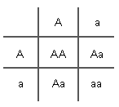 |  | 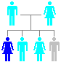 |  | If both parents are carriers of the recessive  allele for a disorder, all of their children will  face the following odds of inheriting it:  25% chance of having the recessive disorder  50% chance of being a healthy carrier  25% chance of being healthy and not have  the recessive allele at all
If a carrier (Aa) for such a recessive disease mates with someone who has it (aa), the likelihood of their children also inheriting the condition is far greater (as shown below). On average, half of the children will be heterozygous (Aa) and, therefore, carriers. The remaining half will inherit 2 recessive alleles (aa) and develop the disease.
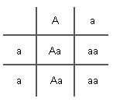 |  | 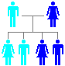 |  | If one parent is a carrier and the other has a  recessive disorder, their children will have the  following odds of inheriting it:  50% chance of being a healthy carrier  50% chance having the recessive disorder
It is likely that every one of us is a carrier for a large number of recessive alleles. Some of these alleles can cause life-threatening defects if they are inherited from both parents. In addition to cystic fibrosis, albinism, and beta-thalassemia are recessive disorders.
Some disorders are caused by dominant alleles for genes. Inheriting just one copy of such a dominant allele will cause the disorder. This is the case with Huntington disease, achondroplastic dwarfism, and polydactyly. People who are heterozygous (Aa) are not healthy carriers. They have the disorder just like homozygous dominant (AA) individuals.
 |  | 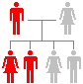 |  | If only one parent has a single copy of a  dominant allele for a dominant disorder,  their children will have a 50% chance of  inheriting the disorder and 50% chance  of being entirely normal.
Punnett squares are standard tools used by genetic counselors. Theoretically, the likelihood of inheriting many traits, including useful ones, can be predicted using them. It is also possible to construct squares for more than one trait at a time. However, some traits are not inherited with the simple mathematical probability suggested here. We will explore some of these exceptions in the next section of the tutorial.
his page was last updated on .
Copyright © 1997-2009 by Dennis O'Neil. All rights reserved.
illustration credits

Information below is from: http://www.upb.pitt.edu/uploadedFiles/About/Sponsored_Programs/Science_In_Motion/Biology_Labs/EXTENSION%20ACTIVITY%20-%20Dragon%20Genetics%20Worksheet3.doc

Activity 3: Do Your Ears Hang Low?
Introduction

The combination of alleles inherited from your parents is called a genotype. When a person exhibits a dominant trait, he/she probably does not know his/her genotype for that trait. Take, for example, the genetic trait of tongue rolling. A tongue rolling allele (R) is dominant; a non-tongue rolling allele (r) is recessive. The alleles you have for that trait could be identical. For example, you may have received a tongue rolling allele (R) from both you mom and dad; in that case, you would also be a tongue roller, with a genotype of “RR”. Or you may have received a non-tongue rolling allele (r) from both your mom and dad; in that case you would not be able to roll you tongue and your genotype would be “rr”. In either case, when both alleles for a trait are identical, they are referred to as homozygous, from the Greek words “homo” (meaning “same”) and “zygote” (from “zygoun”, meaning “to join”). A zygote is a cell that is formed at conception, by the union of two gametes (egg and sperm).

Sometimes the combination of alleles inherited from your parents is different. For example, you may have received a tongue rolling allele from you mom, but not your dad. In this case, your genotype would be “Rr”. This combination of alleles is referred to as heterozygous, from the Greek words “hetero” (meaning “different”) and “zygote”.

The important thing to remember is that both “RR” and “Rr” will result in a tongue rolling kid. In a simple inheritance pattern involving two alleles, it is only necessary to receive one copy of the dominant allele to exhibit the dominant trait. A person who exhibits a dominant trait will probably not know his/her genotype for that trait. On the other hand, a person who exhibits a recessive trait always knows what his/her genotype is because no dominant allele is present.

Follow the directions indicated on the chart on Worksheet #3 to determine if you are dominant or recessive for certain traits. Once this has been established, predict what your possible genotype(s) is/are.
Name:

Date:

Period:

Dragon Genetics Worksheet #3:
“Do Your Ears Hang Low?”

Instructions
Activity 3: Are you dominant or recessive for this trait? Based on your phenotype, try to determine whether you are dominant or recessive for each of the traits listed below. For each trait, read the statement, perform the test or task if necessary, and then, in the first column, write whether you are “dominant” or “recessive” for this trait, and try to predictg your genotype in the second column. | Are you dominant or recessive for this trait? | My possible genotype(s) for this trait is/are:
- SBT Paper – Taste the paper your teacher gave you. Sodium benzoate taste paper is used as a diagnostic tool in medicine. The ability to taste the chemical is a dominant trait. People who cannot taste this chemical are recessive for the trait. (T or t)
- TONGUE ROLLING - Can you roll your tongue into a U shape (like a taco shell)? If so, you are dominant for this trait. If you cannot roll your tongue into a U shape, you are recessive for this trait. (R or r)
- EARLOBES – It is a dominant trait to have earlobes that hang down. A person who has earlobes attached directly to the side of his/her head is recessive for this trait. (L or l)
- EARBUMP – Some people have a bump, called a Darwin’s ear point, on the inside rim of the upper part of the ear ridge. If you have the bump it is due to the presence of a dominant allele. If you are lacking the bump you are recessive for the trait. (B or b)
- WIDOW’S PEAK – If your hairline forms a downward “V” in the middle of your forehead, you have a widow’s peak. (Good examples of widow’s peaks can be found on TV character Eddie Munster and most depictions of vampires.) A widow’s peak is caused by a dominant allele. A straight or even hairline indicates you are recessive for this trait. (V or v)
- HITCHHIKER’S THUMB – People who can bend the last joint of their thumbs back to a 90 degree angle are dominant for hitchhiker’s thum. Those who lack this ability are recessive for this trait. (H or h)
- POLYDACTYLY – If you were born with more than five fingers or toes on either of your hands or feet, you possess a dominant trait for polydactyly. Having five fingers and toes is a recessive trait. NOTE: In the US, most peole with extra toes and fingers usually have them removed shortly after birth. (P or p)
- SYNDACTYLY – Having webbed fngers and toes is a dominant trait. Sometimes only a pair of fingers or toes is webbed. If you have fingers and toes that are separated from one another, then you are recessive for this trait. (S or s)
- CLEFT CHIN – If you have an indentation in the middle of your chin you have a cleft chin. (Actor John Travolta has a prominent cleft chin.) A cleft chin is a recessive trait. The absence of a cleft chin is a dominant trait.(C or c)
- HAIR WHORL – Ask a friend to look at the back of your head to determine if your hair whorls to the right (clockwise) or to the left (counterclockwise). (If you use hairspray or gels on your hair this may be hard to determine.) A clockwise whorl is a dominant trait; a counterclockwise whirl is a recessive trait. (W or w)

THINKQUEST PAGES for reference during teaching:
Gene Therapy
One of the most amazing genetic applications in medicine is gene therapy. Also known as somatic gene therapy and therapeutic gene therapy, this procedure involves inserting (or sometimes deleting) portions of the genes in diseased patients so that they can be cured and live healthier lives.
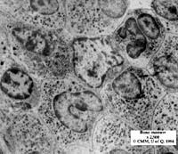  Bone marrow  By permission Nanoworld Image Gallery  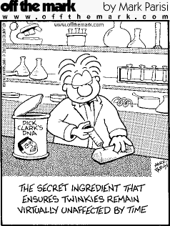  Posted by permission Mark Parisi | Two methods exist for inserting genetic material into human chromosomes. The first, called the ex vivo technique, involves surgically removing cells from the affected tissue area, injecting or splicing the new DNA (the DNA that will correct the disease) into the cells and letting them divide in cultures. The new tissues are placed back into the affected area of the patient. Often, doctors need only culture the patient’s bone marrow because it produces the blood that will eventually travel throughout the body. This type of surgery, however, is especially painful, and patients usually have to undergo it twice--once to extract the marrow and then again to replace it--because the culturing time takes many hours to complete.The second method is called the in vivo technique and requires no surgery or even anesthesia. In this process, the therapeutic DNA is injected directly into the body cells, usually via one of two types of viruses. The most frequently used type is the very simple retrovirus. Dr. Richard Mulligan of MIT has synthetically created the perfect retrovirus: it has no reproduction sequence and exists solely to deliver therapeutic DNA during gene therapy. It has no viral DNA (DNA that would make the cell--and you-- sick) whatsoever and only carries the new DNA that has been spliced into it. After injecting the diseased cell with the new therapeutic DNA, it then dies. Using retroviruses is very safe and provides long-lasting effects. Unfortunately, the new DNA it injects will only help the new daughter cells and not those that already exist. The second type of virus used for the in vivo technique is called an adenovirus, the equivalent of the common cold virus. Although this virus will also die after injecting its spliced therapeutic DNA, it will be attacked by the immune system and the patient will suffer from a temporary sore throat and runny nose. The adenovirus works the same way the retrovirus does, but its effects are much more immediate--within 48 hours. Unlike the retrovirus, though, the new DNA’s effects wear off within weeks. Scientists like the fact that only a few millimeters of altered adenovirus solution is needed to cure the patient, whereas several liters of retrovirus are needed to obtain a much slower result.

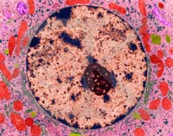  Liver cell nucleus  Copyright Dennis Kunkel | There are other gene therapy techniques, although they aren’t as frequently used. One method involves inserting therapeutic DNA into cultured endothelium tissue (endothelium is the membrane that lines all of the blood vessels) and then grafting it into the patient. Another technique requires the patient to receive an electric shock while submerged in a bath of a therapeutic DNA solution. The shock opens the skin pores, allowing the DNA to enter. Still other options include skin grafts, connective tissue grafts, and injecting the liver with the therapeutic DNA.

Gene Splicing
Gene splicing is just what it sounds like: cutting the DNA of a gene to add base pairs. Contrary to the immediate image, however, no sharp instruments are involved; rather, everything is done chemically.  Chemicals called restriction enzymes act as the scissors to cut the DNA. Thousands of varieties of restriction enzymes exist, each recognizing only a single nucleotide sequence. Once it finds that sequence in a strand of DNA, it attacks it and splits the base pairs apart, leaving single helix strands at the end of two double helixes. Scientists are then free to add any genetic sequences they wish into the broken chain and, afterwards, the chain is repaired (as a longer chain with the added DNA) with another enzyme called ligase. Hence, any form of genetic material can be spliced together; bacteria and chicken DNA can, and have been, combined. More often, though, splicing is used for important efforts such as the production of insulin and growth hormone to cure human maladies. In the past, insulin was only obtainable from the pancreas of cadavers (and it required 50 cadavers to yield one dose!). With modern splicing techniques, enough insulin can be produced for all diabetics. The insulin-producing genes from human DNA are spliced into plasmid DNA; the plasmids are then allowed to infect bacteria, and, as the bacteria multiply, large amounts of harvestable insulin are produced. Splicing has other practical medicinal uses, too. In July of 1996, a 68-year-old woman became the first patient to be treated for arthritis (a disease which affects an estimated 2.1 million Americans) via gene therapy. At the University of Pittsburgh, therapeutic DNA that blocks the production of a specific protein (IL-1) that causes arthritis pain was injected into two of her knuckles. | 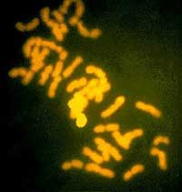  Root-tip cell with stain-highlighted corn chromosome 3 pair amongst oat chromosomes in a partial hybrid plant.  Courtesy USDA ARS  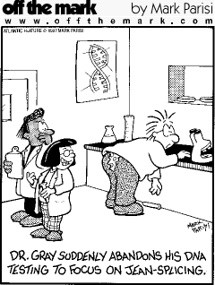  Posted by permission Mark Parisi

Gene Silencing
Another aspect of gene therapy is gene silencing, also called antisense technology. With this method, geneticists can inactivate a gene that may cause disease or be defective.
When DNA replicates, RNA bonds to half of the split double helix, making a mold of sorts. The RNA (messenger RNA or mRNA) is then used to create an identical DNA strand. To silence a gene on a chromosome, scientists, therefore, simply make an RNA strand 15-20 bases in length complementary to the mRNA. The synthesized RNA will attach itself to the mRNA and prevent that portion of the mRNA from creating the gene on the duplicate DNA strand. This method is highly specific.
Gene silencing is used to treat several viruses including AIDS, Herpes, Chicken Pox, and Hepatitis. More importantly, though, antisense technology is used by geneticists in research to learn what happens when certain genes are silenced.
Testing
Genetic tests are administered to determine if the patient has a genetic disorder. All that is required for the test is a blood sample. Although this may sound simple, hearing the results of genetic tests can cause devastating damage. A person or family may want a genetic test performed if they feel that they or their children might have an inherited disease.
Risks:  1. Some diseases are uncurable--psychologically shattering.  2. Many employers won’t hire you--discrimination.  3. Many insurance companies won’t give you a policy if you’ve been tested--afraid of the money they may have to spend on you.  4. You may learn your kids have a disease. | 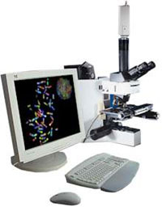  Genetic image analysis workstations  Images provided courtesy of Applied Imaging

Benefits:
1. If disease is curable, you can cure it!
2. You may learn your kids don’t have it.
3. By getting tested, you’re taking action.
4. You may prevent premature death.
Counseling
Genetic counseling allows parents, or couples planning to be parents, to examine the possible risks of giving birth to a child with a genetic disorder. Genetic counselors look at the client’s pedigree (genetic history) to determine if the couple is at high risk. Usually, only couples with a high risk history, a child who already has a genetic disorder, and women over the age of 35 need to be tested.
Human Genome Project
The Human Genome Project is one of the most enterprising and challenging aspects of modern genetic research. Funded primarily by the US Government, this project was created to map and sequence the entire human genome--that is, to locate every gene on every human chromosome. Although this may sound rather basic, the enormity of it emerges when one realizes just how lengthy the human genome actually is. It is estimated that anywhere from 100,000 to 300,000 genes exist! And scientists not only plan to map the genes, but also intend to sequence the 3 billion DNA amino acid “building blocks” that make each gene! It would take thirteen full-volumed encyclopedia sets or 200 Manhattan phone books to equal the amount of genetic information the project scientists plan to organize. It is, therefore, easy to understand why this is a national effort. | 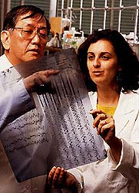  Scientists reading DNA sequencing gel  Courtesy USDA ARS
Francis Crick elucidated the structure of DNA with James Watson in 1953 (see Watson JD, Crick FHC (1953) Molecular Structure of Nucleic Acis. Nature 171:737-738 and the follow up article in May the same year Watson JD, Crick FHC (1953) Genetical Implications of the Structure of deoxyribonucleic acid. Nature 171 964-964). The Department of Energy is also involved along with foreign countries as research and money come from Japan, the United Kingdom, and and other technologically advanced nations. Research and data storage laboratories called Genome Centers are scattered throughout the US from Berkeley, California to Los Alamos. Many colleges and universities are also involved including Stanford University, Baylor College of Medicine, Washington University, and the Universities of Utah, Texas, Washington, and Wisconsin.

A gene is a segment of DNA
Implications and Costs
Implications
“... the Human Genome Project could easily be the most important organized scientific effort of mankind.” say M.R.C. Greenwood and Rachel E. Levinson in their article, “Expanding the Horizons of Biotechnology in the Twenty-First Century.” On one hand, the project involves so many people, and not only geneticists; rather the Human Genome Project relies on all scientific and technological backgrounds from physics and chemistry to engineering and robotics to computer science. Even sociologists, ethicists, and theologians are involved. Never before in the history of humanity have so many professionals united under a single scientific endeavor.
The project’s medical benefits are astounding as well. As each new gene is isolated, examined, and identified, we learn more and more about the human body and how it works on the microscopic and genetic levels. Diseases are more easily diagnosed. Sometimes, even before symptoms appear, doctors can identify at-risk patients simply by examining their genes. Gene therapy, correcting diseases via genetic engineering, can also cure more diseases now that more disease-causing genes have been located. In some cases, doctors no longer need to perform surgery; instead they can solve the problem by merely introducing healthy DNA. | 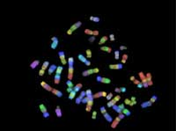  Image of human chromosomes  Image provided courtesy of Applied Imaging
Costs
The estimated total cost of the Human Genome Project is a staggering $3 billion. Why does it cost so much? Well, consider all of the people and equipment involved: computers are needed to store the data; technicians are needed to maintain the computers, geneticists are needed to map the genome; laboratory equipment is required, and so forth. The US government provides most of the funds (other funds coming from big companies and other countries). In 1995, President Clinton proposed to Congress that $241 million be budgeted to the National Institute of Health and the Department of Energy who head the project (this amount includes money for actual research, not employee salaries). This amount is nearly $42 million more than the amount spent in 1994 and $171 million more than the amount in 1993. The project is clearly growing and demanding more attention. | 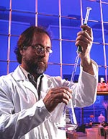  Scientist preparing agarose gel for seperating DNA fragments  Courtesy USDA ARS
The project is also attracting the attention of those in the business sector. Each year, many new biomed companies emerge, hoping to capitalize from the new research.
Mapping Processes
Mapping a gene is not difficult so long as one understands some basic genetic terms and processes. To begin with, linked genes are genes located very near each other on the same chromosome. As crossing-over occurs, strongly linked genes rarely separate from each other whereas those loosely linked do. Using probability data from thousands of heredity experiment, geneticists can determine the likelihood of two linked genes splitting apart. This creates a series of sorts which can be mapped much like dates on a timeline. On a chromosome map, genes aren’t separated by distance, really, but by their linkage strength. | 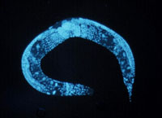  All 97 million-base genomes have been mapped in the Caenorhabditis elegans  By permission NHGRI
Sequencing DNA is much more difficult. First, all 3 billion bases are divided into 100,000 groups, each with approximately 40,000 bases (some groups overlap). Then, each of the fragments is divided again into 100 pieces with 400 bases each. The precise order of the amino acids (adenine, guanine, cytosine, and thymine) is then determined for each 400 base sequence.
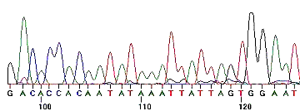  DNA sequencing analysis at the University of Pittsburgh  By permission University of Pittsburgh | This is done with a technique called electrophoresis which reads each acid’s identity chemical one at a time. The overlapped pieces (mentioned above) allow the researchers to fully connect the two strands correctly together to make longer chains.
Current Progress
Even now as you read this, computers at the various national genome centers are deciphering the DNA amino acid “codes”. In a single day, they will be able to sequence 30,000 bases, and, although this may seem like a lot, one must remember that an estimated 3 billion bases exist. Even if several hundred computers are involved it will still take many years before the entire human genome is mapped and sequenced. So far, 4600 of the estimated 100,00- to 300,000 genes have been identified and of those, complete sequences of only 600 are known. As each new discovery is made, it is logged and often published immediately on the Inernet. Victor A. McKusick, M.D. of Johns Hopkins University has recorded all of the known genes into his Mendelian Inheritance of Man, which is updated and published annually.
Chromosome 1
1. GBA: cause of Gaucher Disease
2. AD4: Alzheimer’s disease
Chromosome 2
1. MSH2: tendency toward colon cancer
2. PAX3: Waardenburg syndrome causing deafness and changes in pigmentation
Chromosome 3
1. VHL: tendency towards von Hippel-Lindau Disease causing tumors of the cerebellum
2. SCLC1: associated with lung cancer
Chromosome 4
1. HD: Huntington’s Disease which damages nerve cluster in the brain causing dementia and seizures
2. EVC: Ellis-van Creveld Syndrome causes six fingered dwarfism in primarily Amish communities
Chromosome 5
1. DTD: diastrophic sysplasia results when this gene mutates
2. SRD5A1: human steroid 5-alpha reductase
Chromosome 6
1. SCAI: tendency towards spinocerebellar atrophy, causing loss of muscle coordination
2. IDDMI: Juvenile diabetes
Chromosome 7
1. CFTR: tendency towards cystic fibrosis
2. OBS: tendency towards obesity
Chromosome 8
1. WRN: Werner’s Syndrome causing premature accelerated aging
2. MYC: associated with Burkitt lymphoma
Chromosome 9
1. CDKN2: associated with various cancers
2. TSC1: associated with tuberous sclerosis affecting the kidneys, heart, brain, and retina and causing retardation and seizures
Chromosome 10
1. MEN2A: associated with multiple endocrine neoplasia (ZA) syndrome causing tumors of the thyroid, parathyroid and adrenals.
2. OAT: associated with ornithine aminotransferase deficiency causing blindness.
In Depth
http://library.thinkquest.org/28599/depth.htm
Each of these In Depth articles provides down-to-earth insight into genetic science. Read about cool new discoveries, wild theories, and practical applications while at the same time learning more about genetics.
Frankenstein's Monster: Building New Life
Cardiothoracic Gene Therapy
Human Cloning
Private Industry Tackles Human Genome Project
Jurassic Park: Fact or Fiction?
ADDITIONAL ACTIVITY – STEM CELLS and STEM CELL RESEARCH
All info from http://learn.genetics.utah.edu/content/tech/stemcells/

What is a stem cell?
http://learn.genetics.utah.edu/content/tech/stemcells/scintro/
Internet Interactive, Stem Cell Guy at the Learn.Genetics
What is the goal of stem cell research? http://learn.genetics.utah.edu/content/tech/stemcells/scresearch/ The goal of any stem cell therapy is to repair a damaged tissue that can't heal itself.

What are current stem cell therapies today? http://learn.genetics.utah.edu/content/tech/stemcells/sctoday/

bone marrow transplant, which is used to treat leukemia and other types of cancer, as well as various blood disorders.bone marrow transplant Why is this a stem cell therapy?Leukemia is a cancer of white blood cells, or leukocytes. Like other blood cells, leukocytes are made in the bone marrow through a process that begins with multipotent adult stem cells. Mature leukocytes are released into the bloodstream, where they work to fight off infections in our bodies. If the transplant is successful, the stem cells will migrate into the patient's bone marrow and begin producing new, healthy leukocytes to replace the abnormal cells.
Umbilical Cord Blood Stem Cell Transplant
Newborn infants no longer need their umbilical cords, so they have traditionally been discarded as a by-product of the birth process. In recent years, however, the multipotent-stem-cell-rich blood found in the umbilical cord has proven useful in treating the same types of health problems as those treated using bone marrow stem cells
What are possible stem cell therapies for the future? http://learn.genetics.utah.edu/content/tech/stemcells/scfuture/
Some possibilities include:
- Collecting healthy adult stem cells from a patient and manipulating them in the laboratory to create new tissue. The tissue would be re-transplanted back into the patient's body, where it would work to restore a lost function.
- Therapeutic cloning, as described in Creating Stem Cells for Research, might enable the creation of embryonic stem cells that are genetically identical to the patient.
- One less invasive way to achieve this goal would be to manipulate existing stem cells within the body to perform therapeutic tasks. For example, scientists might design a drug that would direct a certain type of stem cell to restore a lost function inside the patient's body. This approach would eliminate the need for invasive surgical procedures to harvest and transplant stem cells.

WHAT IS THE GOAL OF STEM CELL ESEARCH?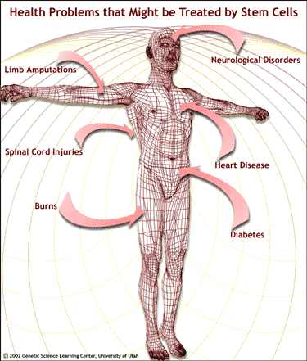
Why don't we live forever?
Because we get sick?
Because we get old?
Because we get hurt and can't heal?
All of these are correct. Each one results from a failure of the body's ability to grow, maintain or repair itself - functions that depend on our stem cells.
In What are Some Different Types of Stem Cells?, we saw how stem cells form the basic building materials for the human body. This makes them good candidates for restoring tissues that have been damaged by injury or disease.
For decades, researchers have been studying the biology of stem cells to figure out how development works and to find new ways of treating health problems.

How would stem cell therapy work?
The goal of any stem cell therapy is to repair a damaged tissue that can't heal itself.
This might be accomplished by transplanting stem cells into the damaged area and directing them to grow new, healthy tissue.
It may also be possible to coax stem cells already in the body to work overtime and produce new tissue.
To date, researchers have found more success with the first method, stem cell transplants.

Supported by a Science Education Partnership Award (SEPA) [No. 1 R25 RR16291-01] from the National Center for Research Resources, a component of the National Institutes of Health, Department of Health and Human Services. The contents provided here are solely the responsibility of the authors and do not necessarily represent the official views of NCRR or NIH.

