Calculating Cardiac Output
Meets Mathematics Georgia Performance Standards: M8N1, M8A1, M8P4

Name: ______________________ Date: _____________

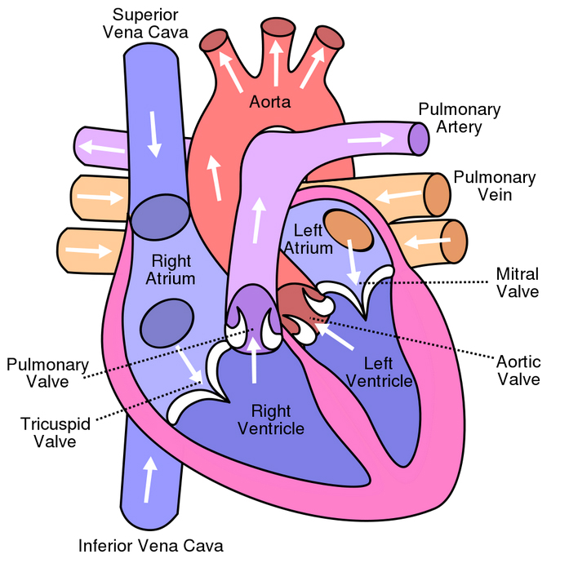
Introduction: Cardiac Output (CO) is defined by the volume of blood being pumped by the heart, in particular by a ventricle in one minute. We express CO in units of “Liters per Minute” (L/Min). An average CO is 5 L/Min for human males and 4.5 L/Min for human females. There are several different ways to calculate CO. In this activity, you will use Fick’s Principle to calculate your CO.

In order to use this method you need to know:
VO₂ = your oxygen consumption
CaO₂ = oxygen content of arterial blood
CvO₂ = oxygen content of venous blood

Materials: calculator, pencil

Step 1
You can calculate your oxygen consumption using this formula: VO₂ = 125 * BSA

a. But what is your BSA? BSA = Body Surface Area, expressed in meters squared (m²)
In order to get your BSA you must know your weight (in kilograms) and height (in centimeters).
Weight = W = _________ pounds = _________ kg (Remember: 1 pound = 0.4536 kg)
Height = H = _________ inches = __________ cm (Remember: 1 inch = 2.54 cm)

Use the following formula of “DuBois and DuBois” to calculate your BSA:

BSA = (W^{0.425} x H^{0.725}) x 0.007184

Your BSA = ________ m²

b. Using your BSA, now calculate your VO₂
VO₂ = 125 * BSA

Your VO₂ = ________ ml/min

Step 2
In order to measure the oxygen content of your arterial (CaO₂) and venous (CvO₂) blood you need special equipment. Therefore, we are going to estimate these numbers today using average numbers. Let CaO₂ = 20, and CvO₂ = 15.
Now you have everything needed to calculate your Cardiac Output (CO).

Fick’s Principle states:

______VO_{2________}
CO = [(CaO₂ - CvO₂) x 10]

Use this formula to calculate your CO.

Your CO = __________ L/Min
Answer Key:

**Note to teachers:
Since this is an individualized activity there is no answer key. Students should come up with CO’s that are near to the averages given on the worksheet.

Step 1, a, requires students to use exponents to calculate their BSA. This may require assistance from the teacher or, students can use an online BSA calculator and avoid using the DuBois and DuBois Formula.

A BSA calculator can be found online at:
http://www-users.med.cornell.edu/~spon/picu/calc/bsacalc.htm

Students must be sure to select appropriate units when entering their height and weight to use this BSA calculator.

