Venn diagram: Health Informatics Careers

Name: __________________________ Date: __________
Introduction: A Venn diagram is often used in mathematics to show relationships between sets. Venn diagrams are made up of two or more overlapping circles. They are useful in a number of applications. In this case, a Venn diagram is used to visually show the similarities and differences in careers in Central Supply for Healthcare. Venn Diagrams help people visualize and organize thoughts.

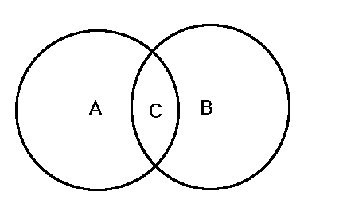

Directions: Pick two careers in the field of Health Informatics (e.g. medical coders, healthcare administrators, health information technologists, health unit coordinators) and fill out the Venn diagram below. Compare and contrast the two careers by determining points that are alike and points that differ. Fill out the Venn diagram below with your information.

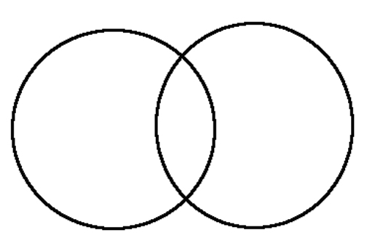
Career One: ___________
Career Two: ___________

