http://www.supermarketguru.com/index.cfm/go/sg.viewArticle/articleId/1787

Catering to Kids' Tastes
January 18, 2011
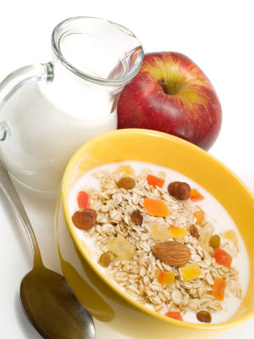
Fat and sugar are less important in foods for children in terms of palatability than sodium, according to new research published in the British Journal of Nutrition. And on top of that, kids who start the day with a bowl of sugary cereal, consume almost twice the amount of sugar than if they ate a healthier option - which, incidentally, they would be just as happy with.
Specifically, kids (between five and 12) served sugary cereal poured themselves more than 24 grams of added sugars versus those given low-sugar cereals who still added table sugar but consumed about half the amount of sugar overall and more fruit. Both groups were equally likely to say they enjoyed their breakfast.
Too much sugar not only contributes to obesity, but according to the American Heart Association it is a key culprit in diabetes, high blood pressure, heart disease and stroke. The AHA recommends that women eat no more than 25 grams (about six teaspoons) of added sugar a day, therefore not naturally occurring in foods such as fruits, and men no more than 37.5 grams.
On a similar note, researchers found that salt may play an important role in the flavor, acceptability and consumption of vegetables for children; but in terms of starchy, not as nutrient dense foods like pasta, which kids eat anyway, the addition of sodium actually increases consumption.
In comparison with “normal” salt levels, a decrease of salt on green beans led to a 25 percent decrease in intake. The study also showed that preschool children with a higher BMI consumed more pasta when more fat was added. Researchers commented that the additional fat and sugar could be avoided in foods for children without having an impact on palatability, allowing the energy density of children’s diet to be limited. Furthermore, decreasing salt on vegetables should be avoided if we want kids to consume more veggies.
Nutritional policies regarding the use of salt, fat and sugar as well as consumer packaged goods reformulations aimed at children should take these results into account, keeping in mind that the addition of fat and sugar can be avoided, helping to prevent obesity and to establish healthy eating habits at a young age. SupermarketGuru encourages parents to uses these tricks at home, maybe mixing two breakfast cereals a “regular version” and one with less sugar, and when preparing vegetables sprinkle a little sea salt and fresh lemon juice to improve the flavor profile catering to your kids.
The American Heart Association recommends limiting sodium intake to 1,500 milligrams; for reference, ½ a teaspoon of salt contains 1,200 mg of sodium.

