Least Wanted Foodborne Pathogens
http://www.fightbac.org/about-foodborne-illness/least-wanted-pathogens?tmpl=component&print=1&page=
The U.S. Public Health Service has identified the following microorganisms as being the biggest culprits of foodborne illness, either because of the severity of the sickness or the number of cases of illness they cause. Beware of these pathogens: Fight BAC!®
LEARN WHERE THEY ARE AND HOW TO AVOID THEM
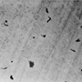 |  | Campylobacter- Second most common bacterial cause of diarrhea in the United States. Sources: raw and undercooked poultry and other meat, raw milk and untreated water.
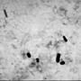 |  | Clostridium botulinum- This organism produces a toxin which causes botulism, a life-threatening illness that can prevent the breathing muscles from moving air in and out of the lungs. Sources: improperly prepared home-canned foods; honey should not be fed to children less than 12 months old.
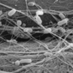 |  | E. coli O157:H7- A bacterium that can produce a deadly toxin and causes approximately 73,000 cases of foodborne illness each year in the U.S. Sources: beef, especially undercooked or raw hamburger; produce; raw milk; and unpasteurized juices and ciders.
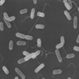 |  | Listeria monocytogenes- Causes listeriosis, a serious disease for pregnant women, newborns, and adults with a weakened immune system. Sources: unpasteurized dairy products, including soft cheeses; sliced deli meats; smoked fish; hot dogs; pate'; and deli-prepared salads (i.e. egg, ham, seafood, and chicken salads).
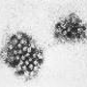 |  | Norovirus- The leading viral cause of diarrhea in the United States. Poor hygiene causes Norovirus to be easily passed from person to person and from infected individuals to food items. Sources: Any food contaminated by someone who is infected with this virus.
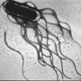 |  | Salmonella- Most common bacterial cause of diarrhea in the United States, and the most common cause of foodborne deaths. Responsible for 1.4 million cases of foodborne illness a year. Sources: raw and undercooked eggs, undercooked poultry and meat, fresh fruits and vegetables, and unpasteurized dairy products.
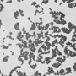 |  | Staphylococcus aureus- This bacterium produces a toxin that causes vomiting shortly after being ingested. Sources: cooked foods high in protein (e.g. cooked ham, salads, bakery products, dairy products) that are held too long at room temperature.
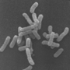 |  | Shigella - Causes an estimated 448,000 cases of diarrhea illnesses per year. Poor hygiene causes Shigella to be easily passed from person to person and from infected individuals to food items. Sources: salads, unclean water, and any food handled by someone who is infected with the bacterium.
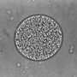 |  | Toxoplasma gondii- Aparasite that causes toxoplasmosis, a very severe disease that can produce central nervous system disorders particularly mental retardation and visual impairment in children. Pregnant women and people with weakened immune systems are at higher risk. Sources: raw or undercooked pork.
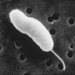 |  | Vibrio vulnificus- Causes gastroenteritis, wound infection, and severe bloodstream infections. People with liver diseases are especially at high risk. Sources: raw or undercooked seafood, particularly shellfish.
"Ten Least Wanted Pathogens" information provided by the Centers for Disease Control. For more information visit www.cdc.gov.
The Partnership for Food Safety Education www.fightbac.org

