FAT TOM is an acronym to help you remember the keys to food safety:
Food  Acidity  Time | Temperature  Oxygen  Moisture

F is for Food
Nutrients in food determine whether microorganisms will grow. High protein, moist foods (meat, milk, eggs and fish), are high risks for food poisoning. That is, they are highly likely to cause foodborne illness because they are an ideal food source to support the growth of bacteria.
A is for Acidity
The degree of acidity or alkalinity (base) of a substance is measured by its pH. pH is measured on a scale from 0 to 14.0. A product with a pH of 7.0 is exactly neutral. Foods with a pH below 7.0 are acidic; a pH above 7.0 is alkaline. The lower the pH, the higher the acidity; the higher the pH, the lower the acidity.
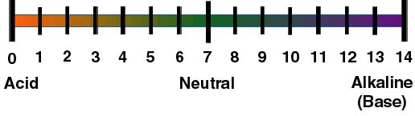
Bacteria love an environment that is neutral or slightly acidic, a pH range between 6.6 and 7.5. High acid foods (like fruits and vinegar) stop or seldom provide the conditions for bacterial growth.
T is for Time
Microorganisms reproduce by cell division. The longer the food is exposed to ideal conditions, the faster cells divide and the greater the risk for food poisoning. When low acid, high protein foods are exposed to the DANGER ZONE (40° to 140°F) for more than 2 hours, pathogens have multiplied so rapidly that the food will quickly make people sick.

T  is for Temperature | 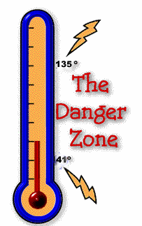
Because microorganisms multiply in the DANGER ZONE, foods should not be left at room temperature for long periods of time. When preparing foods, work with small amounts and then return to refrigeration or heat. In other words, always keep hot foods hot and cold foods cold. After service, do not allow foods to sit for more than 2 hours in the DANGER ZONE. Also, cool left over foods quickly.

0  is for Oxygen  (Air) | 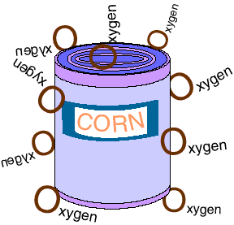
Microorganisms that need (air) to grow are called aerobic. When foods are canned, oxygen cannot penetrate. These foods are shelf stable and do not require refrigeration until they are opened.
Some microorganisms will grow only in anaerobic conditions (in the absence of oxygen). Botulism, a rare type of foodborne illness, grows only in anaerobic conditions and is found in home canned foods that are improperly processed.
 M is for Moisture

Bacteria, yeast, and molds love a moist environment to grow and multiply rapidly. Meats, poultry, fish eggs, produce and soft cheeses are examples of foods with a high amount of moisture.
Salty or sugary food have a lower level of moisture and have a shelf life non-conducive to bacteria. Dry cured and dehydrated meats as well as jellies and jams deprive microorganisms of water due to their high salt and sugar levels and inhibit bacteria reproduction.

