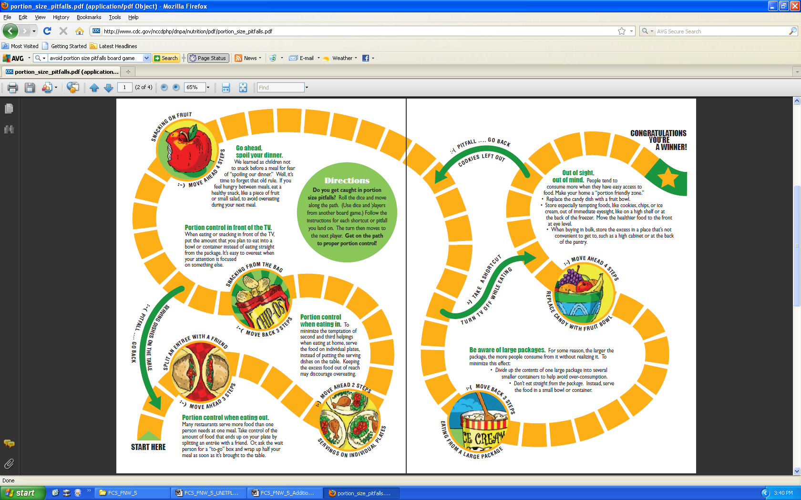
Source: http://www.cdc.gov/nccdphp/dnpa/nutrition/pdf/portion_size_pitfalls.pdf.



