Bones of the Face & Cranium Worksheet

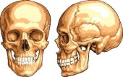
8 Bones of the Cranium:
- _______________
- _______________
- _______________
- _______________
- _______________
- _______________
- _______________
- _______________

14 Bones of the Face:
- _______________
- _______________
- _______________
- _______________
5. _______________
6. _______________
7. ________________ 11. __________________
8. ________________ 12. __________________
9. ________________ 13. __________________
10. ________________ 14. __________________

Notes:_______________________________________________________________________________________________________________________________________________________________________________________________________________________________________________________________________________________________________________________________________________________________________________________________________________________________________________________________________________________

