Haircutting Guidebook

Name: _________________________________________

Basic Face Shapes

Round Oval Heart Square Hexagonal Pentagonal

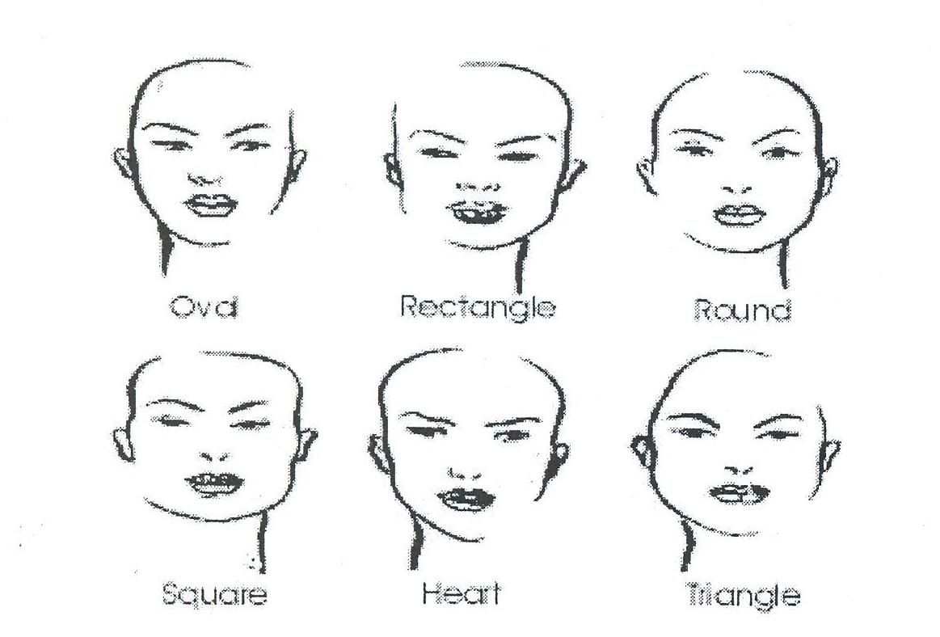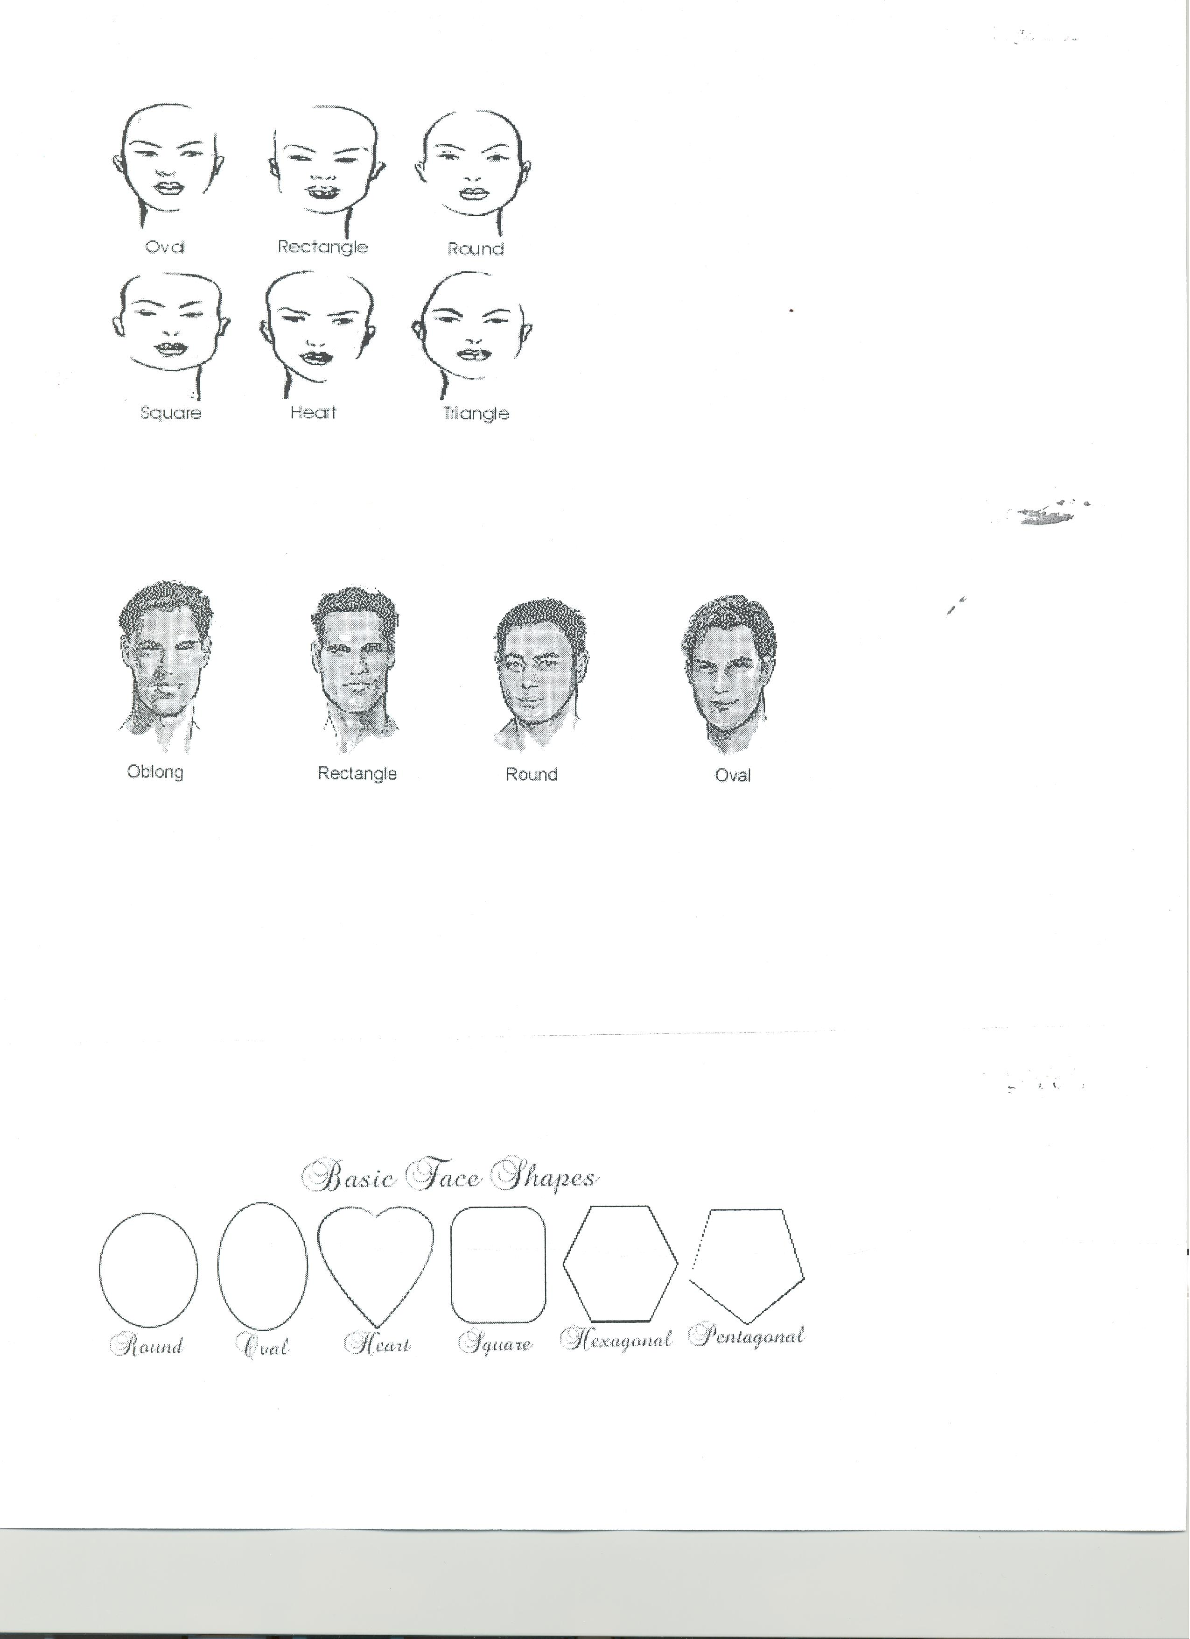

Elevations
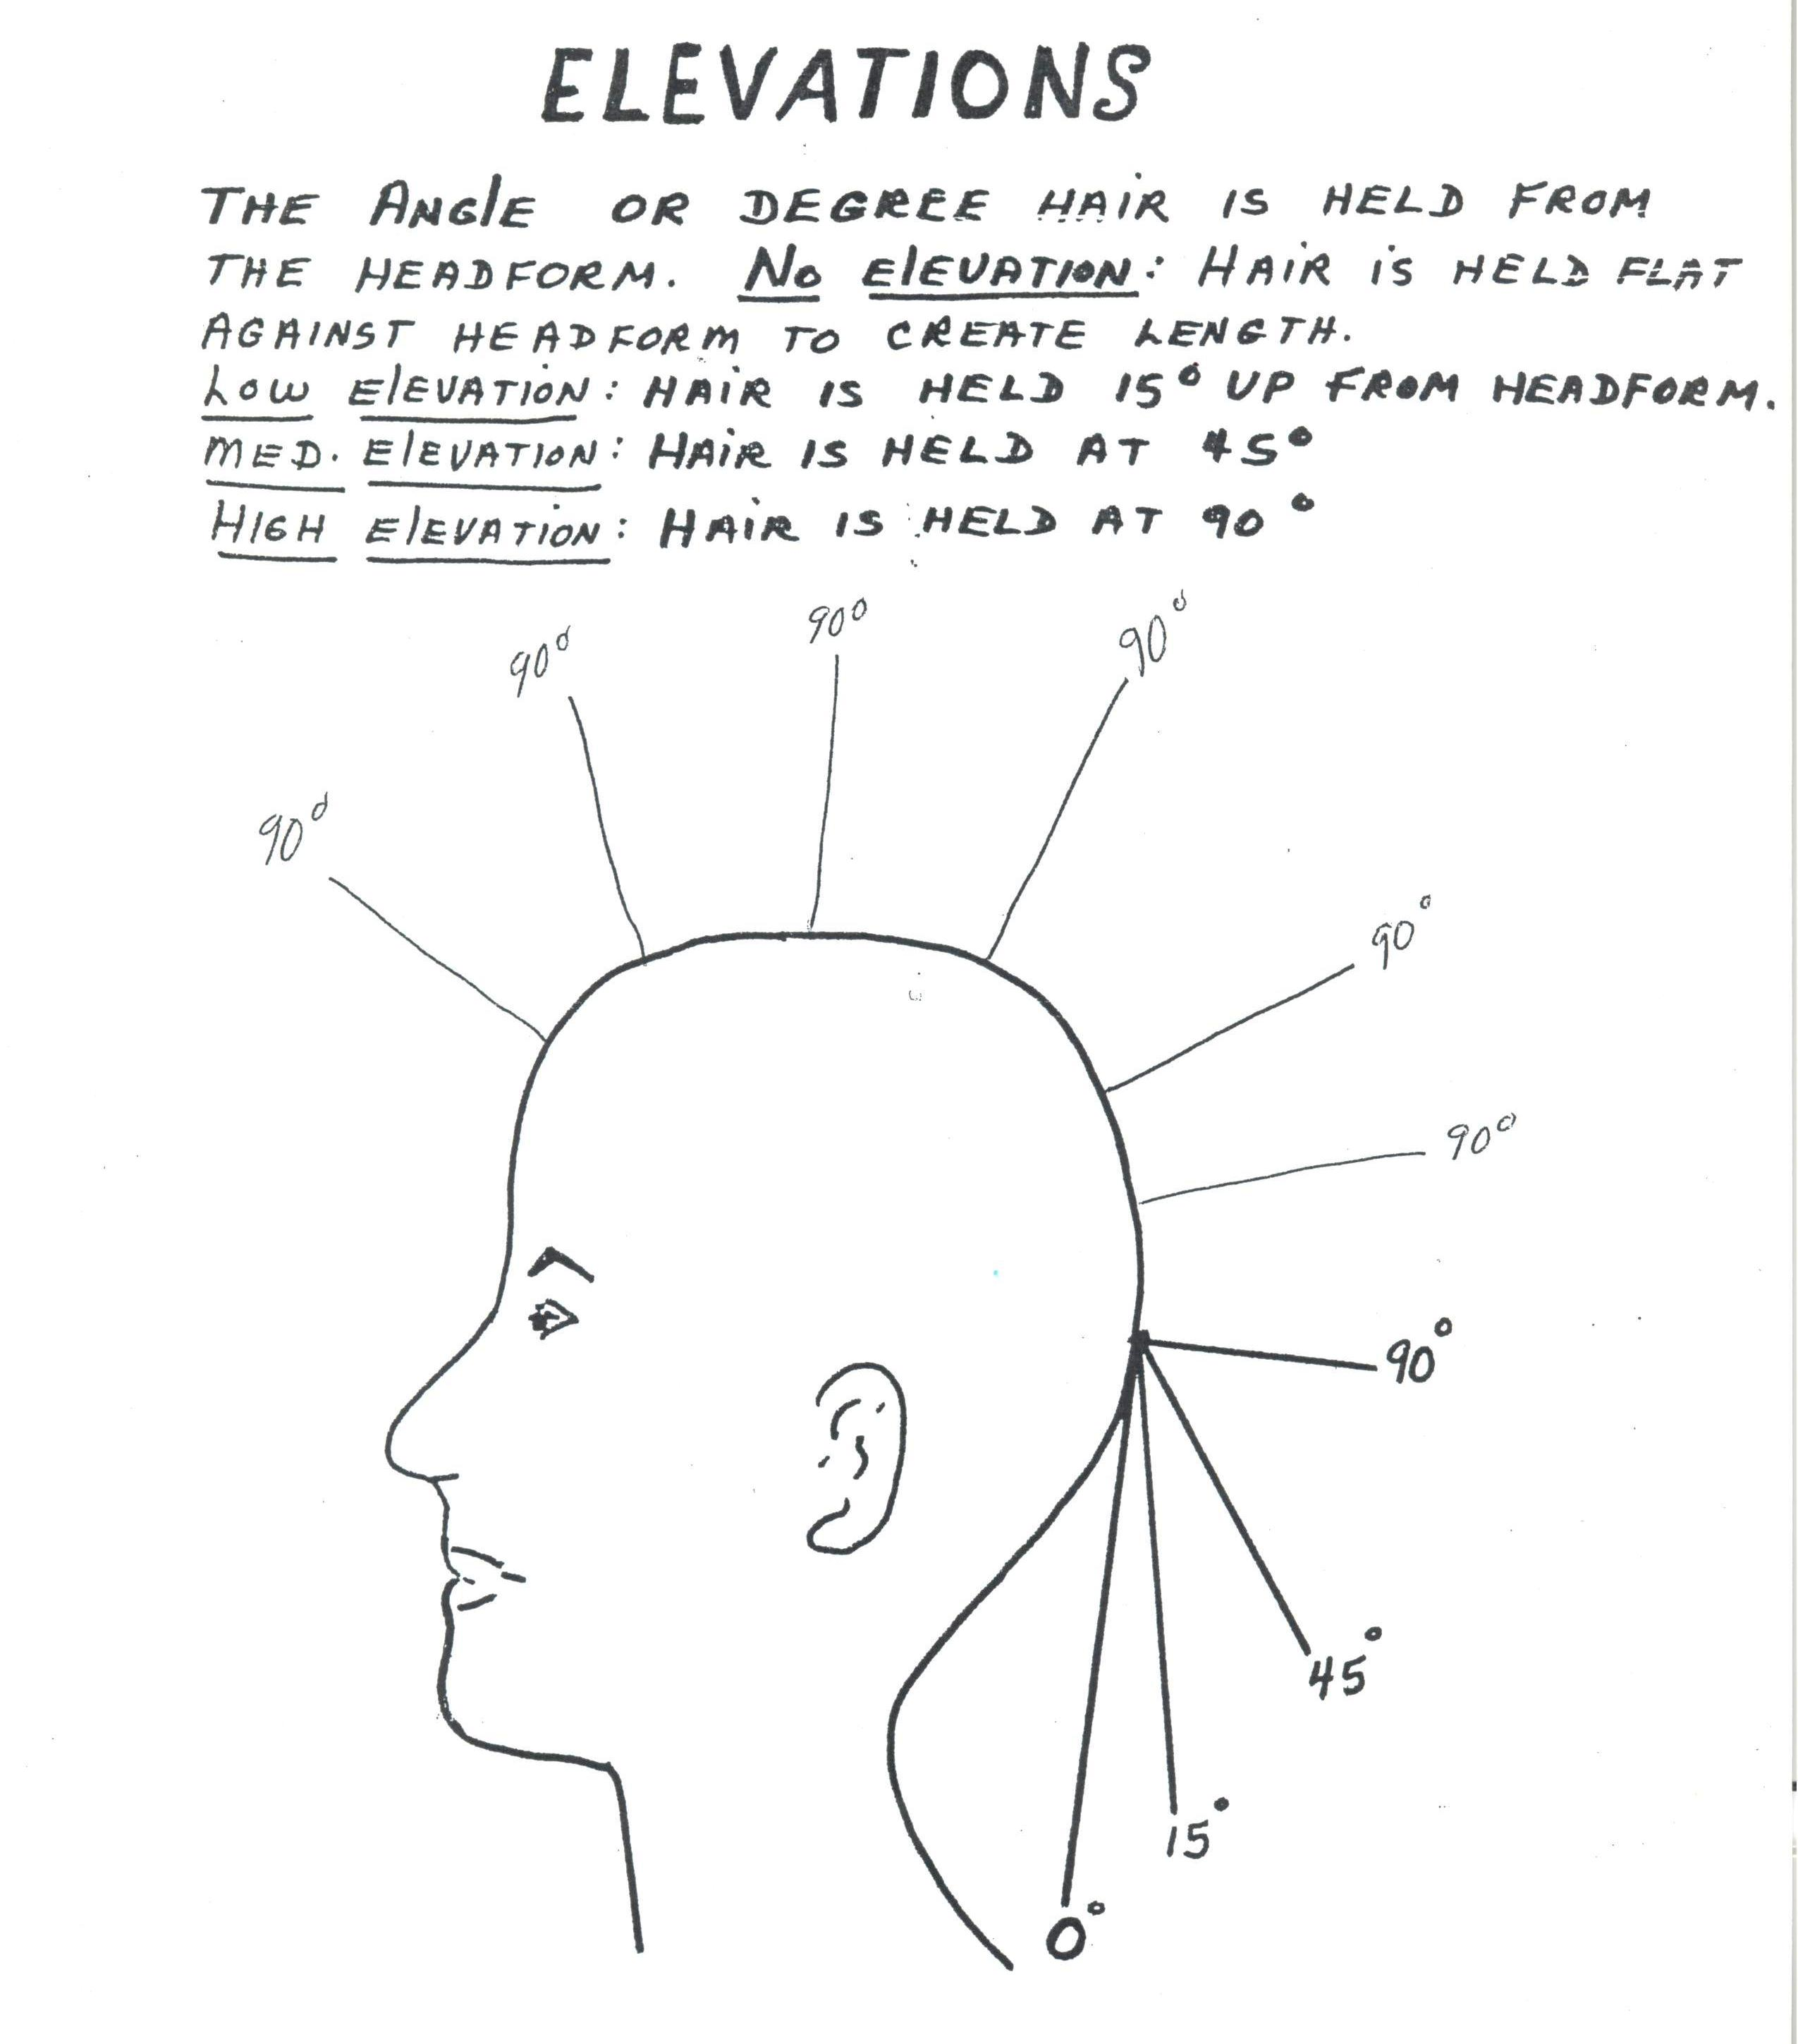

Hairline Shape
Guide points from the hairline shape.
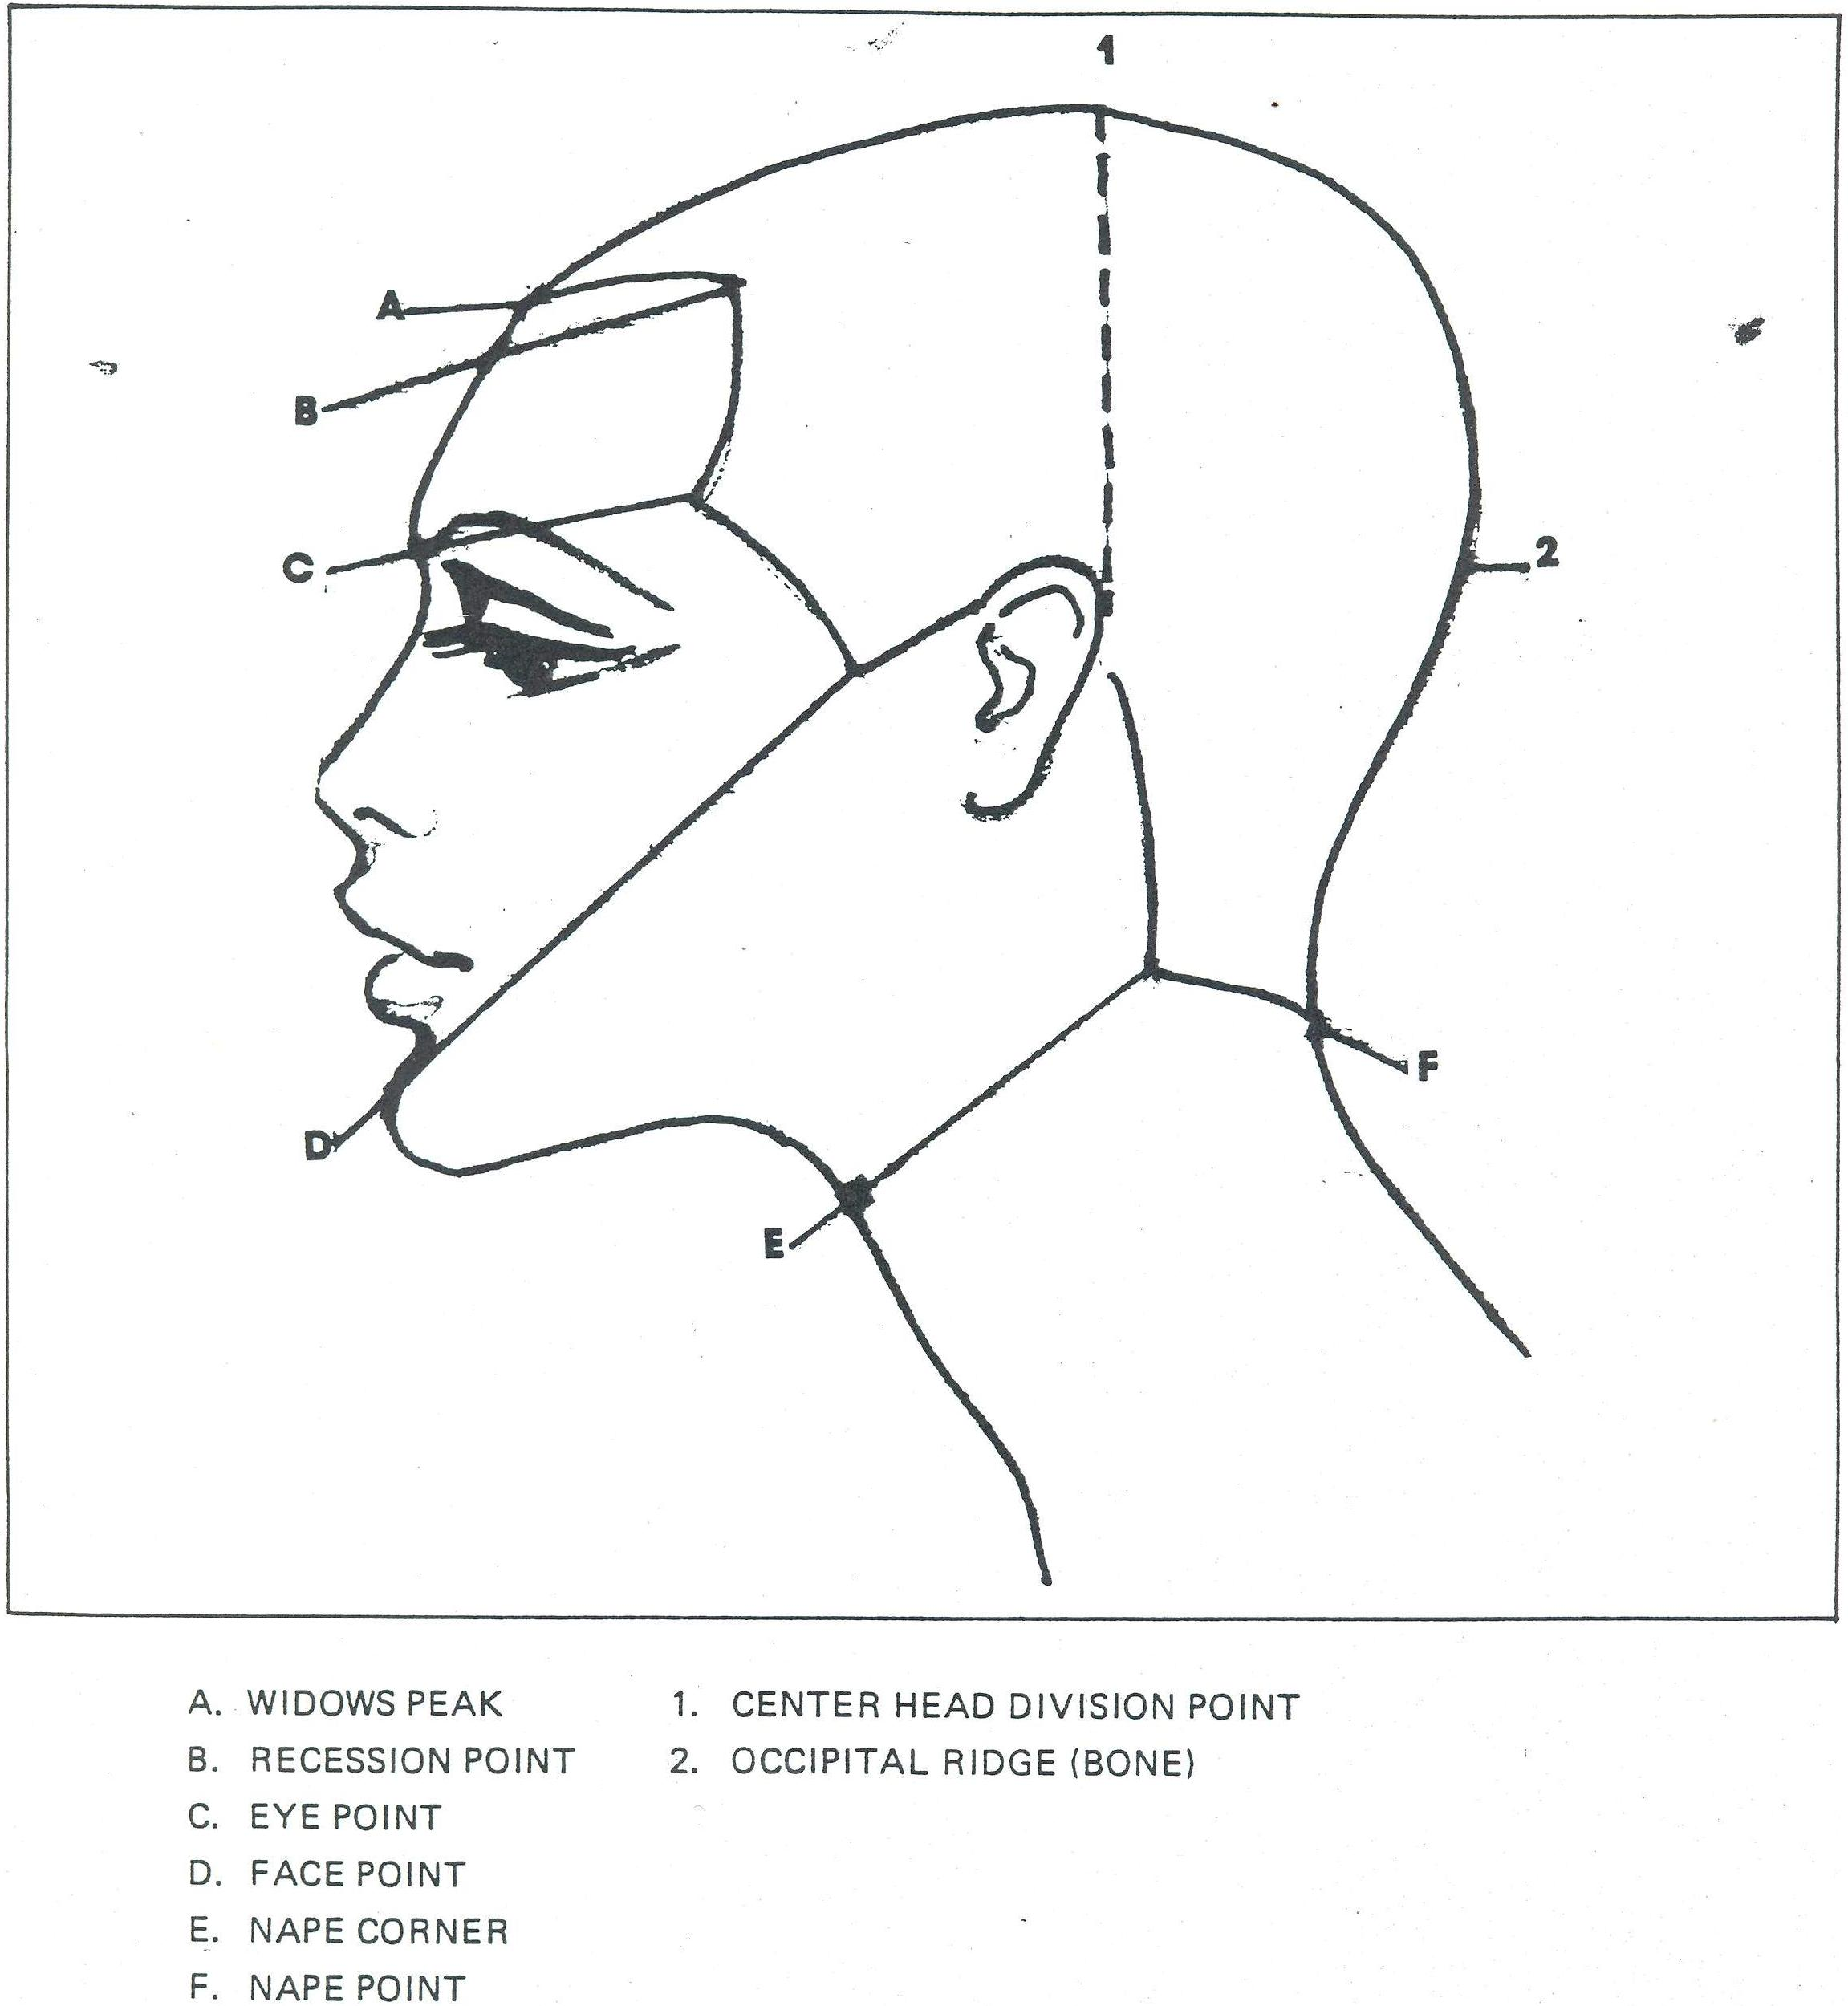

Haircutting Angles

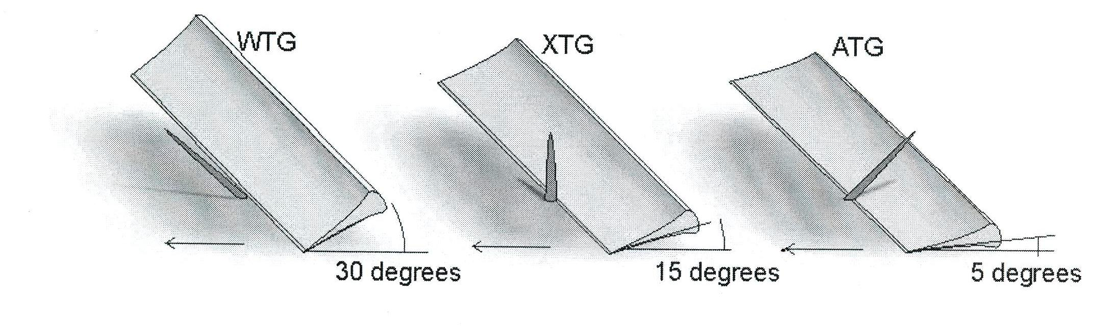

Parts of Razors & Shears
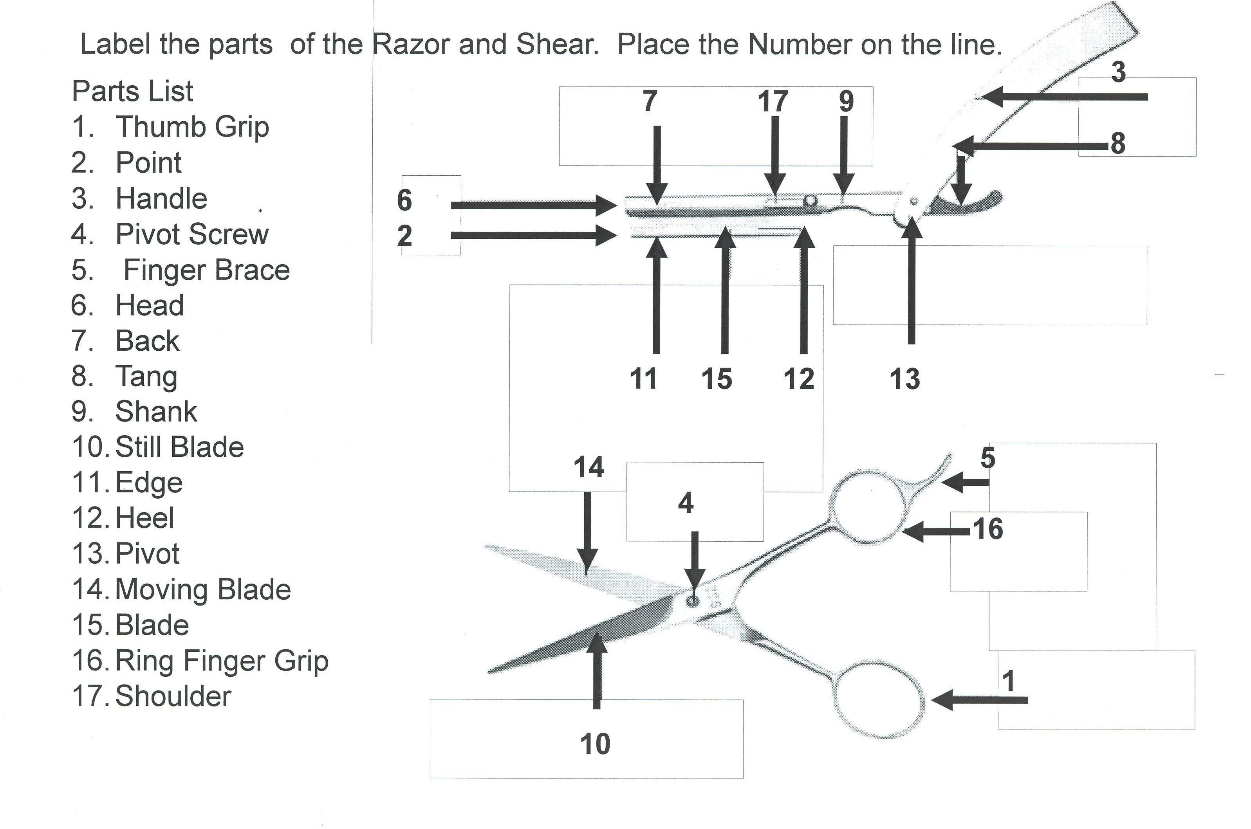

Shaving & Lining the Back of the Neck
Men’s Haircutting

The neck shave is the finish part of a men’s haircut. Shaving the outline areas sideburns, around the ears, and the sides of the neck below the ears gives your client a clean sharp appearance.
- Remove all haircut hair from around the head and neck use clean tissue, towel or hair vacuum.
- Remove neck strip making sure no hair falls down shirt. Keep cape on do not remove cape
- Hair grows down back of neck so you must unfasten cape.
- Spread a towel or paper towel across shoulders and tuck it into the neckline so clothes do not get shaving cream on them.
- Apply a light coat of shaving cream along the hairline if you have a shaving cream warmer it’s always nice.
- Shaving cream should be applied over the ears to the sideburns and down the sides of the neck.
- Follow the hairline with the free hand stroke do not apply to much pressure.
- Be careful not to shave up into the hairline use the point of the razor.
- NOTE: Bend the ear back with the left hand thumb be careful not to cut the ear
- Round, Square, Tapered will normal be your choices of hair line shapes.

Here's how: This could be done on your own self or you can apply with your client.
- Remove your shirt and stand with your back to the bathroom mirror. Hold your hand mirror (or place your swing arm mirror) in front of your face and position it so you can see the back of your head in the bathroom mirror.
- Hold the trimmer with the teeth of the blade facing the back of your neck and parallel to the floor (the clipper should be held with blade side up) and shave a straight guide line horizontally across the back of your neck. Keep this line as close to the bottom of the natural hairline as possible. You should be able to follow the outline left from your last haircut.
- Flip the clipper over so the teeth of the blade are facing upward. Start at the bottom of your neck and shave upward in vertical sections until you come to the horizontal guide line you shaved in step two.
- If you desire a more rounded look, shave off the corners at each side of the neck. If needed, you may also remove any stray hairs behind the ears.
- For those who would like a closer shave than a trimmer can provide, you may shave the area with a razor. The straight razor works well for this because of the detail blade on the back of the razor's head. Use a very thin layer of shaving cream (so you can see the hairline) and shave the neck in the direction the hair grows. Use your trimmer lines as a guide.

Tips:
- Holding the clipper or razor with the hand on the same side of the neck your shaving makes it easier.
- Invest in a swing arm mirror and mount it on the wall so you may stand between it and the bathroom mirror. Not having to hold a hand mirror makes the job far less complicated.
- Go slowly. Rushing through the job will ensure an uneven result.
- Stick as close to the natural hairline as possible -- shaving into the hairline will result in an undesirable effect as the hair grows out.
Clipper & Comb Techniques

It’s best to practice with the clippers turn off before cutting the real hair.
- How to hold the clippers pick up clippers with the right hand
- Place the thumb on the left side and the finger on the right side of the electric clippers
- Do not hold real tight so wrist will not be tight
- With the left hand comb hair down the comb will act as the guard so you will not cut too much of the hair
- Using the clipper and the comb
- Comb the hair down take the clipper while using your comb as a guide and cut slowly across with the clippers along the hairline making sure not to go fast or the clippers will get jammed from too much hair and pull your clients hair out.
- Some barber-stylist likes to start the taper from the middle others from left to right or right to left. You can guide your student where you want them to start the taper.
Standard Clipper Cutting
- Clipper cutting against the grain is accomplished by cutting the hair in the opposite direction from which it grows. Taper the hair by gradually tilting the clipper until it rides on its heels.
- Clipper cutting with the grain means the cut is in the same direction in which the hair grows. When using a clipper on the hair that has a tight curl formation, try to cut with the grain. Cutting tight, curly hair against the grain clogs up the clipper blades.
- When cutting across the grain with clippers, the hair is cut neither with no against the grain. It is usually done on the side of the head.
- Cutting the hair in a circular motion using clippers is advisable in whorl areas, or in places where the hair does not grow in a uniform manner.
- Clipper cutting over a comb is a method of cutting in which the hair may be cut with a minimum change of clipper blades.

