UNDERLYING PIGMENTS: LAB ACTIVITY
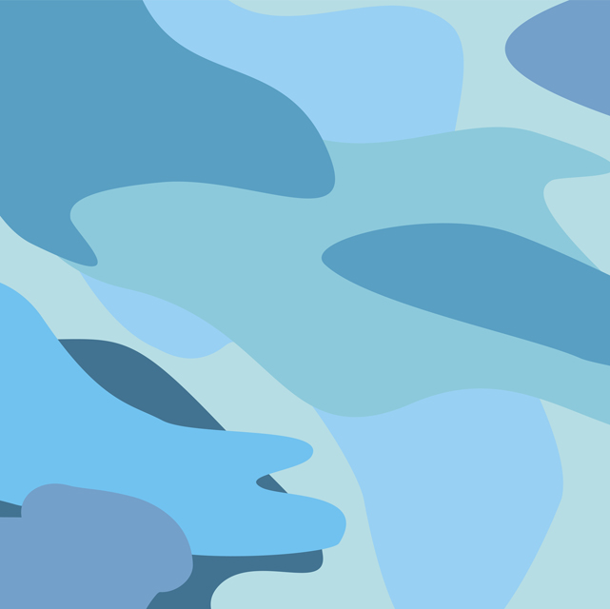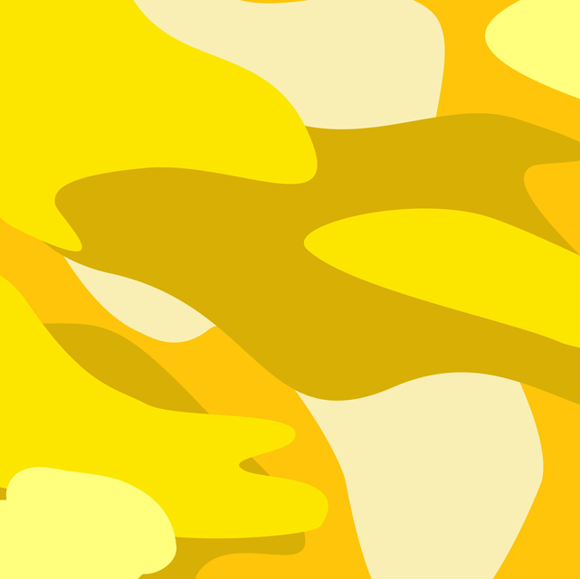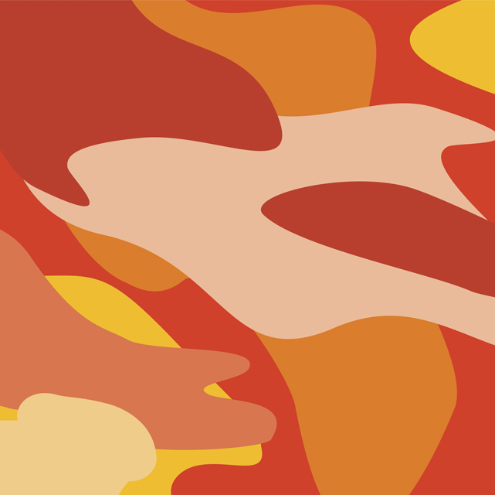
Directions: From the product table, collect small amounts (about 1 oz.) of each primary color of paint in the plastic cups provided (some of you may share paint), a paintbrush, 6 popsicle sticks, and water for rinsing your paintbrush. The following steps for the activity are listed below.
Part I:
- Paint one side a popsicle stick white.
- Paint one side of another stick red.
- Paint one side of a third stick blue.

Allow each stick to dry completely before moving on to Part II.

Part II:
- Paint one coat of red on the white stick.
- Paint one coat of yellow on the red stick.
- Paint one coat of black on the blue stick. You will need to create a black color by mixing some of the paint.

Allow each stick to dry completely before answering the questions in Part III.

Part III: (We will be discussing these answers as a class.)
- Did you achieve a true red color on the white stick? __________
- Did you achieve a true yellow on the red stick? __________
- Did you achieve a true black on the blue stick? __________
- Did you predict the outcome of colors before performing the steps in Part II on top of the colors you painted in Part I? Explain.

- What caused the outcomes from Part II in the coloring process?

Part IV: For your new white hair swatch, create a true red haircolor using the primary colors.

