Metallic Salt Hair Dyes
Metallic salt dyes have been with us for a long time. The old paint and brush-on hair dyes for gray hair used in the 1800s were metallic salt dyes. The basic ingredients have not actually changed that much. Metallic salt dyes of old almost always contained a lead compound, but modern dyes contain a variety of other metals depending on the shade of color. When the metallic salt compound is applied to the hair the metal salts undergo a chemical reaction to deposit a colored film on the hair fiber surface. In general these dyes do not penetrate inside the hair fiber, they just coat the surface.
These surface dyes can bring disadvantages. Although the formulations have much improved over the years, because the dye works by coating the outer hair surface the dye may reduce some of the shine from natural hair. Many modern formulas get around this by adding other chemicals with light reflective properties. One thing that has not been improved significantly is the need for repeated application to gradually increase the hair color change. Usually multiple applications of metallic salt dyes are required to get the desired result and then regular maintenance applications are needed to keep the color. This disadvantage of metallic salt dyes has been turned into an advantage by manufacturers. The makers often claim gradual gray hair restoration properties for their product. There are relatively few metallic salt dyes available today compared to a hundred years ago, but the Grecian formulas for gray hair are such products.
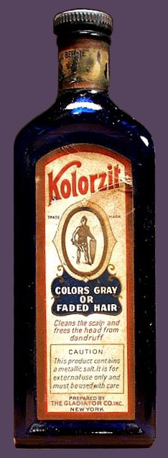
There are some disadvantages of metallic salt dyes. There are relatively few shades of metallic hair dyes available limited by the properties of metal salts. However, the degree of color can be regulated by the frequency of application. The more frequent the application, correspondingly the stronger the color. These dyes tend to produce quite dark and intense colors with frequent use. Metallic salt dyes can interfere with permanent waving so there are restrictions on using these dyes along with other forms of hair processing.
The advantages of metallic salt dyes include their ease of use at home. The gradual change in color with repeated use is subtle so friends and associates may not actually realize you have started using hair dye. These dyes are relatively safe to use. Although made from metals, the modern formulas are not absorbed through the skin. There is usually no need for a patch test as it is extremely rare to become sensitized to metallic salts.
To determine if hair has been colored by a metallic dye, mix 1 oz. of 20-volume peroxide with 20 drops of 28% ammonia. Submerge 20 strands of hair in the solution and let it sit at room temperature for about 30 minutes. If the hair lightens rapidly, the hair contains lead. If there is no reaction after 30 minutes, the hair contains silver or bismuth. If the solution starts to boil and emits a foul odor, the hair contains copper. Hair that has no metallic salts on it should lighten only very slightly.

http://www.keratin.com/ai/ai020.shtml

