BINGO
CTAE Resource Network, Instructional Materials Office
July, 2009

Directions for the Instructor

1. Print the bingo cards. Twenty six different cards are included. Print additional cards at random if needed. Cut each sheet to separate the cards. Cards may be laminated for durability.

2. Give each student a bingo card and chips, markers, or scrap paper. If paper is to be used, ask students to tear or cut 25 pieces of paper into about one-half inch squares. If the cards have been laminated, students can mark their cards with erasable markers.

3. Explain to the students that you will read the definitions to the class and that they should mark the correct answer on their card.

4. Read the definitions only, at random, from the definitions list. Mark the definitions that have been used. The student should place a chip on the cell with the correct response.

5. When a student has placed chips on 5 spaces in a row (diagonally, vertically, or horizontally) the student should call “Bingo.” Ask the winning student to call out his/her answers. Check his/her answers to make sure the correct definitions have been used.

Optional Bingo Variations:

- T-Bingo: The card must be marked in the shape of a “T” to call Bingo.

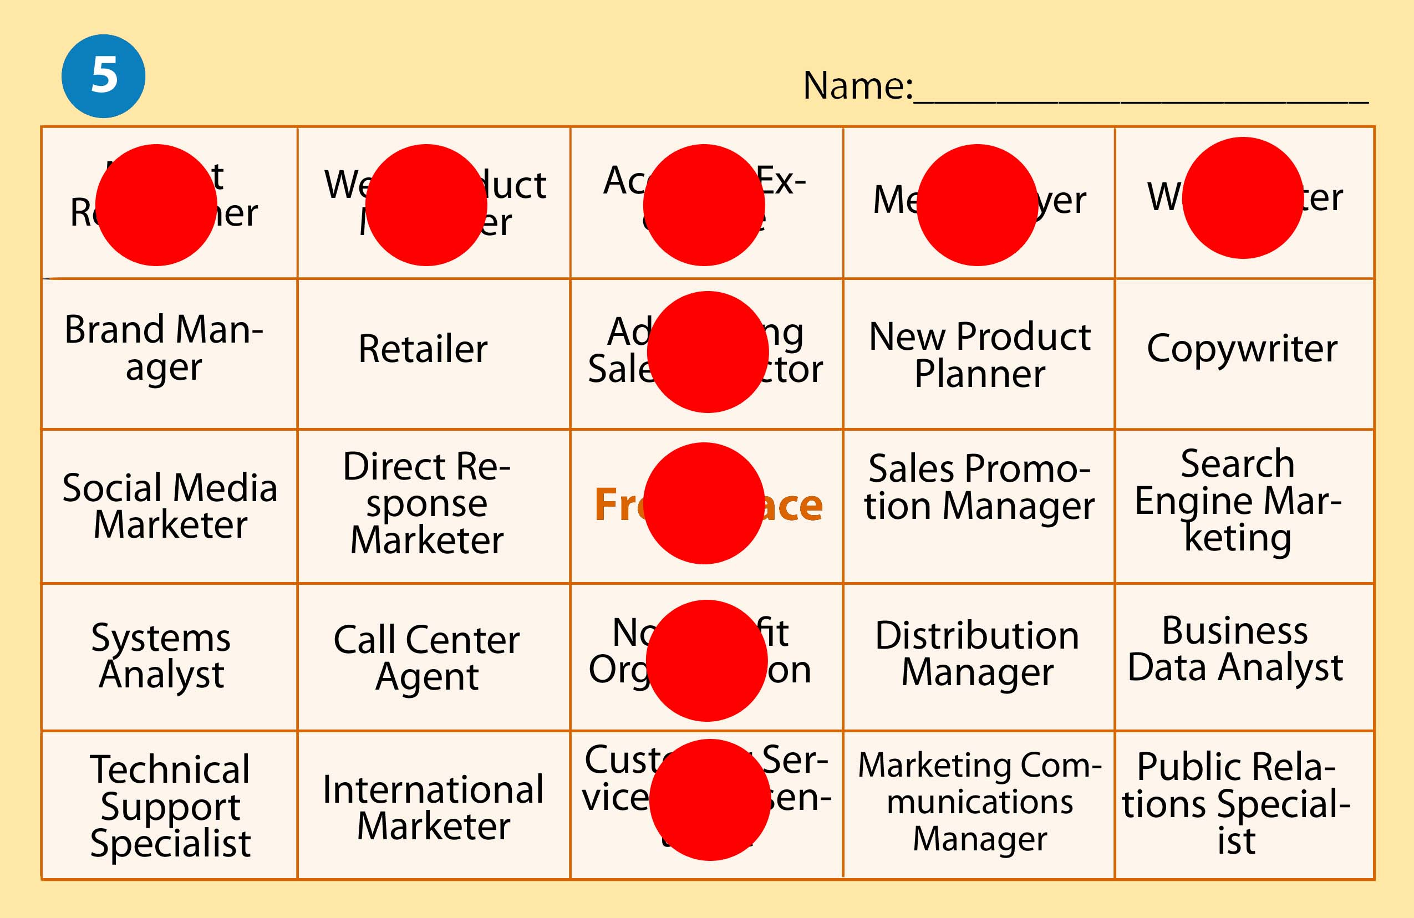

- Corners Bingo: The four outer corners of the card must be marked to get Bingo.



- U-Bingo: The card must be marked in the shape of a “U” to call Bingo.



Definition | Correct Response
An engine that burns fuel within itself as a means of developing power. | Internal Combustion Engine
The part of the engine containing the crankshaft, pistons, cylinders. It is made of cast iron or aluminum and is the foundation for the entire engine. | Block
A hole or holes that have a set depth and contain a piston. | Cylinder
Cylindrical plug that is closed on one end and attached to a connecting rod at the other. When the fuel charge is fired, the force of the explosion will transfer from the closed end through the piston to the connecting rod and crankshaft. | Piston
The main shaft that supports the connecting rods and turns piston reciprocation into motion. | Crankshaft
The connecting link between the crankshaft and the pistons. | Connecting Rod
A large heavy wheel that forms the base for the starter ring gear and provides a mounting surface for the torque converter or clutch assembly. | Flywheel
The area above a piston with the piston at TDC. Measured in cubic centimeters. | Combustion Chamber
Metal section bolted on top of the engine block and forms part of the combustion chamber. | Cylinder Head
A metal device for opening and closing an aperture or port. | Valve
A shaft with offset lobes used to operate valves. | Camshaft
A split ring installed in a groove in the piston. Seals the compression chamber from the crankcase. | Piston Rings
An engine requiring two complete cycles of the crankshaft to fire each piston once. | Four Stroke Cycle Engines
An engine that requires one complete revolution of the crank shaft to fire each piston once. | Two Stroke Cycle Engines
The various parts that make up the valve and operating mechanism. | Valve Train
An engine that is set at an angle. Allows the engine to be installed in a smaller space. | Inclined Engine
An engine in which the cylinders are arranged in two separate banks set at a 60 or 90 degree angle to each other. | V-Type Engine
An internal combustion engine that uses one or more triangular rotors instead of pistons to accomplish the intake, compression, power, and exhaust cycle. | Rotary Engine
A rotating contact that routes secondary current from the coil to the individual spark plug wires. | Rotor (Ignition)
An engine in which all of its cylinders are in a straight row. | Inline Engine
A combustion process used in a type of four-stroke internal combustion engine. | Miller-Cycle
Measurement of an engine’s ability to perform work. One horsepower is defined as the ability to move 33,000 pounds one foot in one minute. | Horse Power
A device that tests engine output at the crankshaft. | Engine Dynamometer
A machine used to measure engine power at the vehicles wheels. | Chassis Dynamometer
Turning effort, and in an automotive engine, this is produced by the pressure from the crankshaft on the pistons. Engine torque is relatively low at idle speeds, but increases at a high rate as engine speed increases. | Engine Torque
The openings through the head from the intake and exhaust manifolds to the combustion chamber | Valve Ports
Piston ground slightly egg-shaped. When heated it becomes round. | Cam Ground Piston
A rod that connects the valve lifter to the rocker arm. | Push Rod

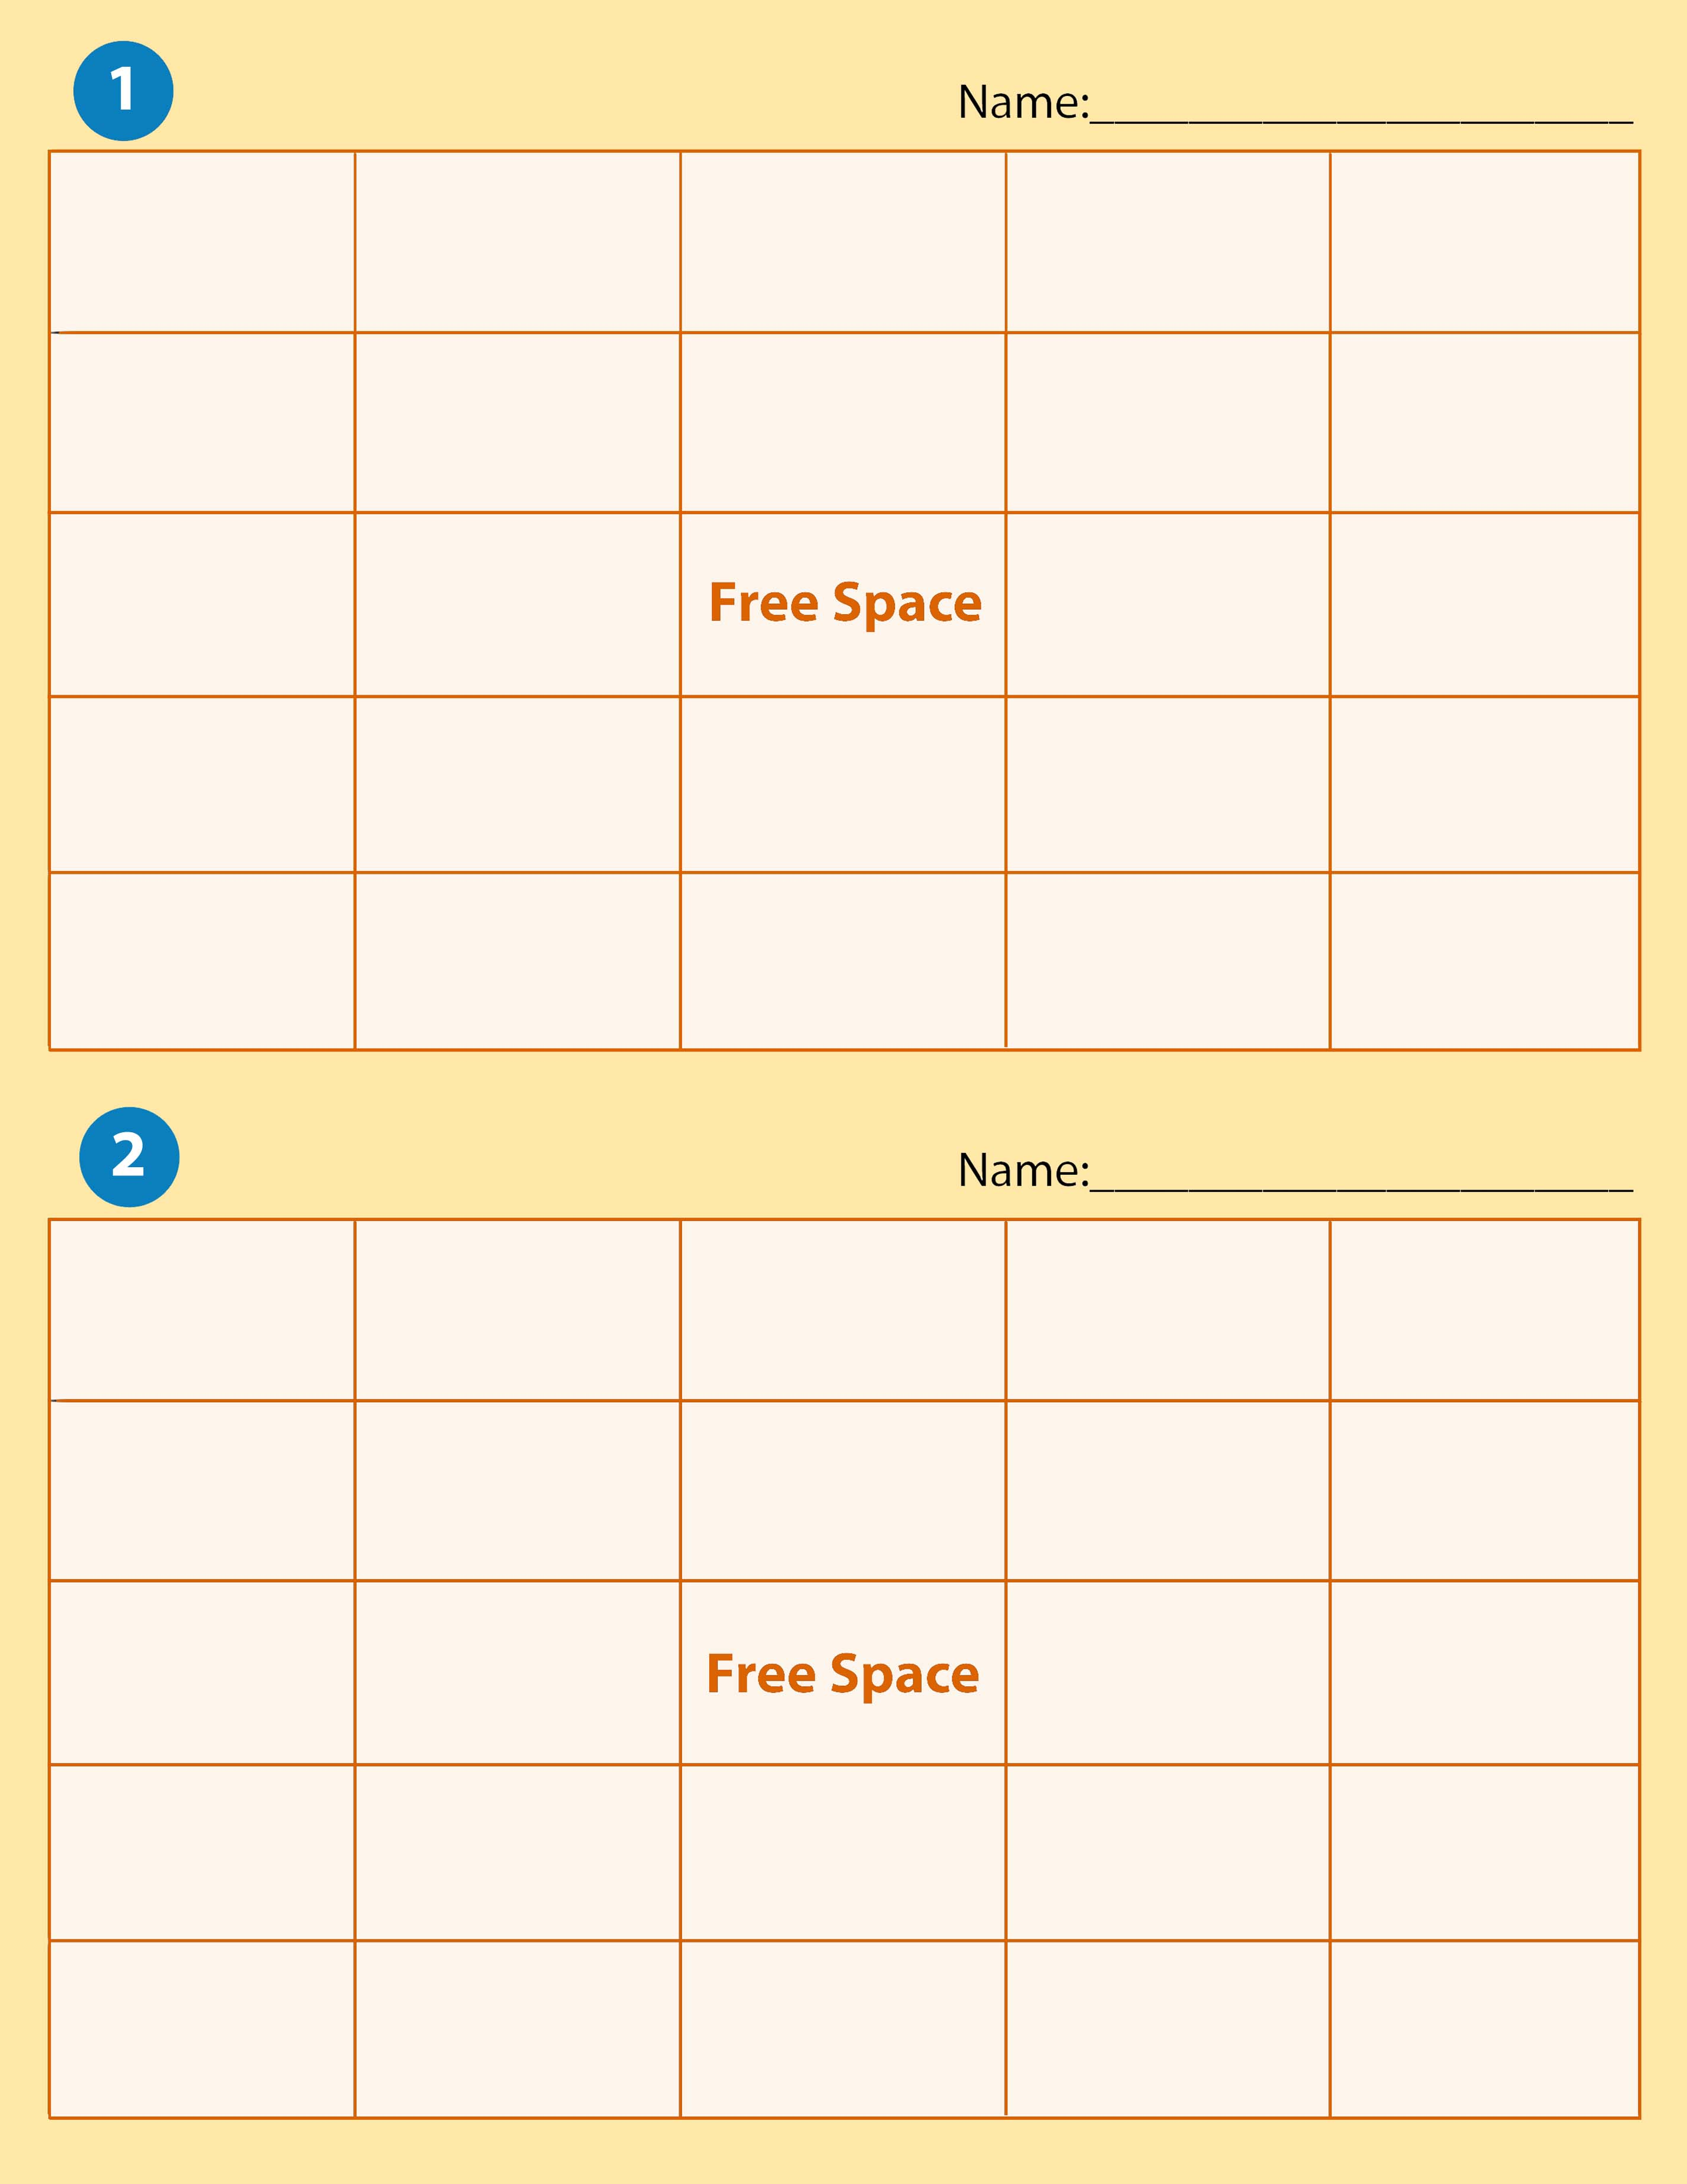

Internal Combustion Engine | Engine Torque | Chassis Dynamometer | Engine Dynamometer | Block
Cylinder | Horse Power | Valve | Fly Wheel | Connecting Rod
Crankshaft | V-Type Engine |  | Inclined Engine | Valve Train
Piston Rings | Two Stroke Cycle Engine | Cylinder Head | Combustion Chamber | Miller Cycle
Rotary Engine | Valve Ports | Push Rod | Cam Ground Piston | Four Stroke Cycle Engine

Rotary Engine | Valve Ports | Cylinder Head | Inclined Engine | Engine Dynamometer
Internal Combustion Engine | Two Stroke Cycle Engine | Chassis Dynamometer | Block | Engine Torque
Push Rods | Valve |  | Fly Wheel | Connecting Rod
Crankshaft | Four Stroke Cycle Engine | Cam Ground Piston | Miller Cycle | Combustion Chamber
Horse Power | V-Type Engine | Cylinder | Piston Rings | Valve Train

V-Type Engine | Cylinder | Miller Cycle | Valve Train | Combustion Chamber
Piston Rings | Horse Power | Two Stroke Cycle Engine | Crankshaft | Fly Wheel
Four Stroke Cycle Engine | Internal Combustion Engine |  | Inclined Engine | Block
Valve Ports | Engine Torque | Valve | Chassis Dynamometer | Cylinder Head
Rotary Engine | Engine Dynamometer | Cam Ground Piston | Push Rods | Connecting Rod
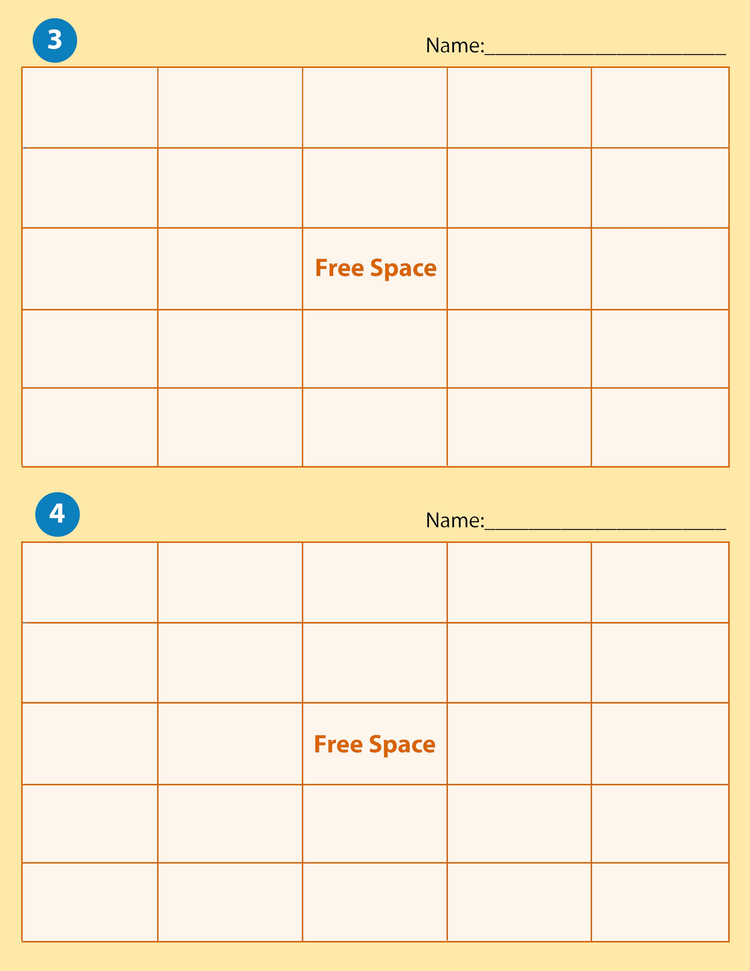

Cam Ground Piston | Push Rods | Cylinder Head | Chassis Dynamometer | Rotary Engine
Valve Ports | Engine Torque | Connecting Rods | Block | Engine Dynamometer
Horse Power | Valve Train |  | Crankshaft | Fly Wheel
Piston Rings | Internal Combustion Engine | Four Stroke Cycle Engine | Inclined Engine | V-Type Engine
Miller Cycle | Cylinder | Valve | Combustion Chamber | Two Stroke Cycle Engine

Push Rod | Valve Train | V-Type Engine | Inclined Engine | Connecting Rods
Four Stroke Cycle Engine | Engine Torque | Block | Fly Wheel | Valve Ports
Cylinder Head | Horse Power |  | Engine Dynamometer | Valve
Cam Ground Piston | Chassis Dynamometer | Rotary Engine | Piston Rings | Two Stroke Cycle Engine
Cylinder | Internal Combustion Engine | Combustion Chamber | Miller Cycle | Crankshaft
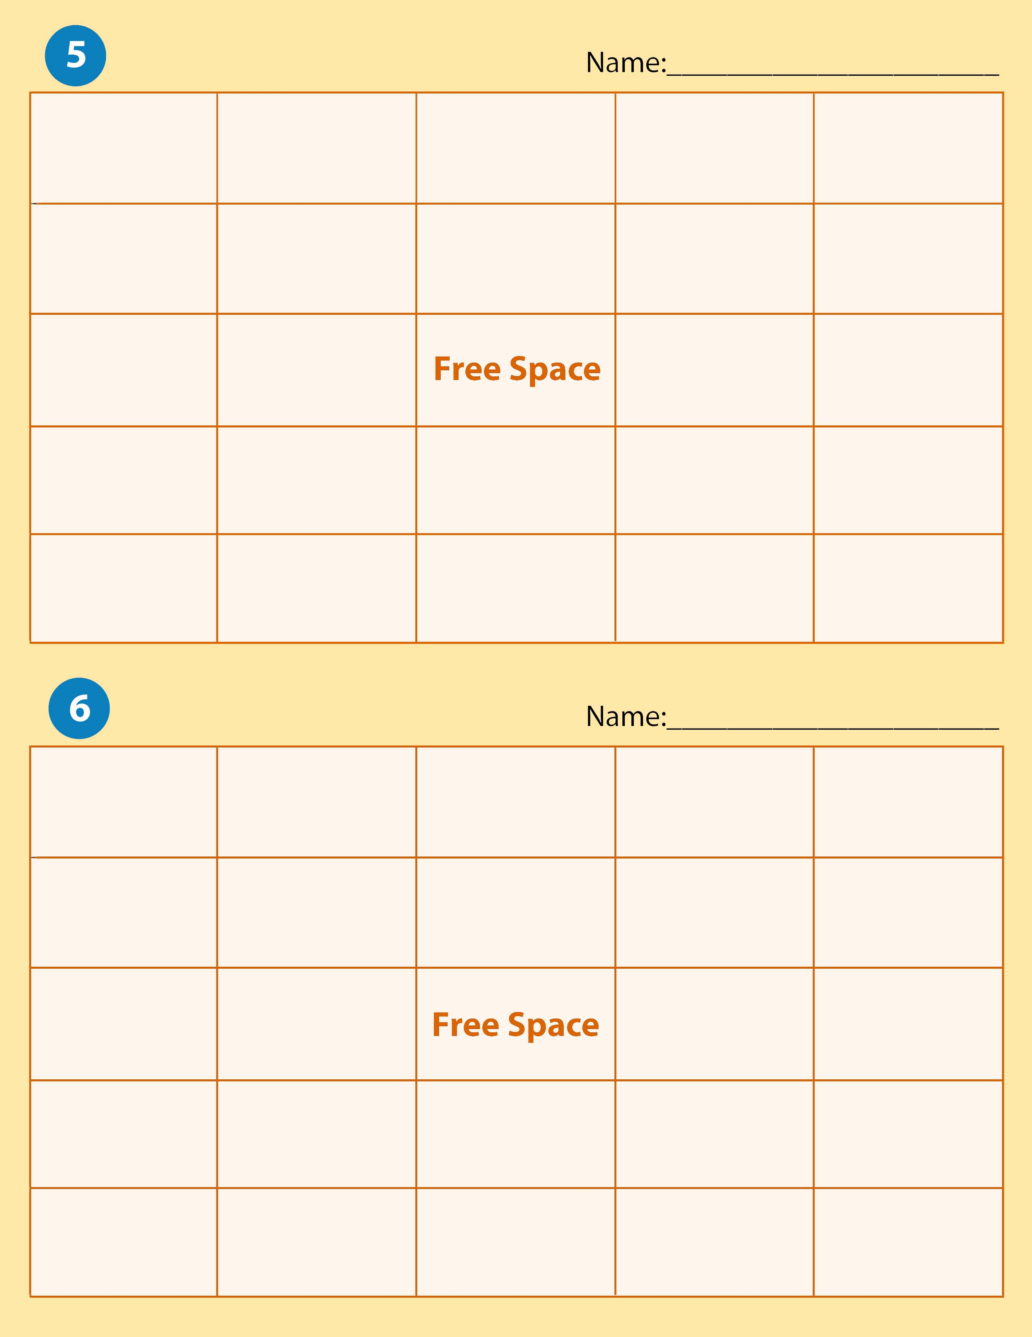

Push Rod | Fly Wheel | Crankshaft | Piston | Camshaft
Cam Ground Piston | Valve Ports | Engine Torque | Chassis Dynamometer | Engine Dynamometer
Horse Power | Rotary Engine |  | V-Type Engine | Inclined Engine
Miller Cycle | Valve Train | Cylinder Head | Valve | Block
Internal Combustion Engine | Combustion Chamber | Four Stroke Cycle Engine | Piston Rings | Two Stroke Cycle Engine

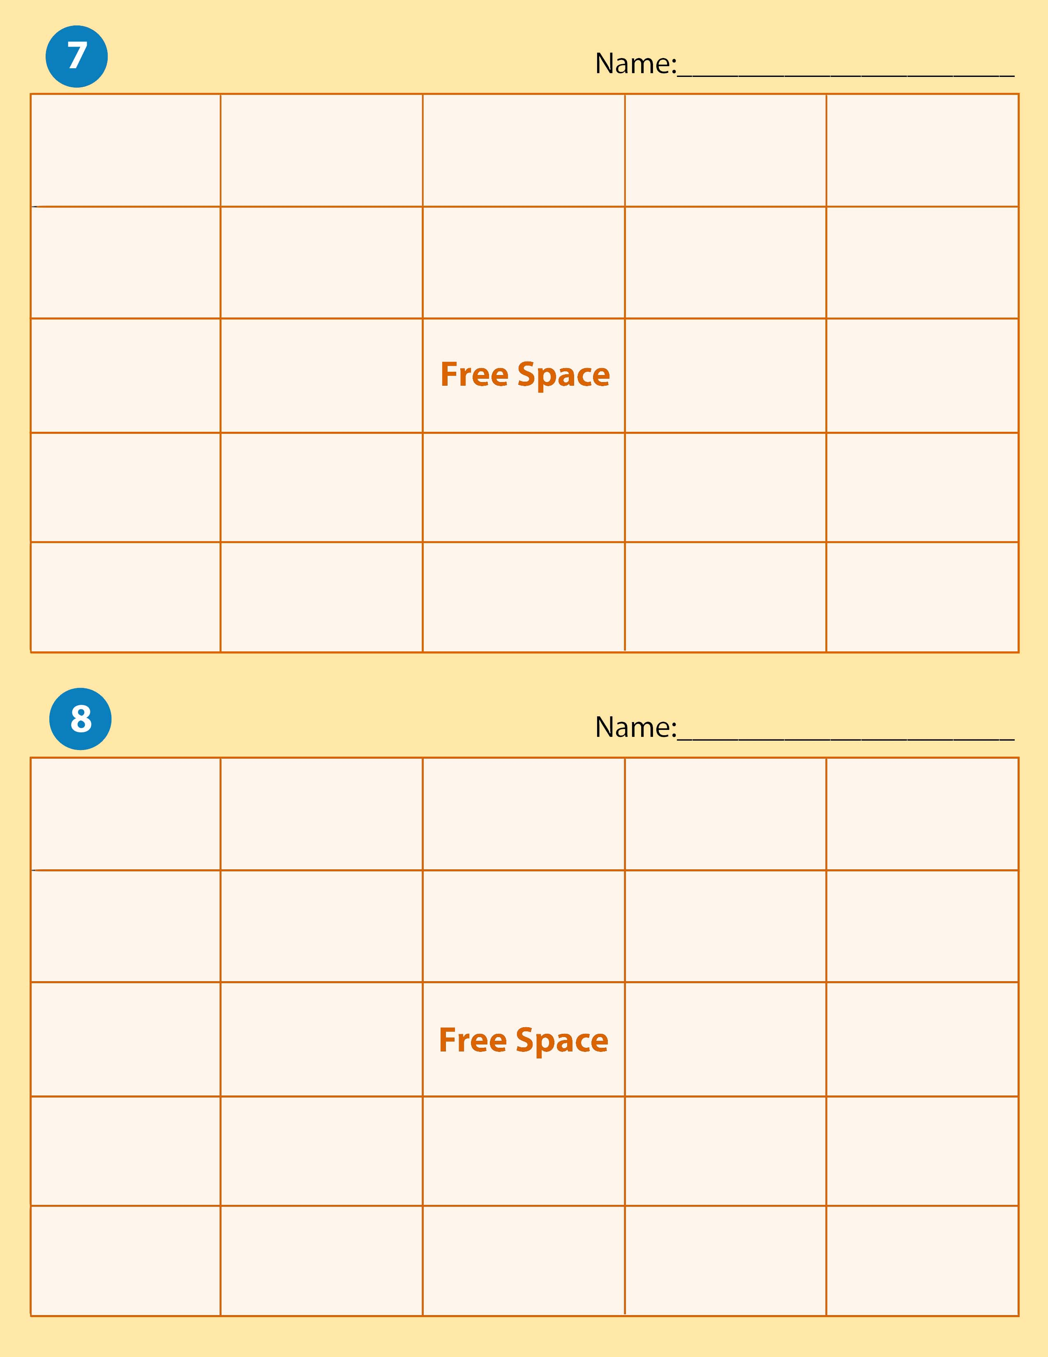

Cylinder Head | Internal Combustion Engine | Piston | Camshaft | Connecting Rods
Chassis Dynamometer | Crankshaft | Cylinder Head | Block | Piston Rings
Horse Power | Engine Dynamometer |  | Valve | Push Rods
Combustion Chamber | Valve Train | Engine Torque | Valve Ports | Cam Ground Piston
Miller Cycle | Rotor | Inline Engine | Cylinder | Fly Wheel

Block | Engine Torque | Miller Cycle | Cylinder | Four Stroke Cycle Engine
Two Stroke Cycle Engine | Piston | Rotor | Rotary Engine | Inline Engine
Camshaft | Crankshaft |  | Combustion Chamber | Cylinder Head
Chassis Dynamometer | Cam Ground Piston | Fly Wheel | Horse Power | Internal Combustion Chamber
Engine Dynamometer | Piston Rings | Connecting Rods | Push Rods | Incline Engine

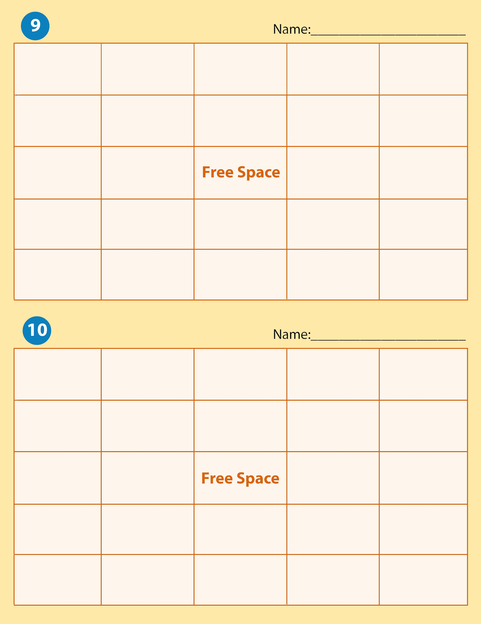

Chassis Dynamometer | Horse Power | Piston | Two Stroke Cycle Engine | Crankshaft
Piston Ring | Push Rod | Connecting Rod | Miller Cycle | Engine Dynamometer
Combustion Chamber | Cylinder Head |  | Four Stroke Cycle Engine | V-Type Engine
Valve Train | Valve Ports | Camshaft | Engine Torque | Rotary Engine
Inline Engine | Fly Wheel | Block | Internal Combustion Engine | Inclined Engine

Cylinder Head | Piston Rings | Push Rods | Combustion Chamber | Horse Power
Camshaft | Fly Wheel | Internal Combustion Engine | Inline Engine | Rotor
Rotary Engine | Connecting Rod |  | Piston | Valve
Valve Train | Cam Ground Piston | Block | Cylinder | Valve Ports
Chassis Dynamometer | Four Stroke Cycle Engine | Two Stroke Cycle Engine | Crankshaft | Engine Dynamometer

Four Stroke Cycle Engine | Push Rods | Horse Power | V-Type Engine | Connecting Rods
Push Rod | Fly Wheel | Piston | Rotor | Crankshaft
Camshaft | Internal Combustion Engine |  | Two Stroke Cycle Engine | Cylinder
Valve Ports | Valve | Cylinder Head | Cam Ground Piston | Block
Miller Cycle | Chassis Dynamometer | Engine Dynamometer | Inline Engine | Incline Engine
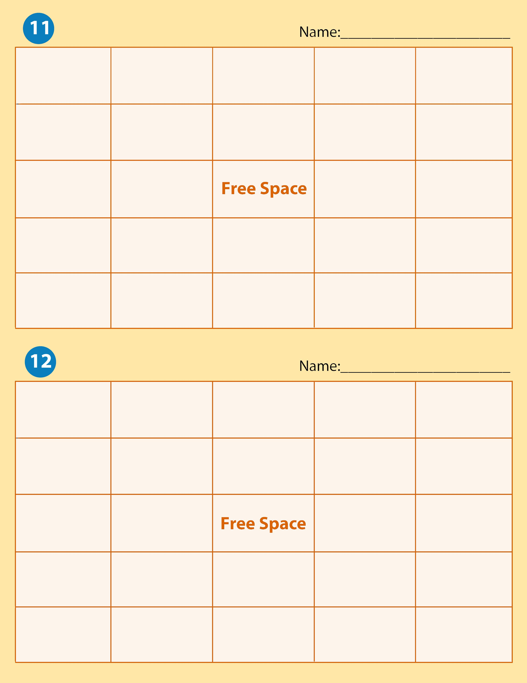

Inline Engine | Rotary Engine | Piston | Engine Dynamometer | Valve
Cylinder Head | Connecting Rod | Push Rod | Rotor | Incline Engine
Combustion Chamber | Fly Wheel |  | Crankshaft | Camshaft
Cam Ground Piston | Chassis Dynamometer | Miller Cycle | Valve Ports | Horse Power
Engine Torque | Block | Valve Train | Internal Combustion Engine | Piston Rings

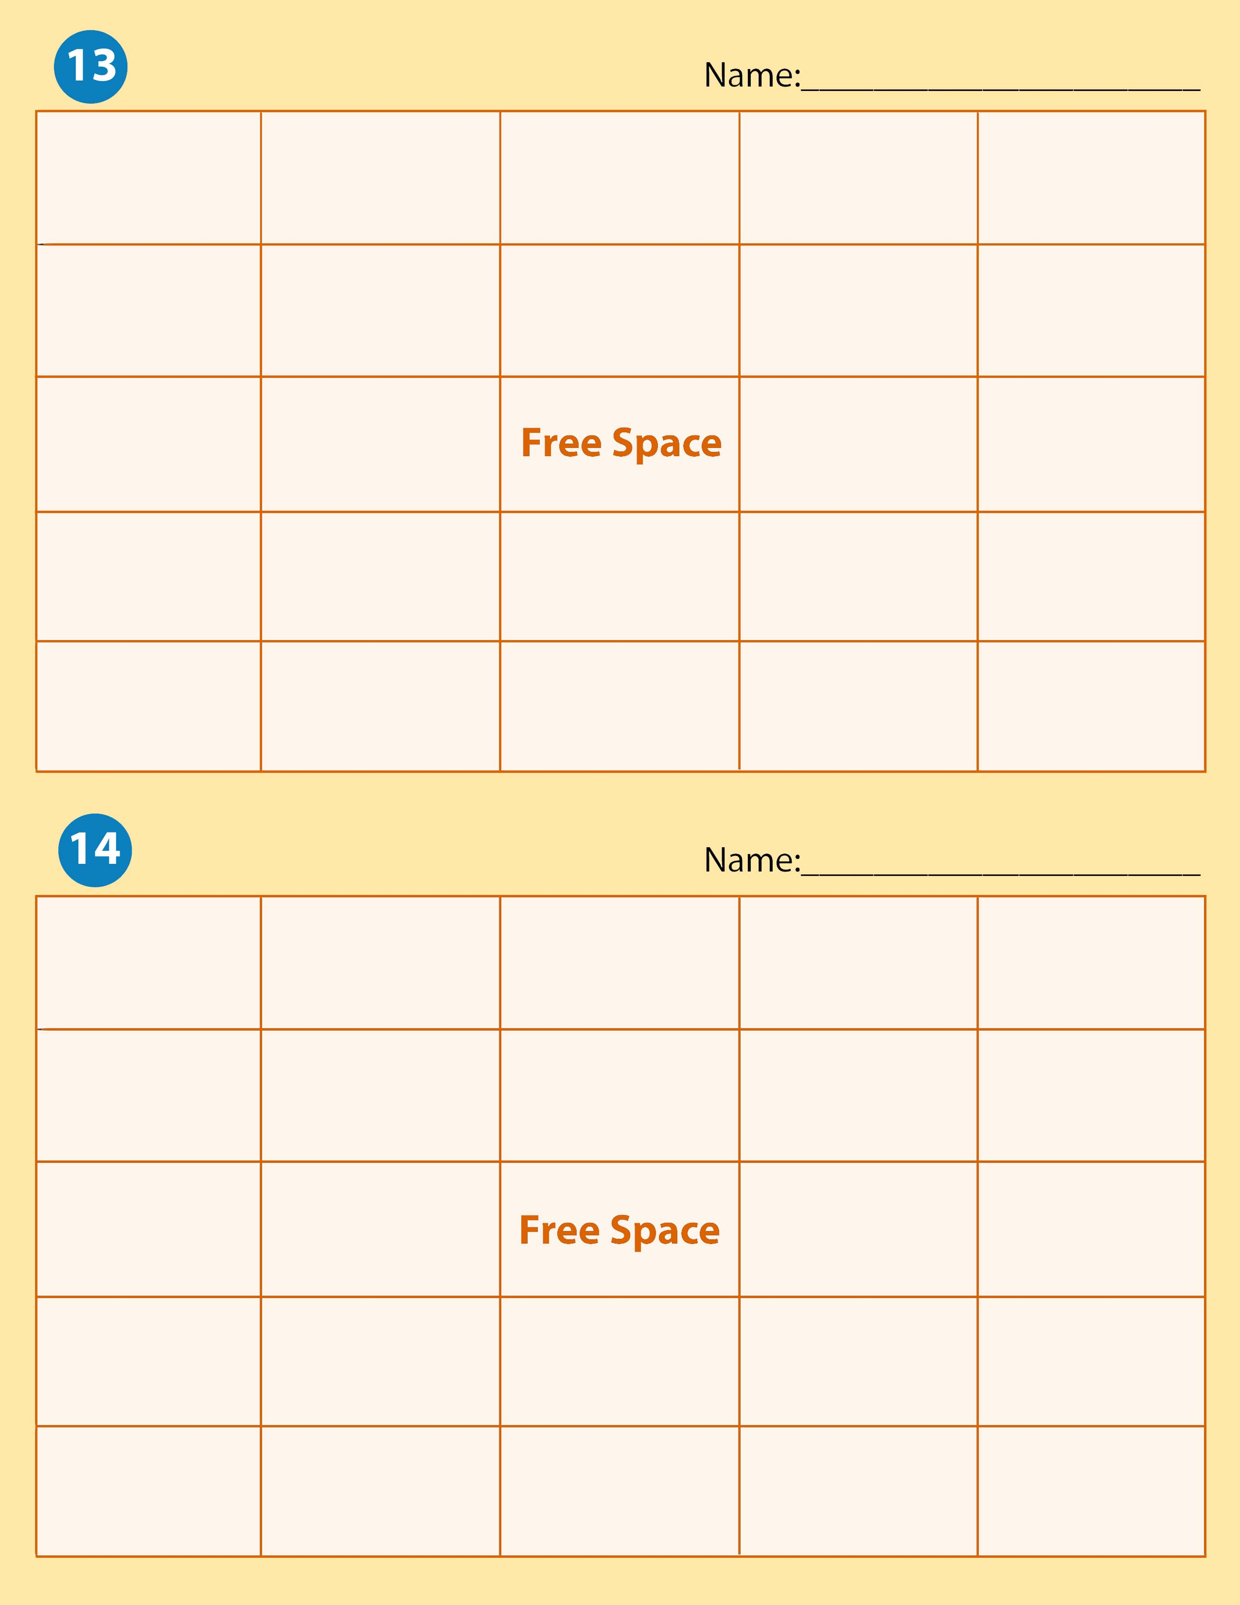

V-Type Engine | Piston Ring | Horse Power | Fly Wheel | Miller Cycle
Cylinder Head | Four Stroke Cycle Engine | Piston | Rotor | Push Rod
Engine Dynamometer | Crankshaft |  | Miller Cycle | Internal Combustion Engine
Chassis Dynamometer | Camshaft | Combustion Chamber | Engine Torque | Valve Ports
Two Stroke Cycle Engine | Block | Valve Train | Valve | Cylinder

Two Stroke Cycle Engine | V-Type Engine | Valve Train | Valve | Camshaft
Rotor | Miller Cycle | Four Stroke Cycle Engine | Engine Torque | Combustion Chamber
Cylinder | Piston |  | Crankshaft | Internal Combustion Chamber
Inline Engine | Rotary Engine | Connecting Rod | Push Rod | Chassis Dynamometer
Horse Power | Engine Torque | Inclined Engine | Piston Ring | Fly Wheel

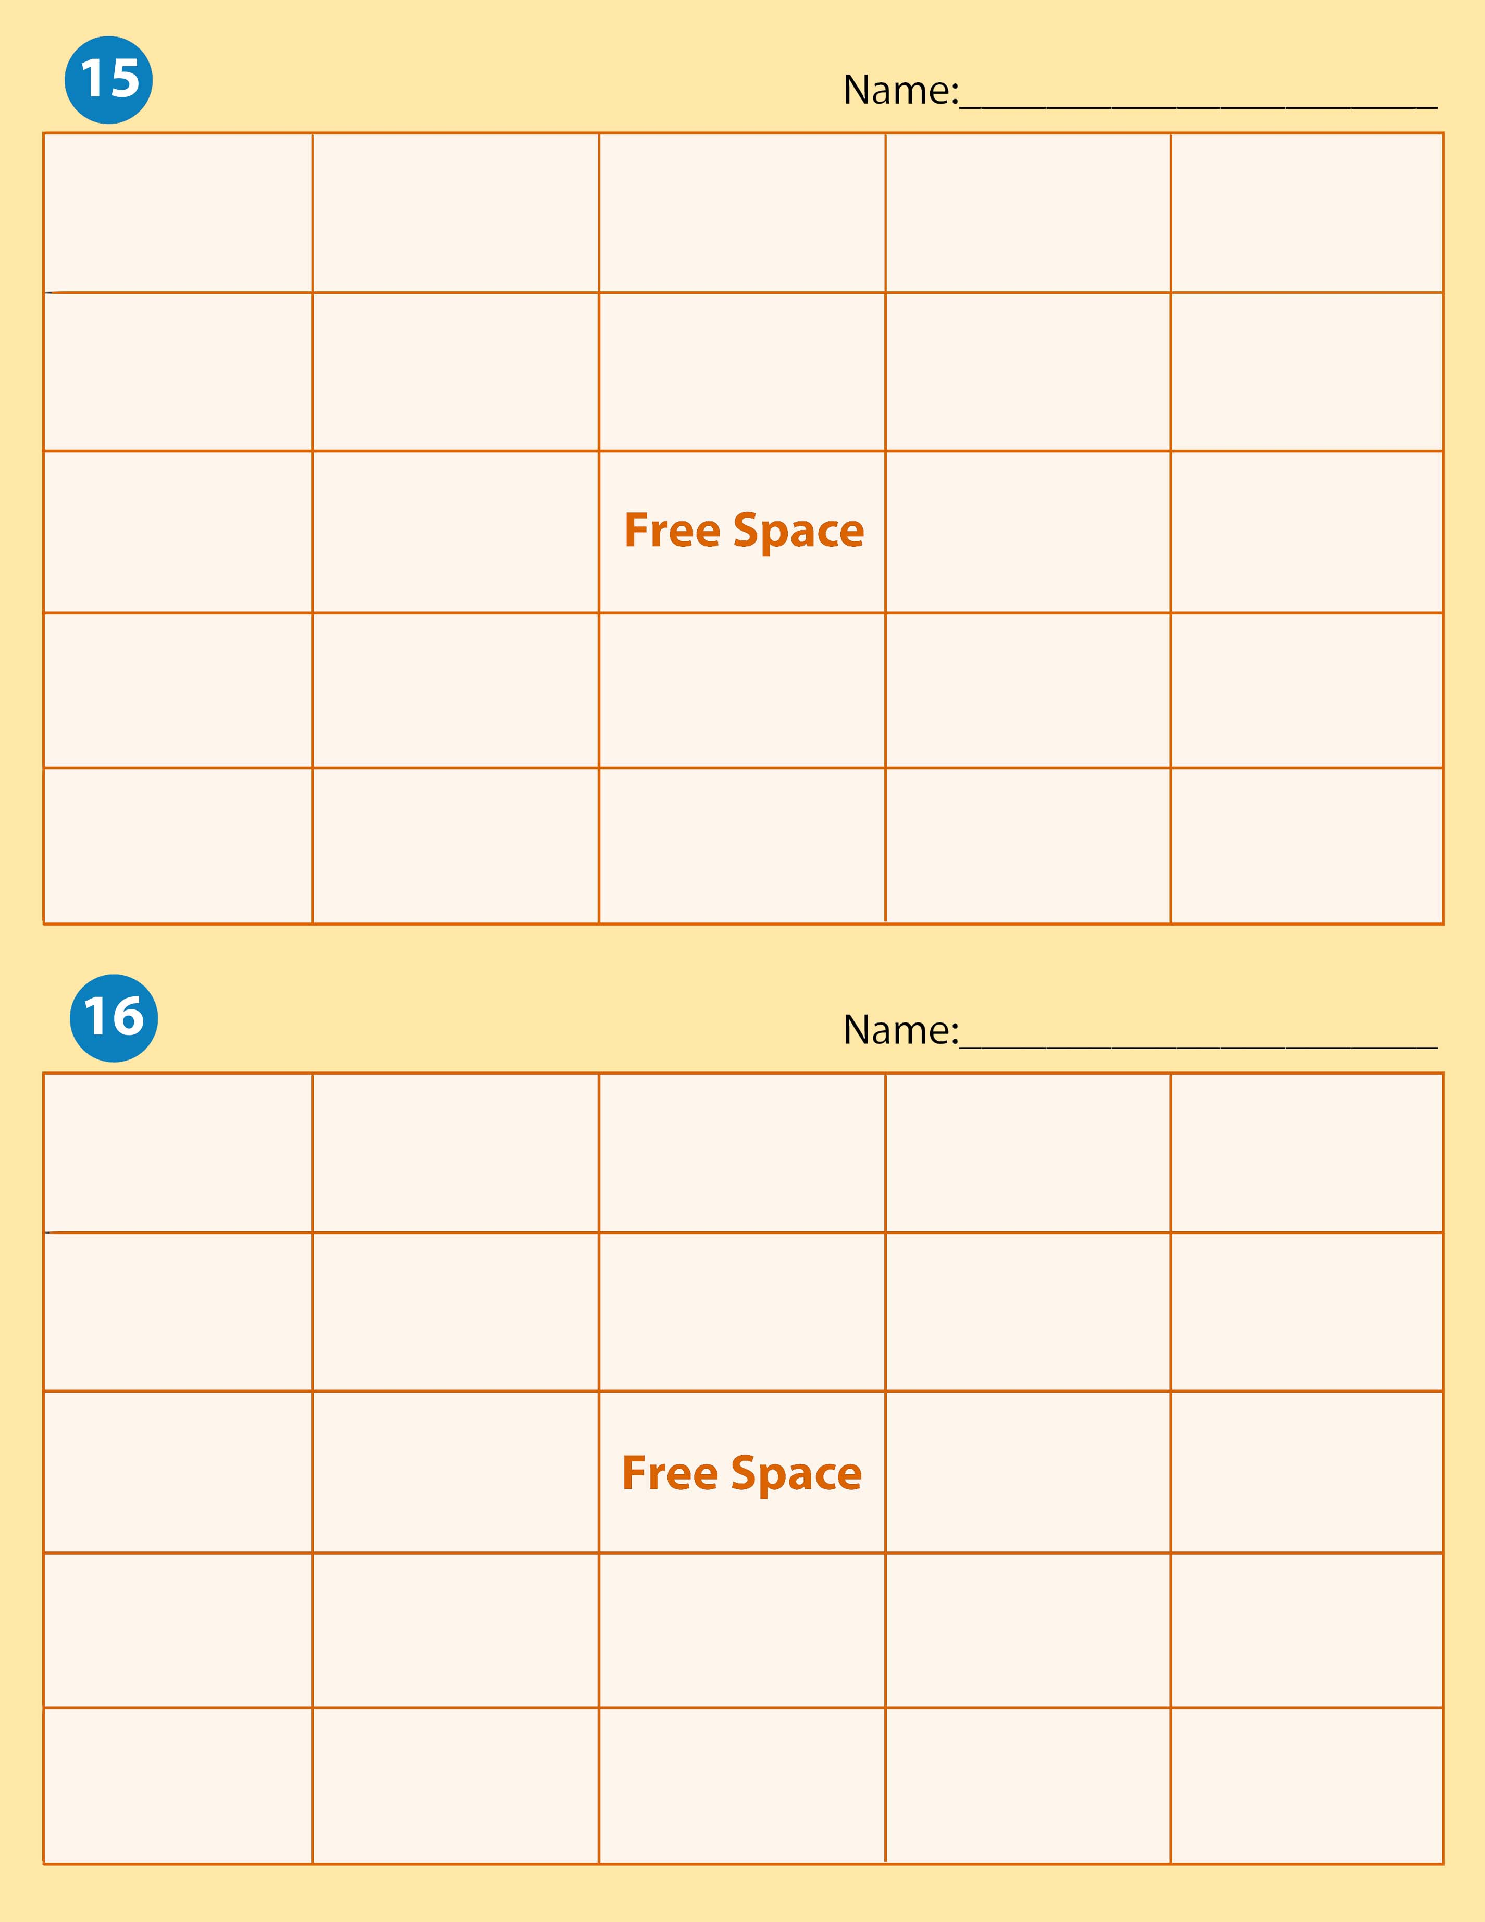
Engine Torque | Internal Combustion Engine | Cylinder | Piston | Rotary Engine
Inline Engine | Engine Dynamometer | Piston Ring | Push Rod | Crankshaft
Horse Power | Chassis Dynamometer |  | Cam Ground Piston | Cylinder Head
Valve | Four Stroke Cycle Engine | Valve Ports | Fly Wheel | Combustion Chamber
Connecting Rod | Miller Cycle | Inclined Engine | Two Stroke Cycle Engine | Rotor

Rotor | Fly Wheel | Four Stroke Cycle Engine | Rotary Engine | Engine Torque
Cylinder | Piston | Crankshaft | Connecting Rod | Combustion Chamber
Cylinder Head | Valve |  | Camshaft | Piston Rings
Four Stroke Cycle Engine | Valve Train | Inclined Engine | V-Type Engine | Inline Engine
Miller Cycle | Horse Power | Chassis Dynamometer | Engine Torque | Push Rod

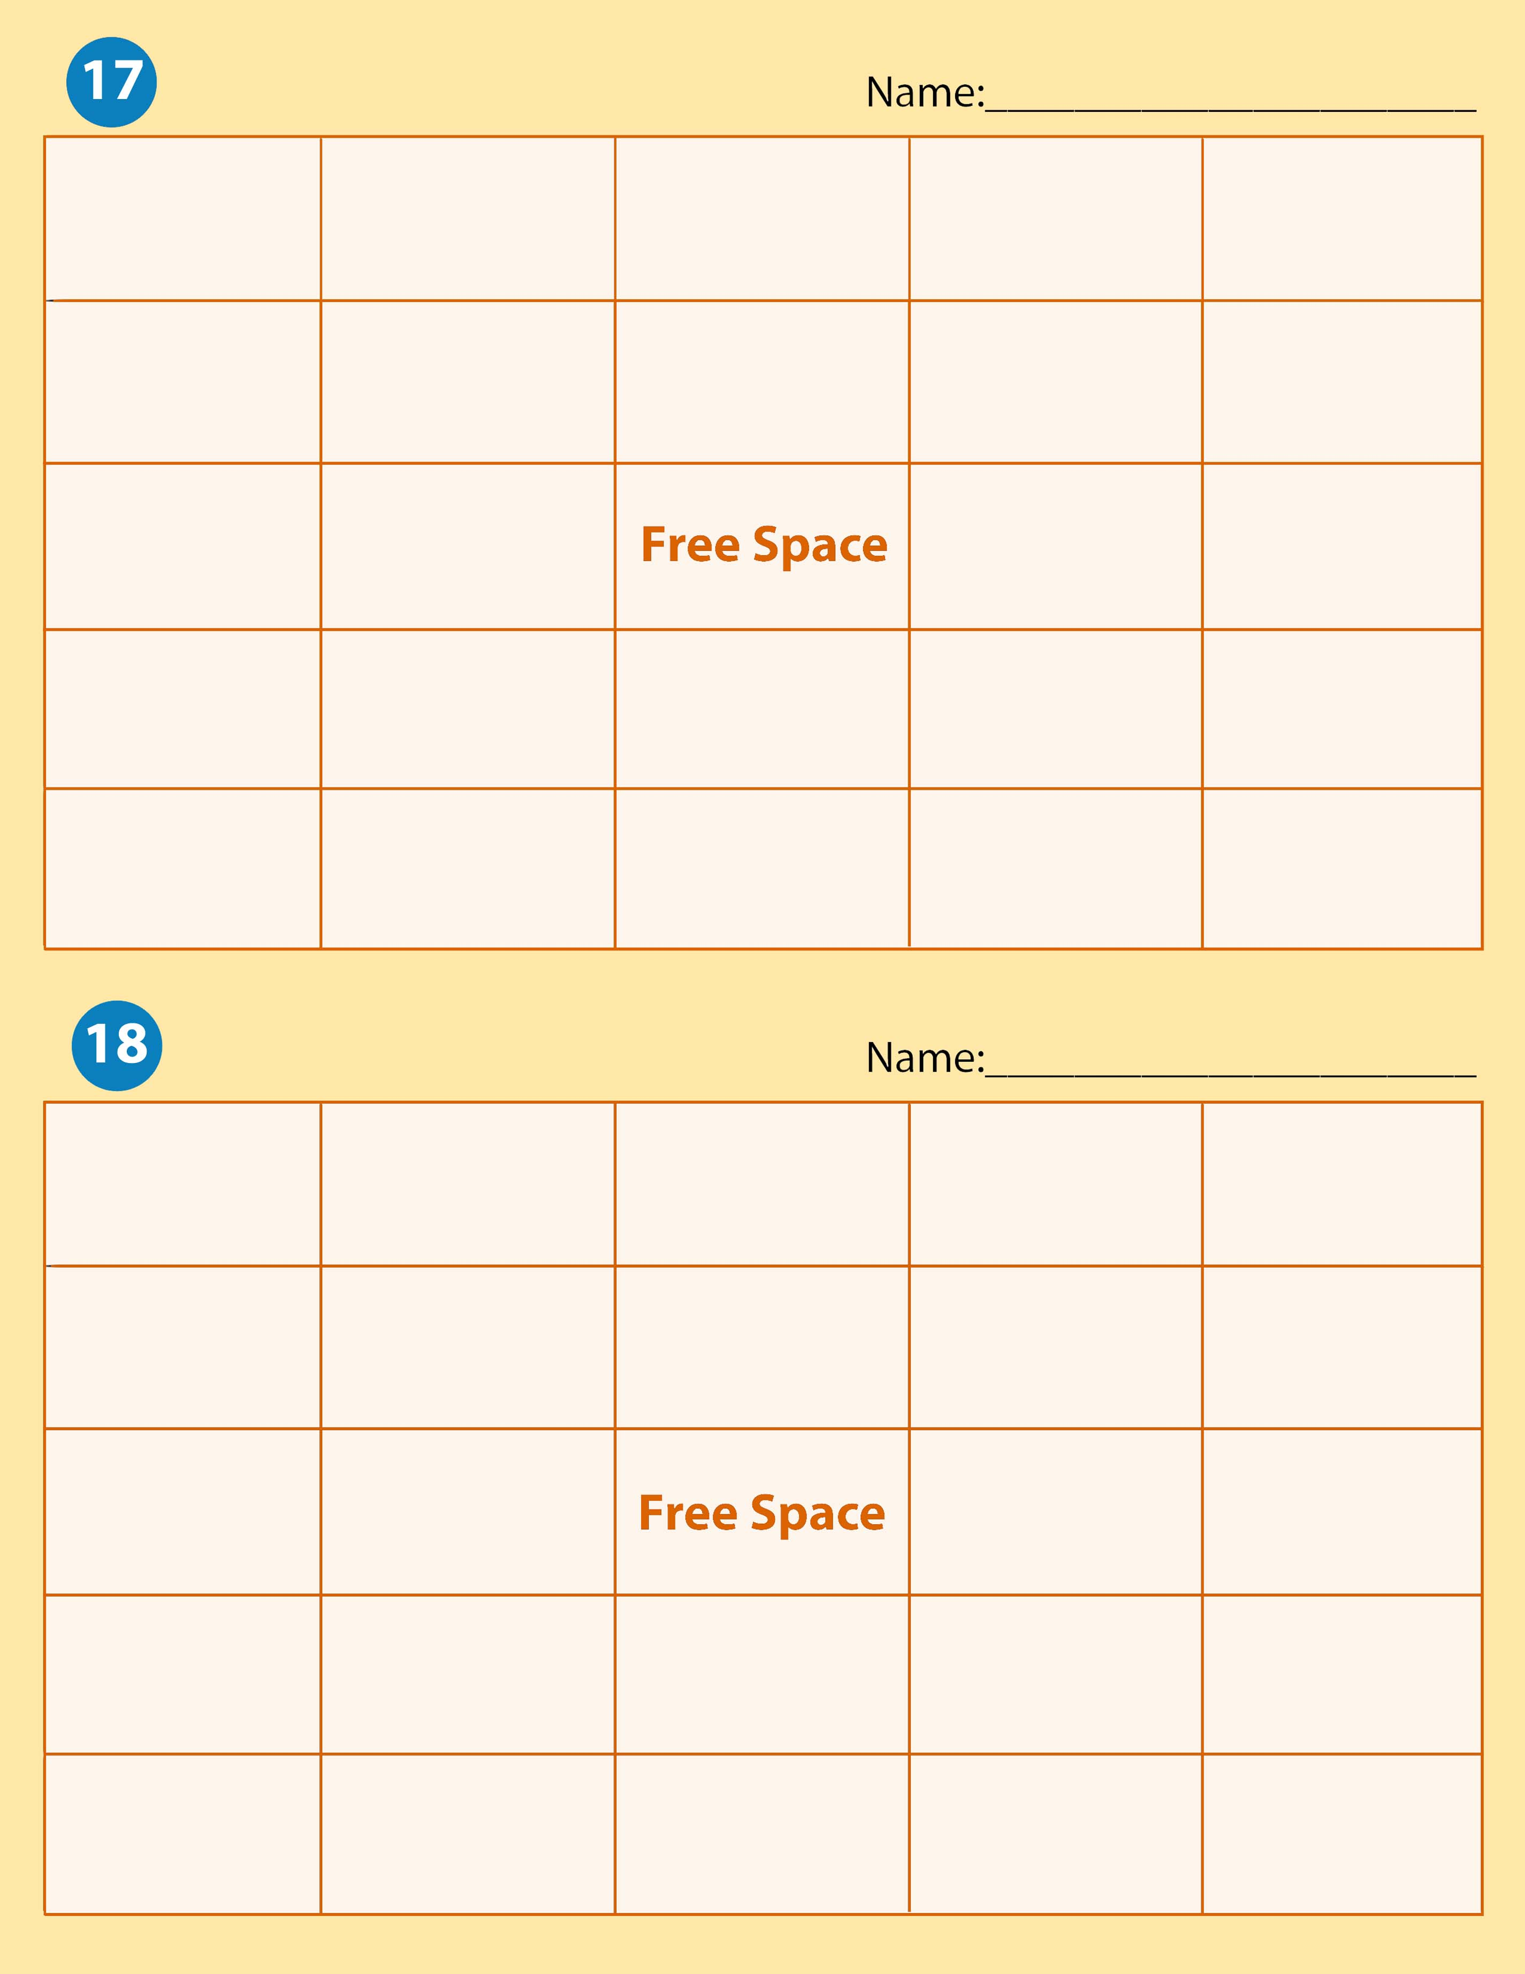

Push Rod | Cam Ground Piston | Engine Torque | Chassis Dynamometer | Engine  Dynamometer
Horse Power | Miller Cycle | Inline Engine | Rotor | Rotary Engine
V-Type Engine | Inclined Engine |  | Valve Train | Two Stroke Cycle Engine
Piston Ring | Camshaft | Valve | Cylinder Head | Combustion Chamber
Fly Wheel | Connecting Rod | Crankshaft | Piston | Clylinder

Four Stroke Cycle Engine | Internal Combustion Engine | Push Rod | Valve Train | Rotor
Chassis Dynamometer | Fly Wheel | Combustion Chamber | Two Stroke Cycle Engine | Engine Torque
Piston | Rotary Engine |  | Valve | Valve Ports
Miller Cycle | Engine Dynamometer | Cylinder Head | Piston Ring | Camshaft
Connecting Rod | Horse Power | Inline Engine | V-Type Engine | Inclined Engine

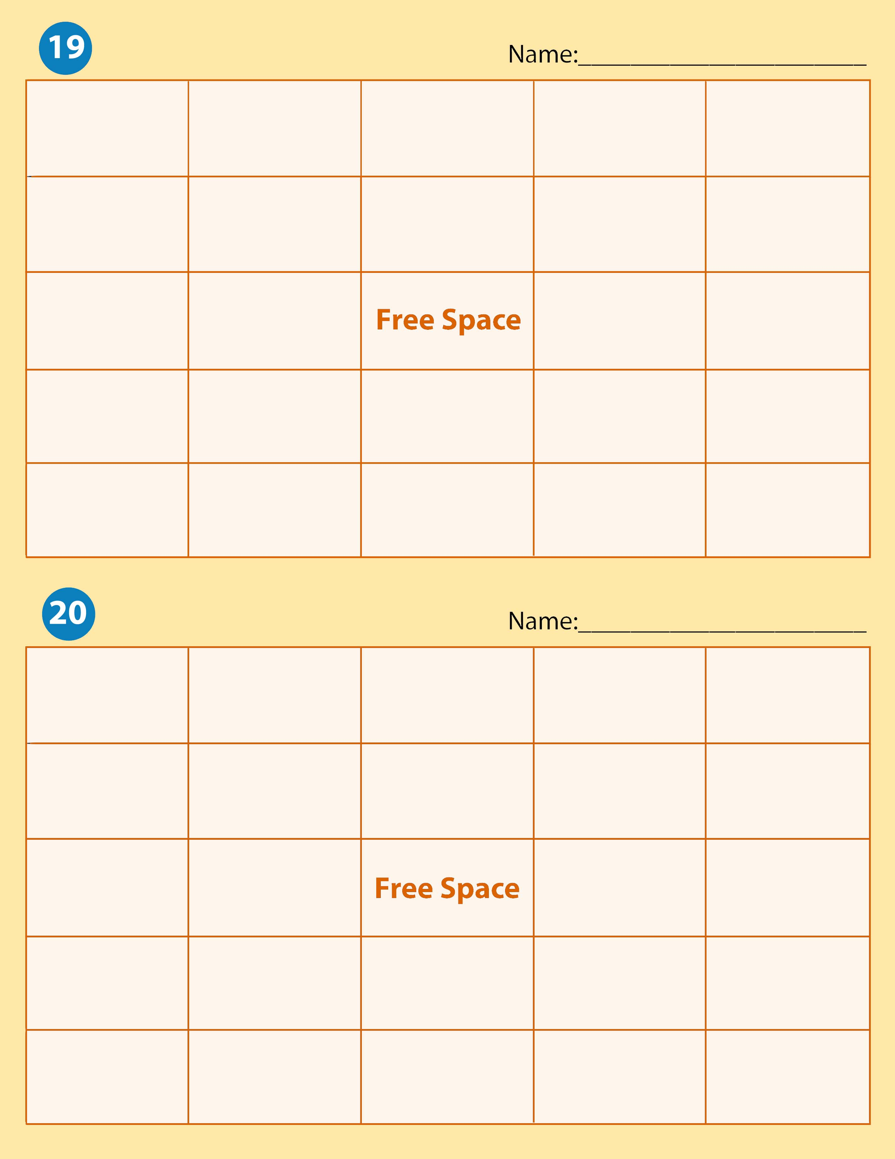
Rotary Engine | Push Rod | Cam Ground Piston | Inline Engine | Rotor
Piston | Block | Horse Power | Miller Cycle | Engine Dynamometer
Fly Wheel | Combustion Chamber |  | Internal Combustion Chamber | Valve
Cylinder Head | Crankshaft | Piston | Piston Ring | Connecting Rod
V-Type Engine | Chassis Dynamometer | Valve Train | Camshaft | Inclined Engine

V-Type Engine | Inclined Engine |  | Valve Train | Fly Wheel | Piston Ring
Cylinder Head |  | Combustion Chamber | Internal Combustion Engine | Push Rod | Valve Ports
Crankshaft |  | Chassis Dynamometer |  | Horse Power | Rotor
Block |  | Cylinder | Rotary Engine | Piston | Cam Ground Piston
Two Stroke Cycle Engine |  | Engine Torque | Miller Cycle | Inline Engine | Valve

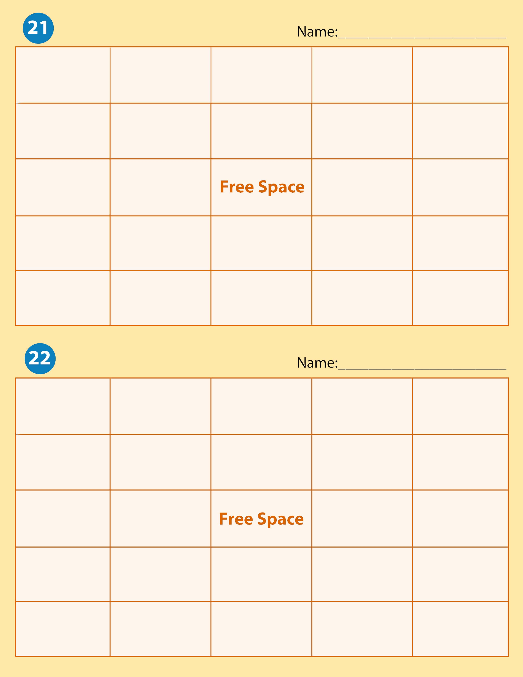

Camshaft | Connecting Rod | Piston Ring | Engine Torque | Cylinder
Push Rod | Inline Engine | Chassis Dynamometer | Piston | V-Type Engine
Rotor | Valve |  | Valve Ports | Cylinder Head
Rotary Engine | Engine Dynamometer | Horse Power | Four Stroke Cycle Engine | Crankshaft
Miller Cycle | Internal Combustion Engine | Inclined Engine | Combustion Chamber | Block

Miller Cycle | Fly Wheel | Piston | Four Stroke Cycle Engine | Rotary Engine
Connecting Rod | Cylinder | Rotor | V-Type Engine | Horse Power
Crankshaft | Two Stroke Cycle Engine |  | Inclined Engine | Engine Torque
Cam Ground Piston | Valve Train | Cylinder Head | Valve Ports | Internal Combustion Engine
Combustion Chamber | Valve | Piston Ring | Push Rod | Camshaft

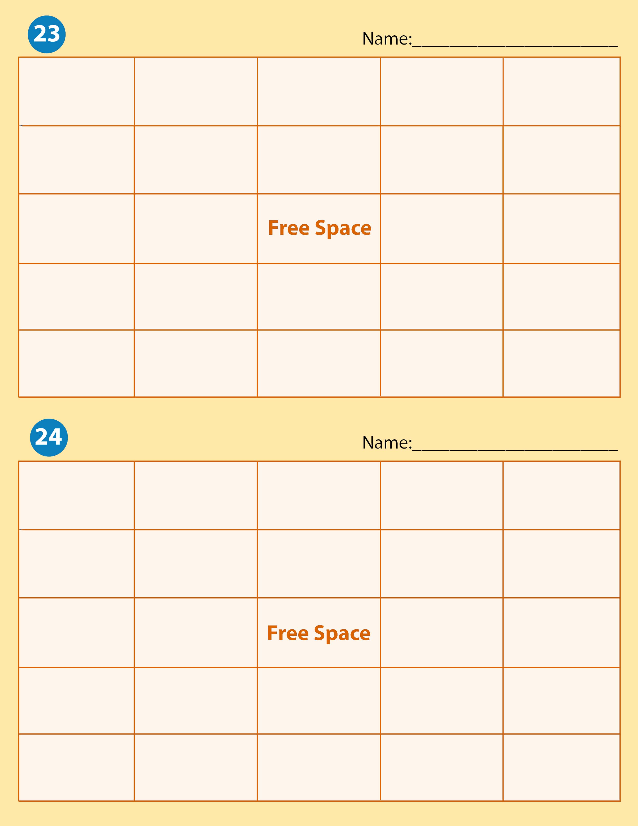

Piston Ring | Miller Cycle | Engine Dynamometer | Combustion Chamber | Cylinder
Cylinder Head | Internal Combustion Chamber | Block | Piston | Rotary Engine
Horse Power | Push Rod |  | Connecting Rod | Crankshaft
Cam Ground Piston | Piston Ring | Four Stoke Cycle Engine | Two Stroke Cycle Engine | Engine Torque
Fly Wheel | Inclined Engine | V-Type Engine | Chassis Dynamometer | Rotor

Valve Ports | V-Type Engine | Miller Cycle | Piston Ring | Valve Train
Miller Cycle | Crankshaft | Piston | Rotor | Engine Dynamometer
Inclined Engine | Connecting Rod |  | Push Rod | Cylinder Head
Engine Torque | Fly Wheel | Chassis Dynamometer | Cam Ground Piston | Rotary Engine
Inline Engine | Cylinder | Valve Ports | Horse Power | Internal Combustion Engine

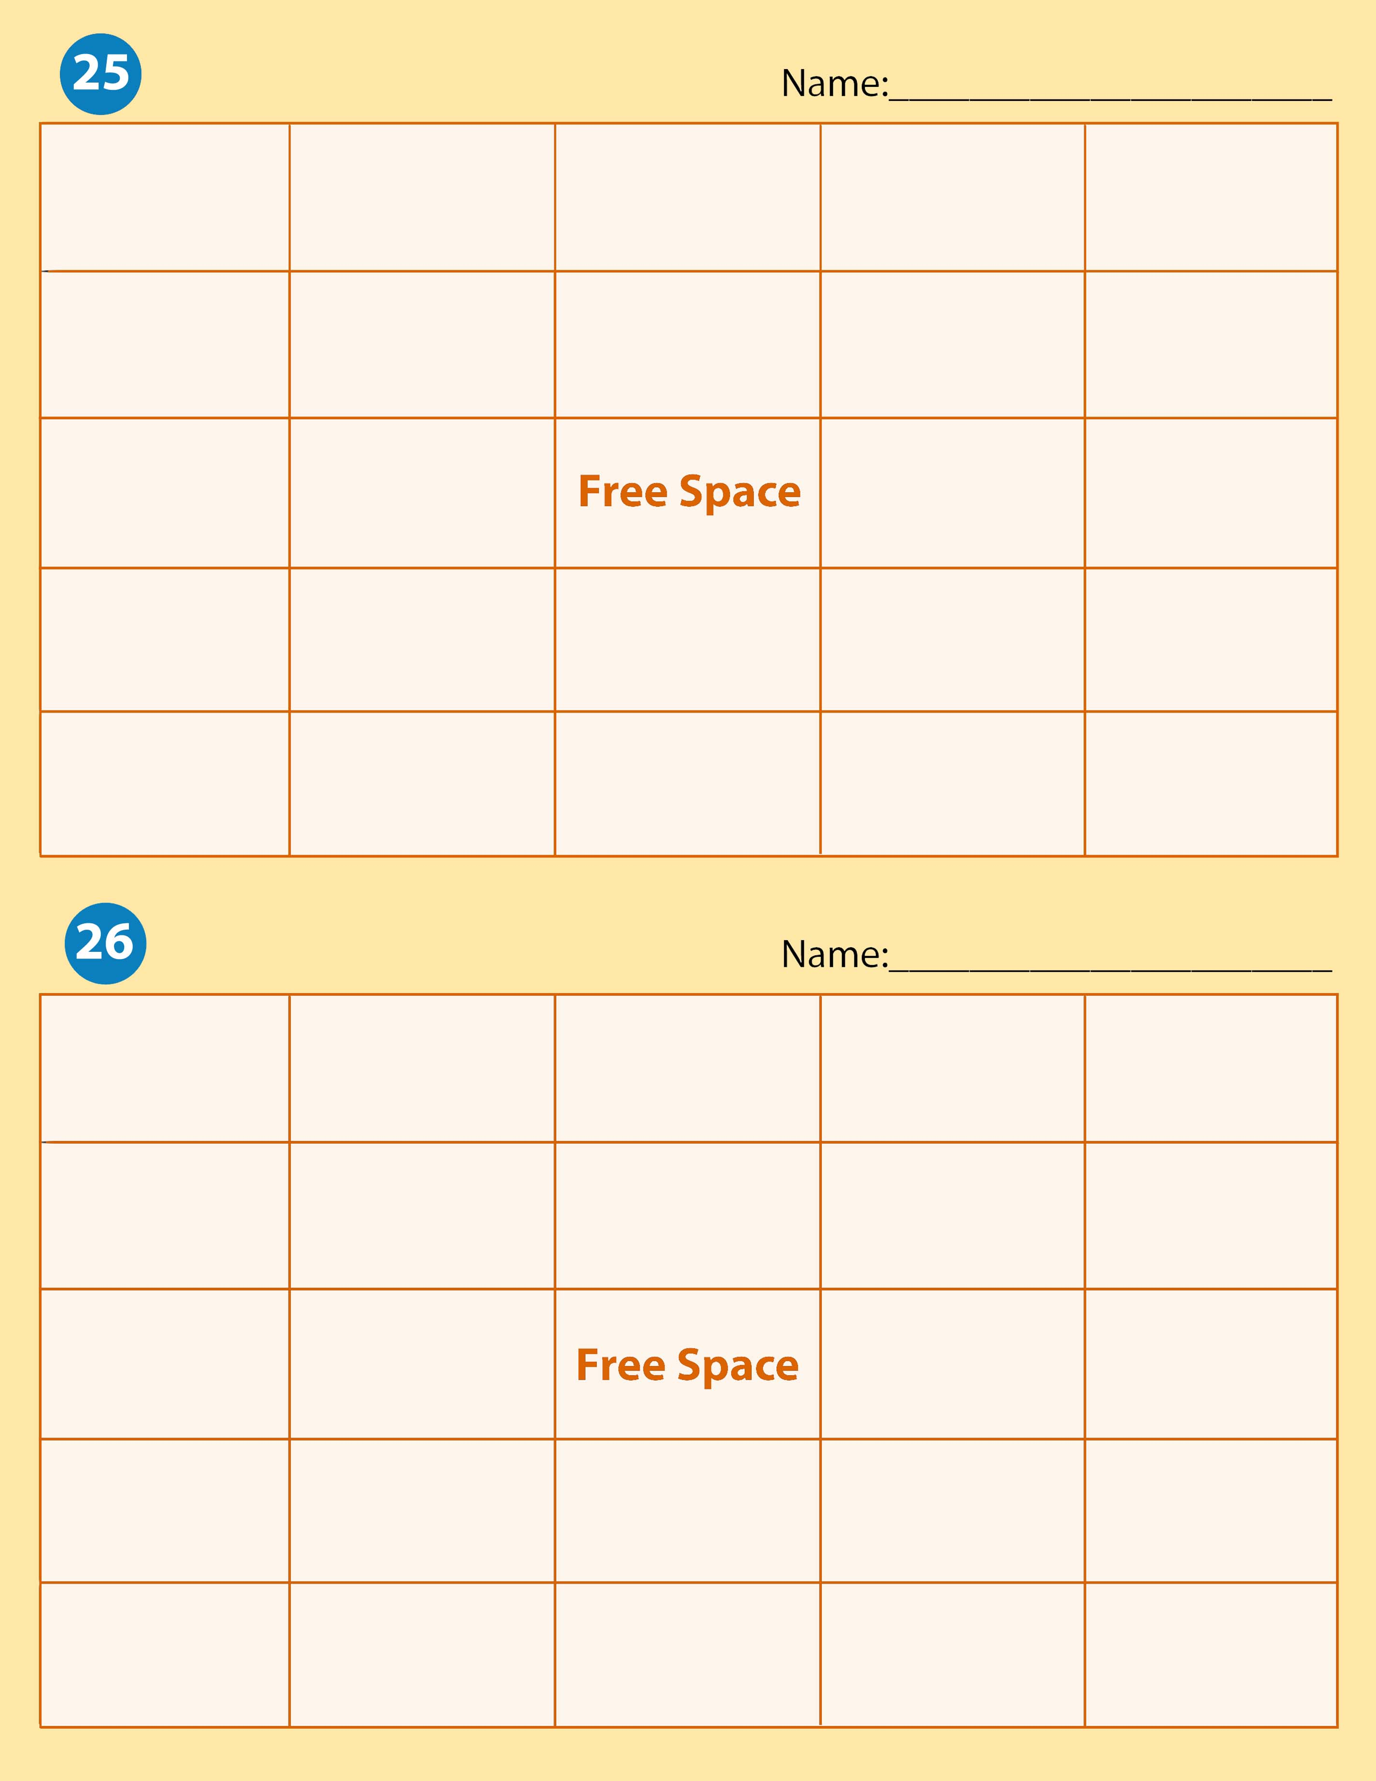
Rotary Engine | Chassis Dynamometer | Piston Ring | Rotor | Horse Power
Combustion Chamber | Inline Engine | V-Type Engine | Fly Wheel | Cylinder
Piston | Cylinder Head |  | Valve | Valve Ports
Connecting Rod | Camshaft | Inclined Edninge | Engine Dynamometer | Push Rod
Cam Ground Piston | Internal Combustion Chamber | Crankshaft | Engine Torque | Miller Cycle

Cam Ground Piston | Engine Dynamometer | Valve Train | Cylinder Head | Connecting Rod
Piston | Internal Combustion Engine | Cylinder | Miller Cycle | Engine Torque
Horse Power | Inline Engine |  | Piston Ring | Valve
Market Researcher | Call Center Agent | Technical Support Specialist | Leasing  Specialist | Retailer

