A Curious History
The pineapple (scientific name Ananas comosus) originated centuries ago in South America, probably near present-day Brazil and Paraguay, and indigenous peoples had spread the fruit throughout Central America long before European explorers arrived.
  Christopher Columbus and native Americans.  Image from the Florida Memory Project. | A fateful interaction with Christopher Columbus propelled the pineapple into the European (and eventually the American) consciousness. Columbus and his crew “discovered” the pineapple in Guadeloupe in 1493 on their second (less famous) voyage to the New World. They called it the piña, due to its resemblance to a pinecone, and brought the “exotic” fruit back to Spain.  Later explorers were equally enchanted. Sir Walter Ralegh, for example, wrote of “the great abundance of Pinas, the princesse of fruits that grow vnder the Sun” in his 1595 travelogue Discoverie of the Large, Rich, and Bewtiful Empyre of Guiana.  It took some time for Europeans to learn to grow the prized pineapple, which thrives in tropical climates, but by the mid-1600s it was being produced in “hot-houses” in Holland and England. Soon thereafter, the pineapple was introduced to Africa, Asia, and other parts of the world.

Symbol of Hospitality
American colonists began importing the pineapple from the Caribbean in the 17th century. Due to its seemingly exotic qualities and rareness, the pineapple soon became a symbol of hospitality in early America. Because trade routes between America and Caribbean islands were often slow and perilous, it was considered a significant achievement for a host to procure a ripe pineapple for guests. Similarly, some accounts tell of New England sea captains who, upon returning from trade routes in the Caribbean or Pacific, would place a pineapple outside their homes as a symbol of a safe return.  Due to its association with warmth and friendliness, pineapples in America were often used as the “crowning” piece in large displays of food. Similarly, the pineapple symbol was used frequently in the 18th and 19th centuries to decorate bed posts, tablecloths, napkins—anything associated with welcoming guests. Today, the pineapple remains a fitting symbol for the hospitality industry, and pineapple-themed products still abound. From lamps to candle holders to salt and pepper shakers and beyond, the pineapple motif says “Welcome!” | 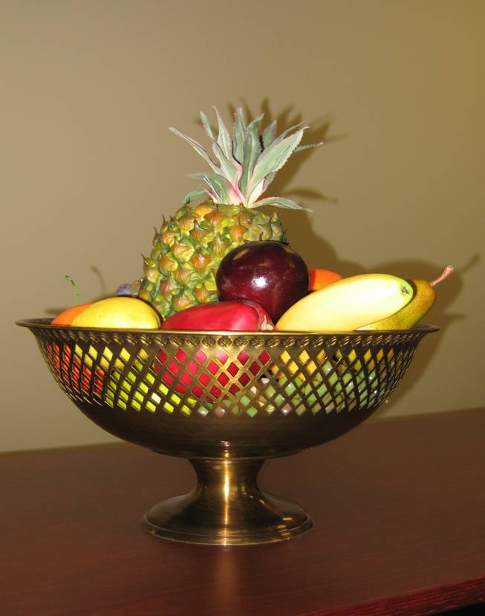  Pineapple centerpiece from the exhibit

The Pineapple Business in America
In America, commercial production of pineapples began in earnest in Florida in the late 19th century. In fact, for a short time, Florida was among the world's most prolific producer's of pineapple. However, by the 1930s, pineapple production in Florida began to fall off, largely due to changes in climate and increased competition from central America and Hawaii.
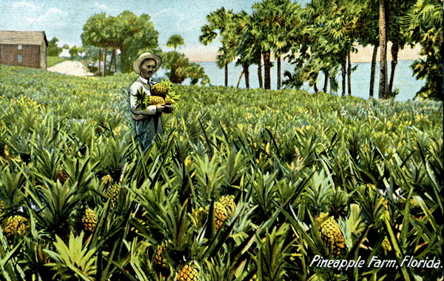  Florida pineapple farm.  Image from the Florida Memory Project. | According to some sources, pineapples were introduced to Hawaii as early as the 16th century. But pineapples weren't canned in Hawaii until about 1885, and the American territory did not become world famous for its pineapples until Jim Dole founded his highly successful Hawaiian Pineapple Company in 1901. Remarkably, by the 1920s, the pineapple was Hawaii's largest industry, and, until recently, Hawaii was the world's largest producer of canned pineapples.  Gradually, much of the world's pineapple production has shifted to central America and Asia, where the fruit can be produced more cheaply.
Although pineapples are no longer a uniquely American product, the symbol of hospitality still looms large in both Florida and Hawaii, for the most important industry in both states today is... the hospitality and tourism business!

