Show Me the Money
You are new in the payroll department and the computers have gone down. The following employees had mistakes on their payroll checks and need your assistance solving their problems. You are the fourth person they have been referred to, so they are really upset about the situation.

EMPLOYEE | SITUATION | SOLUTION
Raymond makes $20.19 per hour. His gross pay was $646.08. His total taxes to be taken out should be 17%
- What dollar amount of taxes should be taken out of his pay?
- What is his net pay?

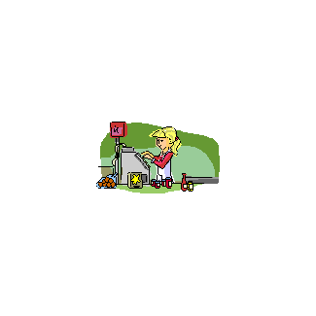   | Marie makes $10.26 per hour. She worked 47 hours last pay period. Her gross pay was $482.22.  - What’s wrong with her check?  - What can be done to help her?
Jody makes $3.35 per hour and did not make any tips this pay period. The gross amount of her pay check totaled $120.60 for 36 hours of work.
- What’s wrong with her check?
- What can be done to help her?

Show Me the Money
Answer Key

- Raymond’s taxes to be taken out should be:
  - $646.08 X .17 = $110.17
  - His net pay should be: $646.08 - $110.17 = $535.91

- Marie worked 7 hours of overtime and should be paid time and a half. The company only paid her the regular hourly rate for the 47 hours of work. Her check should have been calculated as the following:
$10.26 X 40 hours = $410.40
$10.26 + $5.13 = 15.39 X 7 hours = $ 107.73
$518.13
The department can:
- Cut another check in the amount of $35.91
- Reissue a check for the full amount of $518.13

- Jody is a tipped employee and her tips must equal to the minimum wage law of $7.25. Since her tips did not provide a salary equal to $7.25/hour, the employer must make up the difference. Therefore, her check should gross:
$7.25 X 36 hours = $261.00
The department can:
- Cut another check in the amount of $140.40
- Reissue a check for the full amount of $261.00

